This week we are going to make our own version of ‘Alga on Orange and Red Background’ 1947. | LI: I am learning how to make art like Henri Matisse.  SC: I can create my own version of Alga on Orange and Red Background. | WATCH IT  This video shows Matisse creating one of his cut outs.  https://www.youtube.com/watch?v=GN0okOq8Hyc
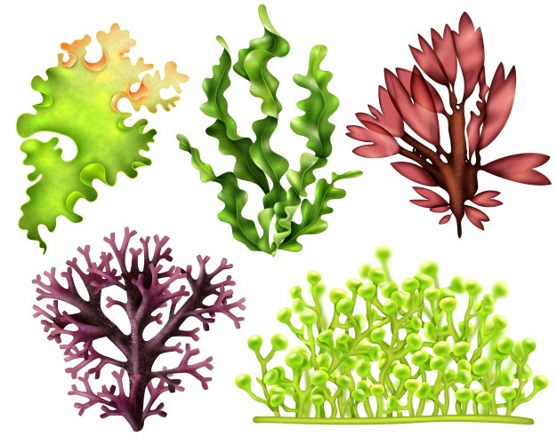 | Lesson 2  cut outs | MY NEW ART WORD  gouache  A water-based, opaque (not see through), quick-drying, matte paint.  This is the type of paint that Matisse used.
Step 1: Background.  - Choose two colours.  - Paint one sheet of paper as your main colour. Paint the other another colour.  - Once dry cut a strip from one colour.  - Glue onto your paper in the same pattern as Matisse. | Step 2: Alga shape  - Use the pictures of alga above to choose a shape for your alga.  - Cut it out of white paper.  - Glue onto the centre of your background. | Step 3: Add little squares  - Choose another colour for your little squares.  - Paint a sheet of paper.  - Cut out the little squares and glue onto the alga shape.
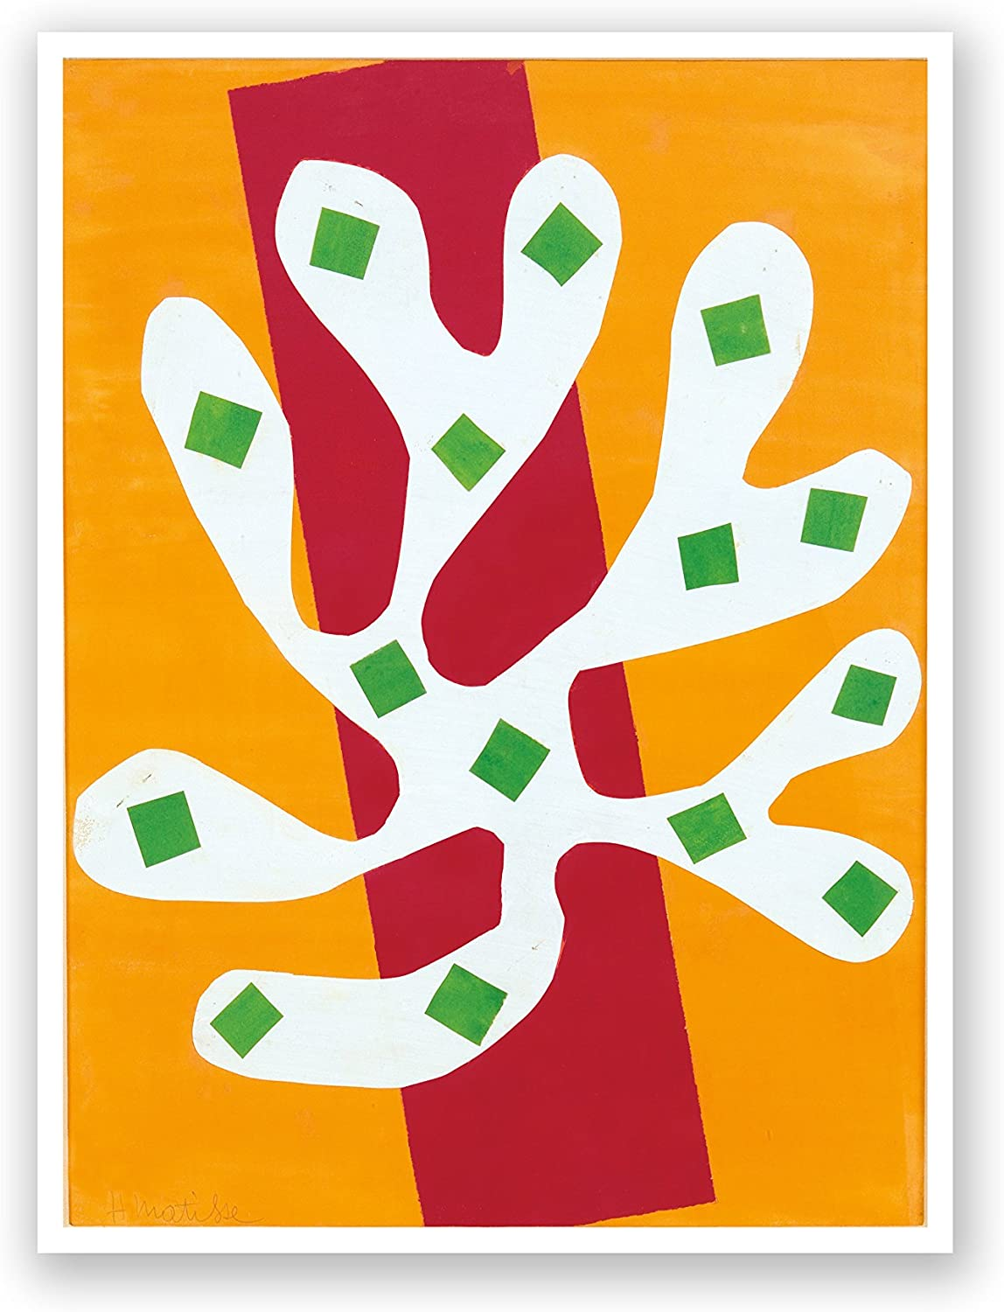
White Alga on Orange and Red Background
Henri Matisse
1947

