Music  See the plans set by Mrs Keenan. |  | Join in with Joe Wicks Daily workout  Live at 9am or see it on youtube later.  https://www.youtube.com/channel/UCAxW1XT0iEJo0TYlRfn6rYQ
Numeracy – Word problems  See your group plan.  Complete the set tasks and then follow up with some sumdog. | Wednesday 6th May  06.05.20  Daily Timetable  Here are your activities for today.  Have fun! |  | Literacy – Sight words  See sight word sheet for your group.
 | Please post two things every day on twitter so we know how you are getting on.
Art – Henri Matisse: Lesson 2  See art learning grid  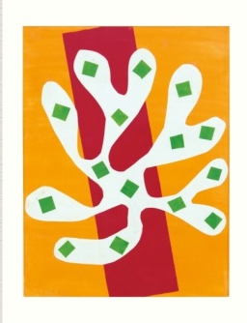 | Family fun- Cloud spotting  Hopefully the sky will be clear. Lie down somewhere outside and look at the clouds.  Look for clouds that look like other things.  What can you see? Any animals? |  | Help out at home  Make your bed.

