Safety  Over the next few weeks we are going to look at lots of ways to keep ourselves safe.  This week we are looking at online safety.  See separate sheet.  HWB  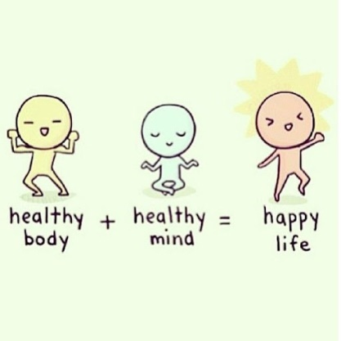 |  | Join in with Joe Wicks Daily workout  Live at 9am or see it on youtube later.  https://www.youtube.com/channel/UCAxW1XT0iEJo0TYlRfn6rYQ  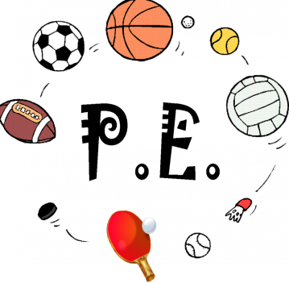
Friday Riddles (last week’s answer – a clock)  Post your answers in the comments on the riddles tweet.  Riddle – What type of cheese is made backwards? | Friday 1st May  01.05.20  Daily Overview  Your activities for today.  Have fun! |  |  | Literacy – procedure writing    See writing plan.
 | Finish off Friday
Have a great weekend!!   |  |  | Family fun  Time for a wee boogie! Put on some tunes and have a family dance around the house. |  | Help out at home  Tidy one of your draws in your bedroom.

