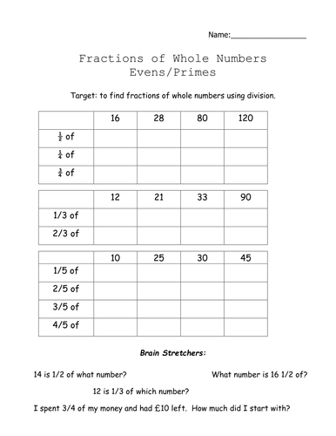
Last year we looked at finding fractions of a number. Remember to find ½ of a number you divide by 2, 1/3 of a number you divide by 3 and ¼ of a number you divide by 4. How would you find 1/5? Have a go at the worksheet attached as a bit of revision from last year.

