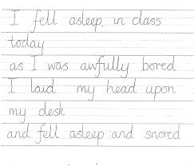
Copy this funny poem into your jotter, on paper or on the ground in chalk in your best joined up writing. Remember tall and short letters.

