Writing
This term we are looking at procedure writing.
Procedure writing’s purpose is: To provide instructions about how to make or do something.
This week we are going to look at an example to learn the structure of the writing. For this type of writing the structure is easy to remember as each section is labelled with what it is going to be.
TITLE
This tells you the thing that is being made or the activity that is being done.

GOAL
This tells you what you will achieve at the end.

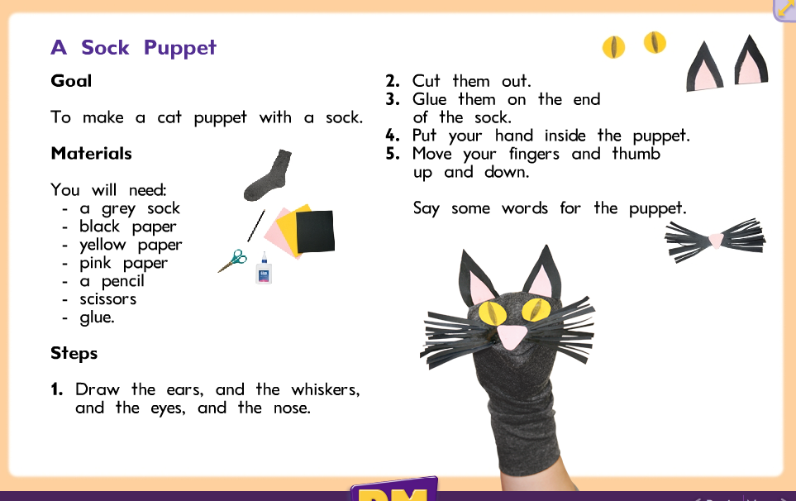
STEPS
Lists the steps in order of how you do them. These should be numbered.
MATERIALS
Tells you what you need to achieve your goal. It could be ingredients, materials, or objects.

- The best way to learn how instructions work is to have a go. So have a go at making the sock puppet yourself. You can change things in the materials. If you do talk about what you would write instead.
- Now see if you can find any instructions in your house. Good places to look are craft books, cookbooks, magazines. You can even have a look online. Talk with an adult about the different parts of the writing. Do all the instructions you found have all the different parts? If not what would you write to add in the missing information?

