Safety  Over the next few weeks we are going to look at lots of ways to keep ourselves safe.  This week we are looking at online safety.  See separate sheet.  HWB  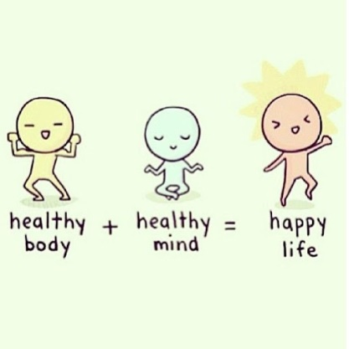 |  | Join in with Joe Wicks Daily workout  Live at 9am or see it on youtube later.  https://www.youtube.com/channel/UCAxW1XT0iEJo0TYlRfn6rYQ  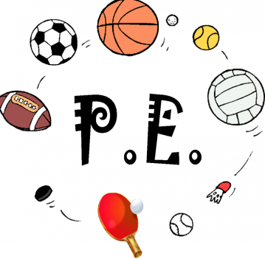
Friday Riddles (last week’s answer – a easter egg)  Post your answers in the comments on the riddles tweet.  Riddle – What has hands but doesn’t clap? | Friday 24th April  24.04.20  Daily Overview  Your activities for today.  Have fun! |  |  | Literacy – procedure writing    See writing plan.
 | Finish off Friday
Have a great weekend!!   |  |  | Family fun  Play eye spy but with other senses….I can smell….I can hear….I can touch….I can taste…. I can touch….something beginning with. |  | Help out at home  Help out drying the dishes.

