HWB  Safety  Over the next few weeks we are going to look at lots of ways to keep ourselves safe.  This week we are looking at online safety.  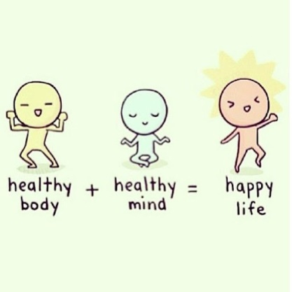 |  |  | 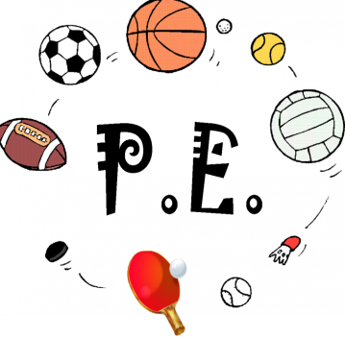  Join in with Joe Wicks Daily workout  Live at 9am or see it on youtube later.  https://www.youtube.com/channel/UCAxW1XT0iEJo0TYlRfn6rYQ
Numeracy – word problems    See your group plan.  Complete the set tasks and then go wild playing maths games. | Thursday 23rd April  23.04.20  Daily overview  Have fun! |  |  | Literacy – sight words & comprehension    Comprehension.  Limes – Do the first one verbally.  Apples– Do the Second one verbally.  Bananas – Do the third one and write the answers in your jotter.  Reading books will start next week so in the meantime share a story together.  Use the blooms questions to talk about the story. Pick one question from each theme.
 | Please post two things every day on twitter so we know how you are getting on.
Science – My Body    Over the next few weeks we will be looking at our bodies.  P1’s will be learning about My Senses  P2/3 will be extending their learning on senses and learning about |  | Family fun  Have a dance around the house to your favourite tunes! |  |  | Help out at home  Tidy your bedroom.

