Friday Riddles (last week’s answer – a sponge)  Post your answers in the comments on the riddles tweet.  Riddle – I’m colourful but I’m not a rainbow  I’m hunted for but I’m not treasure  I sometimes contain chocolate but I’m not an advent calendar  I have a shell but I’m not a crab  I’m sometimes painted but I’m not hung on a wall  I’m left by a bunny but I’m not the remains of a carrot |  |  | Join in with Joe Wicks Daily workout  Live at 9am or see it on youtube later.  https://www.youtube.com/channel/UCAxW1XT0iEJo0TYlRfn6rYQ  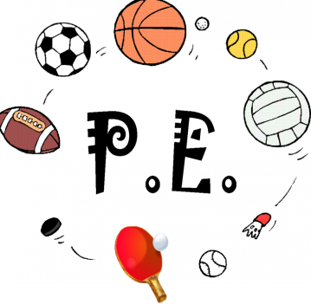
Finish off Friday  Times are busy and I know you are all juggling lots of commitments. So apart from writing Friday will be a day for you to catch up or finish off anything you haven’t got to. As we don’t want you to feel like the smiley on the left but more like the smiley on the right!   | Friday 3rd April  03.04.20  Daily Timetable  Your activities for today.  Have fun! |  |  | Literacy – writing  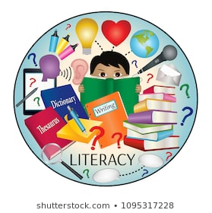  See writing plan.
Daily Lego (creative) Challenge

Day 11: Can you build a castle for Prince Charming and Cinderella?

Post your constructions on twitter.
Have a great weekend!!   |  | Family fun  Read a story together. Use funny voices maybe someone could do the actions. |  |  | Help out at home  Have a go at washing or drying the dishes.

