HWB  Fluffy Bunny Peace out. Grown –ups have a go too! You won’t regret it.  https://www.youtube.com/watch?v=bySktY53P6c  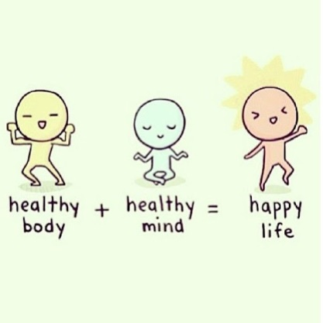 |  |  | 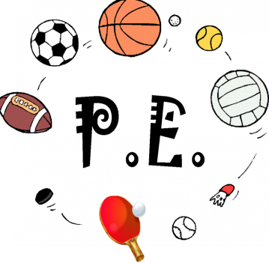  Join in with Joe Wicks Daily workout  Live at 9am or see it on youtube later.  https://www.youtube.com/channel/UCAxW1XT0iEJo0TYlRfn6rYQ
Numeracy    Have a go at the Spring games on TOPMARKS.  https://www.topmarks.co.uk/Flash.aspx?f=SpringNumber | Thursday 2nd April  02.04.20  Daily Timetable  Your activities for today.  Have fun! |  |  | Literacy  Easter rhyming challenge  Lamb Spring  Chick Bunny  Bun Egg    How many rhyming words can you come up with for each of the Easter words? Beat your challenge level!  Limes – 2, Apples – 5, Bananas – 10 for each word.  Limes – chose one word for each rhyme and say a sentence.  Apples – chose two words for each rhyme and say a sentence. Chose another word and write a sentence.  Bananas – chose three words for each rhyme and write a sentence for each one.
Daily Lego (construction) Challenge
Day 10: You and your friends decide to build a treehouse.

Science – Egg-cellent egg-periments!    Choose one of the egg-periments and post your results on twitter. |  | Family fun  Get outside and look for signs of Spring.  Tweet some photos of what you saw. |  |  | Help out at home  Empty the bins!

