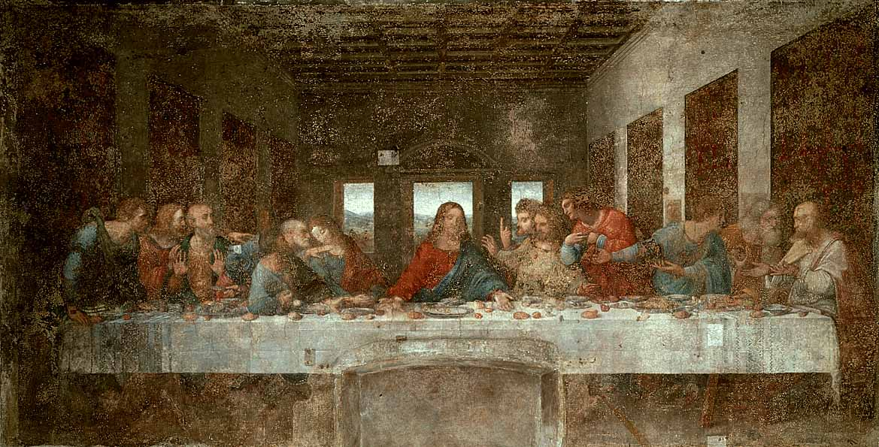

The Last Supper by Leonardo Da Vinci

**Information about the picture.**

This picture was painted by Leonardo Da Vinci in 1495.

It shows Jesus eating with his 12 disciples.

Jesus didn’t know the last supper was his last meal.

Jesus did not know one of his disciples would betray him.

**Talking and Listening : Share your ideas.**

What do you like this picture or not? Why?

Do you like the colours the artist used?

Who do you think is in this picture?

What are they doing?

Why do you think it’s called the Last Supper?

Are the characters men or women?

Imagine it is your last school dinner at Dechmont Infants. Who would you like to invite to that meal?

Draw a picture of you with all your guests.

Think about what the table would look like?

Would you add decorations?

Try and choose a colour palette of four colours for your picture.