Friday Riddles  Post your answers in the comments on the riddles tweet.  Riddle – What has holes but still holds water?  Mrs Short say ‘Well it’s definitely not a bucket!?’  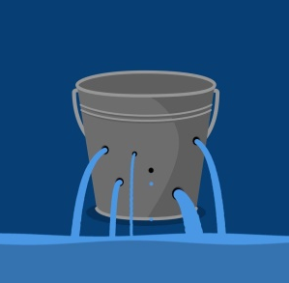 |  |  | Join in with Joe Wicks Daily workout  Live at 9am or see it on youtube later.  https://www.youtube.com/channel/UCAxW1XT0iEJo0TYlRfn6rYQ
Finish off Friday  Times are busy and I know you are all juggling lots of commitments. So apart from writing Friday will be a day for you to catch up or finish off anything you haven’t got to. As we don’t want you to feel like the smiley on the left but more like the smiley on the right! | Friday 27th March  27.03.20  Daily Timetable  Your activities for today.  Have fun! |  |  | Literacy – writing  See writing plan.
Daily Lego (creative) Challenge

Day 4: Build/make a set for a new Star Wars movie.
Post your constructions on twitter.
Have a great weekend!! |  | Family fun  Watch a film together. Snuggle up and watch a fun film together. |  |  | Help out at home  Hep out with cooking. This could be peeling carrots for tea or making a cuppa (get an adult to help you with the hot water!)

