**Reading Plan : Thursday 26th March 2020**

**CHECK OUT READING GROUPS AT THE FRONT OF YOUR READING HOMEWORK DIARY**

|  |  |  |  |
| --- | --- | --- | --- |
| **GROUP** | **BOOK** | **PAGES** | **ACTIVITY** |
| Image result for hungry caterpillar**Carle** | Big, Bad Bug | Whole book | Do activities above book  I can read Phase 2 Set 1  Read and Draw sentences – The Man sat on a log & I hug my Mum. |
| Image result for crayons story **Jeffers** | Run, run, run! | Speed sounds  Vowels  Green & Red word  Pg 6- 12 | Answer relevant questions on Pg 21  Dictation – (see note below)  **He ran past a cat.**  **He ran past a man in a van.** |
| Image result for tiger who came to tea**Kerr** | Rag the rat | Speed Sounds  Vowels  Story Green words  Red words  Story 1 | Answer questions on P12  Dictation (see note below)  **Rag the rat with his big top hat.**  **Rag the rat taps it.** |
| Image result for cat in the hat **Seuss** | Alien Adventures | Read to pg 11 | Do activites on Page 11  Which watch do you like best?  Give me three reasons.  Then design your own watch and tell me about it. Do it I your literacy jotter. |

**WHERE DO I FIND THE READING BOOKS?**

**For all reading books log into** <https://www.oxfordowl.co.uk/> using the class login button and details in your home learning pack.

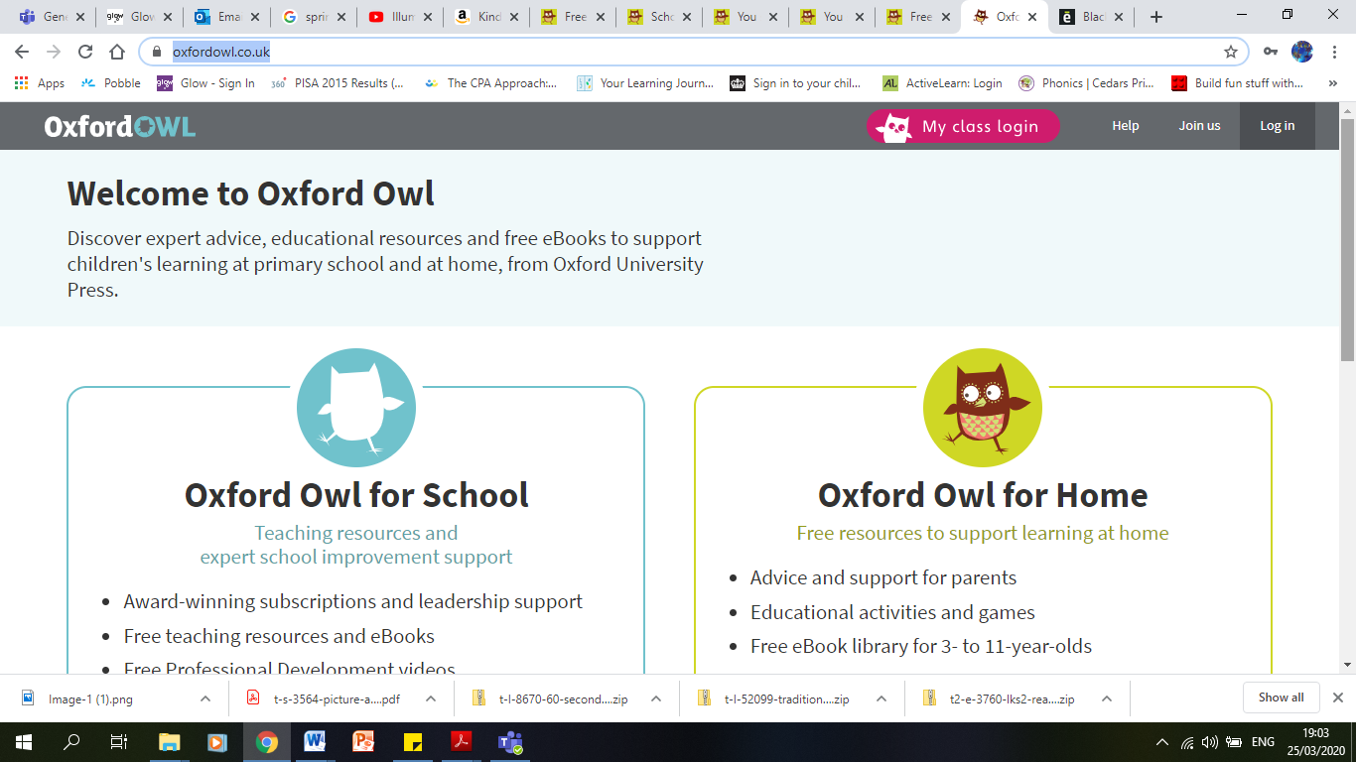

Login in here.

Use the details in your home learning pack.(In the list of links on the back of t the letter saying ‘READ THIS FIRST PLEASE’

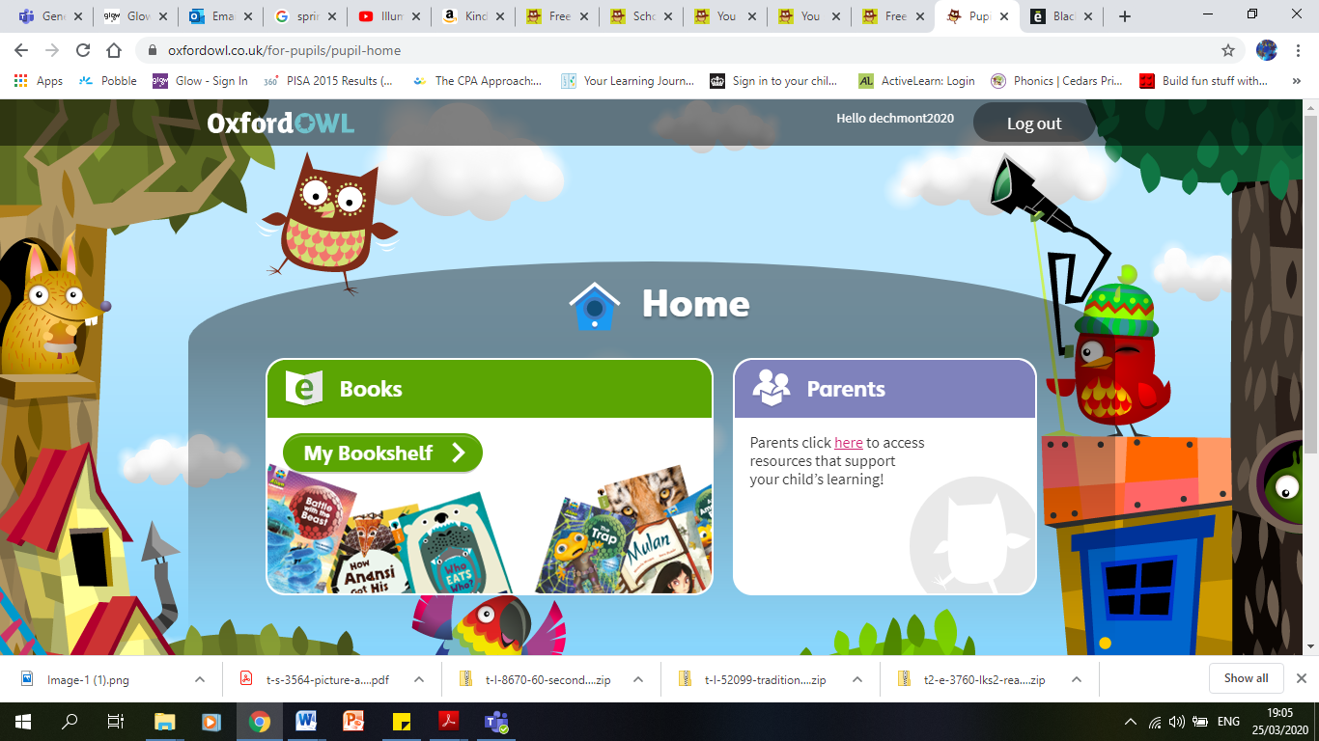 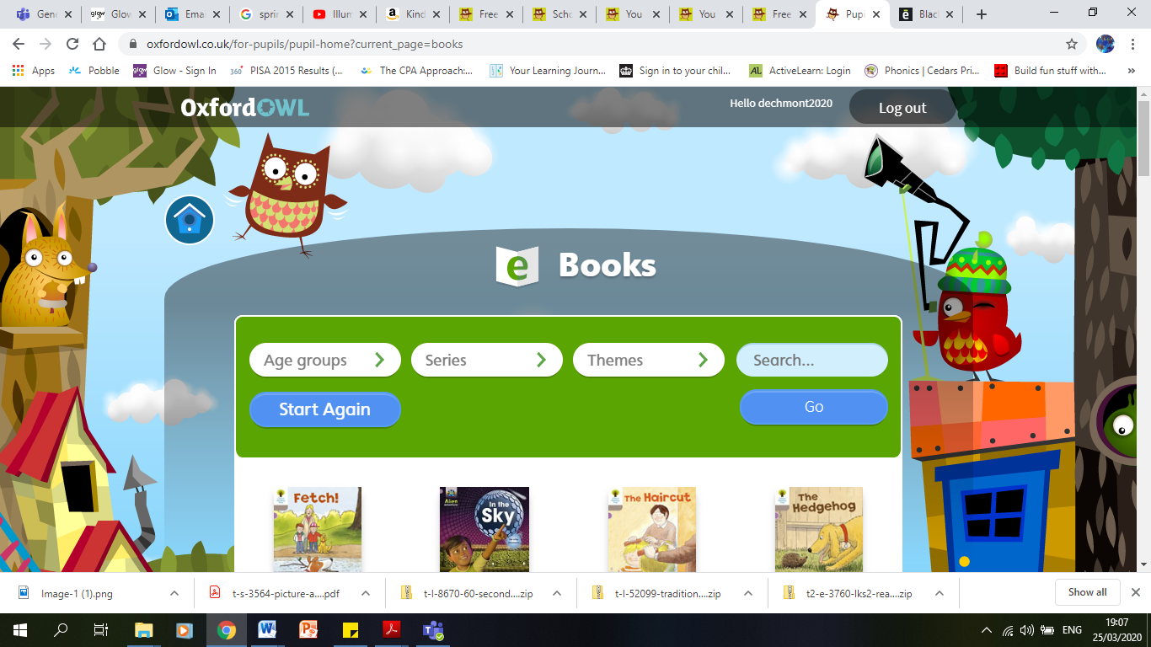

Click on my bookshelf

Type the name of the book into the search bar and book should appear.

**What is dictation?**

Dictation is a method to help children begin to write independently. It helps develop skills like sounding out (where they use their phonics (letter sound) knowledge to help them write words. It also helps with building memory for writing as it encourages them to remember what is being said to them.

**How do I do it?**

* **Before you start –** Ask what goes at the start of a sentence? (Capital letter) what goes at the end? (full stop) and what goes between each word?(finger spaces). Remind them to sound out the words. They can use their fingers to help work out how many letters there are in each word.
* **During –** Say the sentence one time and ask them to repeat it. Say the sentence another time. Encourage them to repeat the sentence as they write it. If they do forget that is ok just repeat the whole sentence again.
* **After -** ask them to reread the sentence to check they haven’t missed any words.

Don’t worry if they misspell words.

Write the sentence underneath and ask them to check for any differences.

If there are ask them to copy the correct sentence underneath.

Afterwards – Draw a picture to match the sentence.