NUMERACY – Wednesday 25th March 2020
CHECK THE FRONT OF YOUR READING HOMEWORK DIARY TO SEE WHICH GROUP YOU ARE IN IF YOU HAVE FORGOTTEN.
Numicons | Numbers  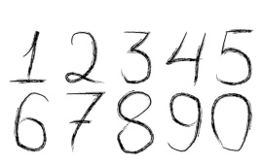 | Digits  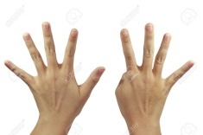
LI – I am learning how to double. | LI – I am learning my two times tables | LI - I am learning how the four and eight times tables link to the two times tables.
SC – I can double a number up to five/ten. | SC – I can create arrays for my two times tables. | SC - I can create the pattern of the 2x, 4x and 8x tables.
Listen - Double Ducks Story (to remind you) https://www.youtube.com/watch?v=hnRT0HSzvAg  Make – Double Number Butterflies  Cut out some butterfly shapes and fold in half.  Add spots to their wings to make a double. You can draw/paint/collage the dots.  Do three different numbers between 1 and 5.  Take a photo and post it on twitter or in your learners journals.  Sing – Double Number Song  https://www.youtube.com/watch?v=M9YQ4phTB0E  Play – TOPMARKS: Maths Fishing – choose game1: Doubles of all numbers to ten. (This game won’t work in CHROME. Please use internet explorer)  https://mathsframe.co.uk/en/resources/resource/306/Maths-Fishing-Multiplication | Make/ Write – make arrays for the two times table.  Collect together some objects like lego/gravel/buttons.  Use numbers from 1 and 10. Starting with 1.  Write the sum in your numeracy jotter 1 x 2 =  Make the array (showing one group of two)  O  O  Count all the objects to get your answer.  Now draw the array in your book. Use the squares to help you.  Put a photo of your arrays on twitter or in your learners journals  STUCK – use The Array to help you work them out  https://www.scootle.edu.au/ec/viewing/L106/index.html#  Play – TOPMARKS: Hit the button (This game won’t work in CHROME. Please use internet explorer)  Choose times tables and 2x  Sing – Multiply by two  https://www.youtube.com/watch?v=iiR8hqJeQsw | Revision  Write – complete your two times table booklet.  Make – TOPMARKS: Splat Square. (This game won’t work in CHROME. Please use internet explorer)  Select 1-100 chart  Mark up the 100 square to show the pattern created by the two times table.  Now make one for the 4x and 8x table.  Can you see the connection between the three patterns?  Play – TOPMARKS: Hit the button (This game won’t work in CHROME. Please use internet explorer)  Choose times tables and 4x, 8x  Sing – 4 times table song https://www.youtube.com/watch?v=_fddxui9y0U

