Carmondean Primary School
Sports Day (at home) 2020
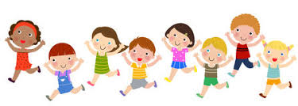

Welcome pupils, staff and families to our Annual Sports Day!
Thursday 18th June should have seen us all gather out on the field for a day of fun activities and although we can’t do that, being at home will not stop us from having a sports day to remember. I hope that you enjoy taking part in the different activities and remember that as we find ourselves away from each other, we are coming together as a School and in House Teams to see who will be our Sports Day Champions this year.
Raeburn won last year
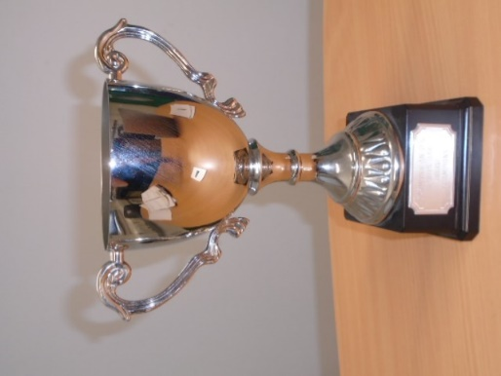
Who will win this year?

Before you begin please think about SAFETY.

- Put on clothing suitable for PE activities
- Find a space suitable to do the activity
- If the sun is shining; put on sun cream and a hat
- Make sure you have water nearby to keep you hydrated.
- Ask an adult to supervise

There are 8 activities in our alternative sports day. 7 of them are scoring stations and there is a description of how to set them up, what to do and how to score on the next page. I would like to say a big thank you to Primary 7 and the sports committee for their ideas for this year’s sports day. It was a great help to me.
You will need to write down your results for each activity (you can use the attached score sheet or just write it down on a bit of paper) and when you have completed them all please click on this link to submit your results to me.
https://forms.office.com/Pages/ResponsePage.aspx?id=oyzTzM4Wj0KVQTctawUZKVTBRXKOnk1IgNWQjxFRYcFUMVhDSUFDUzVQV1c1MkpTUFM1RkxWNFBURC4u

Please submit your results by 12 noon on Friday 19th June 2020
I would love to see photos of you taking part so you can:
- Add them to the comment section of the sports day blog post.
- post in Teams.
- Send them to you class teacher
- Tweet them to me @MrsFerguson15 **Please do not add any names to pictures you send**

Good luck and enjoy!
Mrs Ferguson
P.E. Teacher

Activity 1 – Speed bounce

Roll up a towel/ books/small hurdle. How many times can you jump, with feet together, side to side over the towel in 20 seconds?

Video Resource https://youtu.be/jB1NWH0qpTA

Activity 2 – Target Throw

Collect 5 teddies (or balls or rolled up socks), 1 big target, 1 medium target and 1 box. Can you throw the teddies into the box? Score points where they land.
5 points = in the box, 3 points = on the medium target and 1 point = on the big target. Don’t stand too close!
3 steps away for P1& 2; 4 steps away for P3 & 4 and 5 steps away for P5-7.

Video Resource https://twitter.com/MrsFerguson15/status/1259831413727277057?s=20

Activity 3 – Shuttle run
Set up 2 markers 5m apart (outside if possible)

How many times can you run between the 2 markers in 1 minute. You must run to the marker and back again to count as 1.

Activity 4 – Dribble & Score

Collect 1 ball, 3 items that you can use to dribble around and 2 items to set up goals (cones and goals if you have them but if not, then any marker will do).
Place these markers 1 m apart

X 0 1m 0 1m 0 1m goals

Using your feet, dribble the ball in and out of the cones and at the last one kick the ball into the goal. Run back to the start and go again.

You have 2 minutes to see how many goals you can score.

Activity 5 – Star Jumps

How many star jumps can you do in 30 secs?

Start in a space with your legs together and make sure your legs
and arms go fully out and in each time.

Activity 6 – Egg and spoon

Find a small round object (a ball, small pair of socks, potato, boiled egg) balance it on a spoon and walk up and down your shuttle run area.

How many laps can you do in 1 minute? To the marker and back counts as 1. If it drops go back to the start of that lap.

Video Resource https://youtu.be/OwMovXURIuQ

Activity 7 – Balance

How long can you stand with one foot off the ground?

Stand tall with your arms on your hips and raise one foot off the ground. If your arms come off your hips or your leg starts to move then stop the timer and record your time. Please record this time in seconds only and just as a number e.g. if you could stand for 1min 10sec then this would be submitted as 70.

Video Resource: https://twitter.com/WLPENetwork/status/1257958456281182208?s=20

Activity 8 - Obstacle (non - scoring event)

Create an obstacle course for you and others at home to try.

Can you include obstacles that make you go over, under, through, in, out, along?

Time yourself and see if you can beat your score or challenge someone at home to beat your score.

Score sheet

Name: | Class: | House:

Activity | Score
1 Speed bounce
2 Target Throw
3 Shuttle Run
4 Dribble & Score
5 Star jumps
6 Egg & Spoon
7. Balance

Score sheet

Name: | Class: | House:

Activity | Score
1 Speed bounce
2 Target Throw
3 Shuttle Run
4 Dribble & Score
5 Star jumps
6 Egg & Spoon
7. Balance

