“I Like to Move it”
Animal movements

Today you are going to move like different animals and we are using the Song “ I like to Move it from Madagascar to help us.
Warm Up
Find a safe place to warm up and then copy the moves from Jump Start Johnny “I like to Move it” https://www.jumpstartjonny.co.uk/home
Main Activity
- Ask an adult to call out these animals and see if you can change your movements to be like the animal
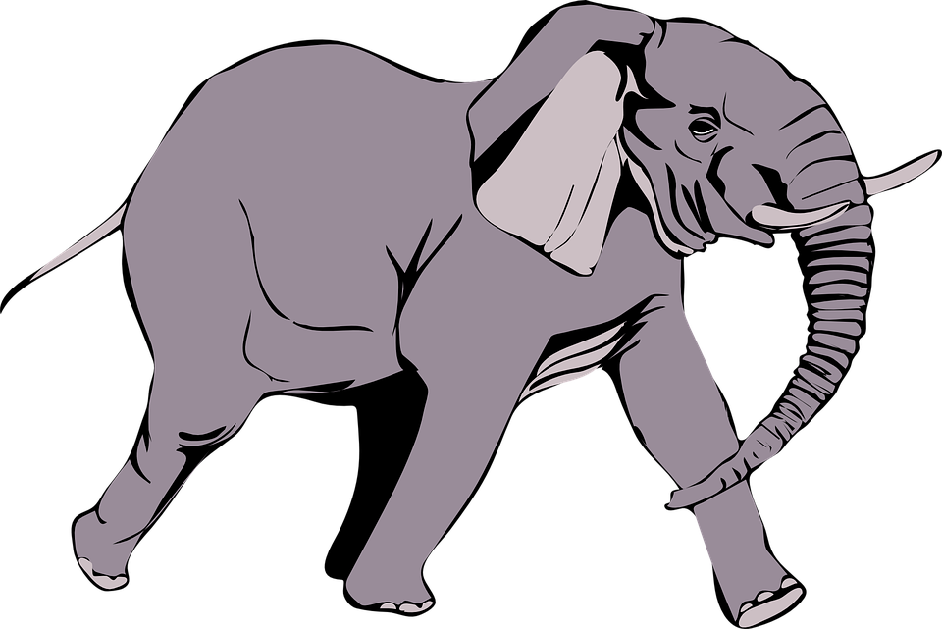Can you STOMP like an Elephant?
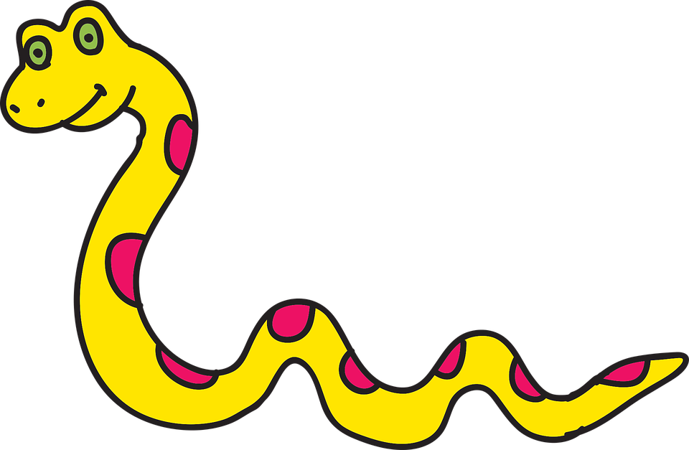
Can you SLITHER like a Snake
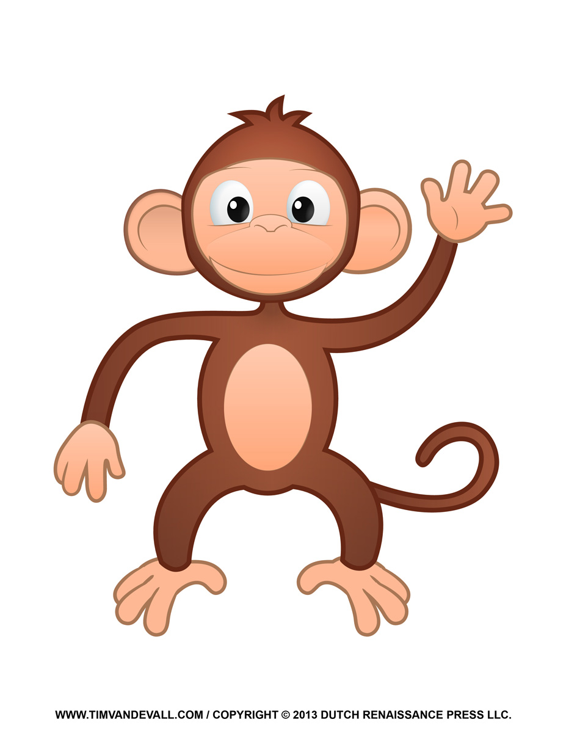
Can you SWING your arms like a Monkey?

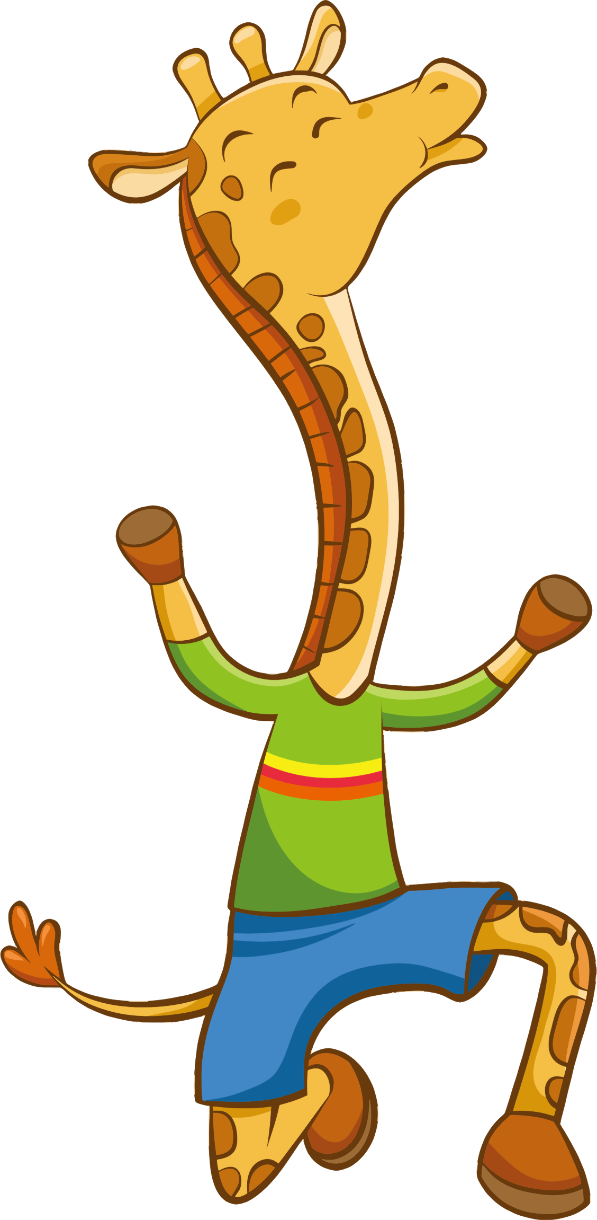
Can you STRETCH like a Giraffe?

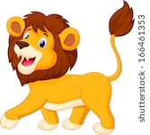

Can you PROWL like a Lion?

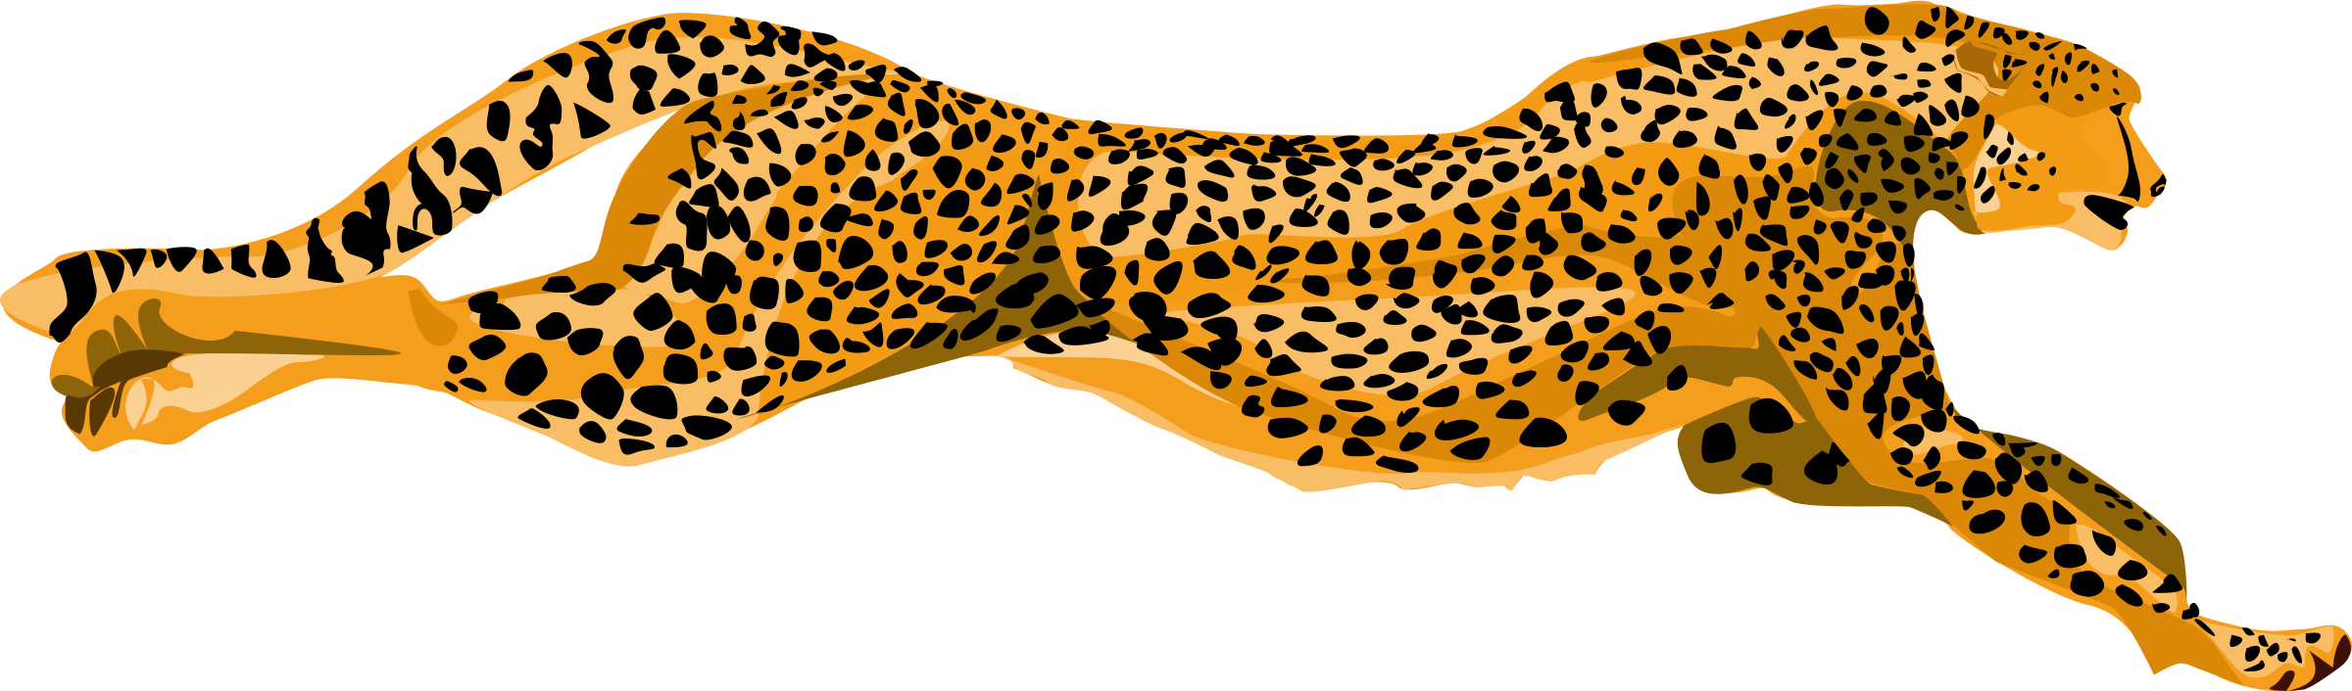Can you RUN fast like a Cheetah?.

- Print out the animal cards and do the movement when the card is shown to you.
- Can you come up with any other animal movements to add to these?
- Play animals statues- move like an animal to music and freeze in that animal shape when the music stops
Extension: try Zumba Kids “ I like to Move it” Dance starts 1min into clip. https://www.youtube.com/watch?v=emKoR6Mlr4I

