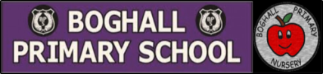

Nursery to P1 Transition at Boghall Primary School
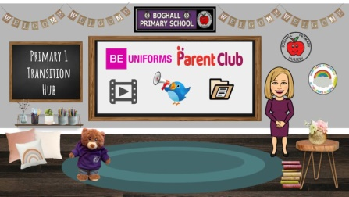
We fully appreciate that the transition from Nursery to P1 is a very important milestone for both your child and as Parents. All of us here at Boghall Primary hope you and your child have as smooth a transition as possible and are here to answer any questions you may have. Therefore, we have noted some important events in the coming months that would be great if you and your child could get involved in. We look forward to getting to know you and your child and welcoming you to Boghall Primary .
IMPORTANT: Virtual Primary 1 Hub! All our information this year will be available through our online Virtual Primary 1 Hub here:

CLICK HERE FOR VIRTUAL HUB

This will be updated on the following dates (see below) and we will email you when there is a new update.

April 2022
- Post card home acknowledging placement at Boghall Primary School.
May 2022
Date | Activity | How to access
Thursday 12th May | Information session general welcome and introduction. Issue key dates. | Link will be sent out via email*
Friday 13th May | Virtual video tour of the school including classrooms. | On virtual Hub and Link will be sent out via email*
W/C 16th May | Glow form sent out to gather any questions you may have. | On virtual Hub and Link will be sent out via email*
W/C 23rd May | Letter from your child’s P7 Buddy | Posted to your house/delivered to Nursery
w/c 30TH May | Home visit/doorstep drop off of key information and book bag. We will safely deliver this for you. We hope to see both you and your child for a quick chat. | Door step drop off – blocks of time will be communicated via letter home.
June 2022
Date | Activity | How to Access
Thursday 2nd June | Video message from Boghall Bear | Available on school blog and Virtual Hub – also in Nursery for Children to watch.
w/c 7th June | Story telling session with P1 Staff. This will familiarise your child with their Class Teacher.  Buddies to visit Nurseries to meet children. | Film will be shared on virtual Hub and in Nursery for children to view.
Monday 20th June and Tuesday 21st June 13:45-14:45 | Classroom visits & Buddy Teddy Bears Picnic | sent out via email*
w/c 20th June | A video message from your child’s new class Teacher | On virtual Hub and Link will be sent out via email*
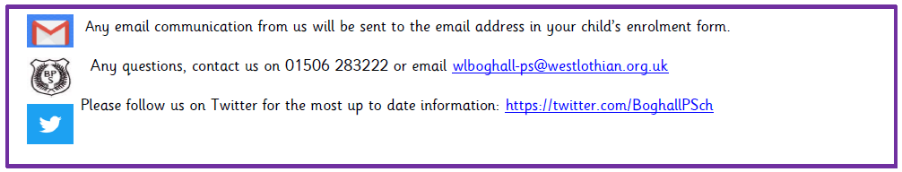  w/c 20th June | Information on arrangements for first Day sent out | sent out via email*

