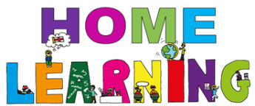

Week Beginning: 1st February 2021
Class: Primary 1 Teachers: Miss Cushley and Miss Keillor Learning theme: How To Grow a Dinosaur

Here are some ideas for you to complete throughout the week at a time that best suits you and your family. There are a range of digital and non-digital activities for you to do – please feel free to adapt these as you wish. We are also encouraging you to use the Seesaw app where your class teacher will be posting literacy and numeracy activities for your child. Seesaw will allow your child to interact and communicate with a class teacher and share all of their amazing work with us. You can upload any learning you have completed from this grid to Seesaw and you should log in to Seesaw to complete the activities we have provided for you each week.If you have any questions this week please just send us an email!
HWB  You have all been working so hard over the last couple of weeks and it is important to make some time for you!  Click on the link to take part in a dinosaur themed cosmic yoga for kids.  https://www.youtube.com/watch?v=rnlDBKD2S78  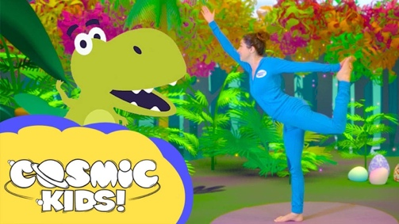 | Art & Design  For this activity you will need to be prepared to get outside and get a little messy. Your challenge is to go outside and create a mini ‘dinosaur environment’ using boxes, stones, mud, playdough, sand, leaves, dinosaur figures, anything you can find in your garden.  Send your teacher some pictures on Seesaw.  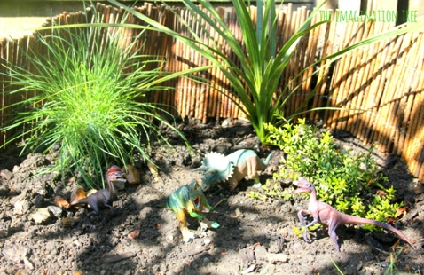 | Drama  Watch the video below which shows the different kinds of dinosaurs and their roars (make sure your volume is turned down, it can be a bit loud).  Once you have done this, choose 4 of these and record yourself doing your best ROAAAR and tell me what dinosaur it is.  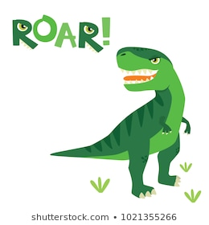  https://www.youtube.com/watch?v=yJTLAnatTvM
HWB – Random Acts of Kindness  This week we are setting you a random acts of kindness task. During this difficult time sometimes we can feel a bit sad. By taking part in the random acts of kindness tasks we are not only making other people feel happy but we can also make ourselves feel happy.  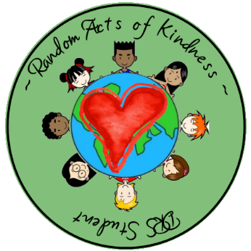  You will find a grid to take part over on Seesaw. | STEM  This activity is called Build a Dino. For this activity you will need; bendable straws, marshmallows, toothpicks, a rolling pin (if you have one).  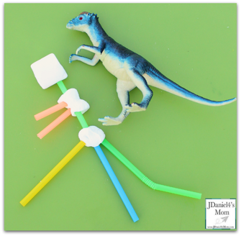  Using these materials, you are being asked to make your own dinosaur that will stand up on its own. – You could add it your dinosaur environment in your garden. | Art & Design  This activity will give you a step by step guide to drawing a dinosaur. For this activity, click the below and follow the draw along video which will help you draw a dinosaur. Make this dinosaur as colourful and crazy as you can!  https://www.youtube.com/watch?v=mO3yBR6Omxw  