Week Beginning: 8th February 2021
Class: Primary 1 and 2 Teachers: Miss Keillor, Miss Cushley, Miss Arkless and Miss Anderson Learning themes: Valentine's Day/Chinese New Year

Here are some ideas for you to complete throughout the week at a time that best suits you and your family. There are a range of digital and non-digital activities for you to do – please feel free to adapt these as you wish. We are also encouraging you to use the Seesaw app where your class teacher will be posting literacy and numeracy activities for your child. Seesaw will allow your child to interact and communicate with a class teacher and share all of their amazing work with us. You can upload any learning you have completed from this grid to Seesaw and you should log in to Seesaw to complete the activities we have provided for you each week.If you have any questions this week please just send us an email!
HWB – Pancake Day  With an adult, have a go at making your own pancakes. Check out the recipe we have provided on our school blog for instructions on how you can make pancakes at home!  OR  Design and draw a detailed picture of your perfect pancake. What toppings would you choose? | HWB - Pancake Day  As part of our Literacy on Tuesday we will be exploring ‘Instruction Writing’  ’  Watch as Miss Anderson and her daughter have a go at making some pancakes and teach you all about how to write a set of instructions. | Valentine's Day  Kadinsky is an artist famous for his concentric circles. But February is the month of love.  So we are going to learn a little about Kadinsky and try to create our own love heart art.  This activity will be available on Seesaw from Monday.
Chinese New Year  Listen to the story of Chinese New Year on Seesaw on Wednesday.  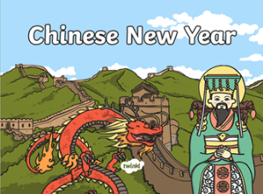  Can you write your name in Chinese?  We are going to do a little bit of de-coding, can you find the letters used in your name and write them in Chinese?  You will find the Chinese letters on the school blog.  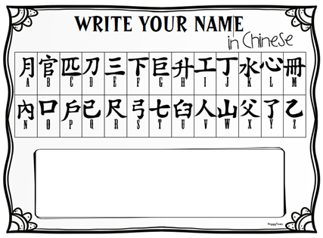  Don’t forget to share a picture of your name with us on Seesaw! | Chinese New Year  Listen to the story called ‘Dragons in the City’ on Thursday.  Can you design your own dragon? Use pens and paper or you might want to make a model dragon with anything you find around the house. | Valentine's Day  Listen to our video all about Valentine’s Day on Seesaw. Valentines Day is about celebrating the people that we care about – this can be anyone that means a lot to you!  This week we would like you to have a think about someone that means a lot to you and why. We would like to create a film for Primary 1 and Primary 2 where we can share who the important people in our lives are with each other. If you would like to be a part of this, please share a short video of yourself telling us about someone who is important to you on Seesaw by 4pm on Thursday!  If you’re happy for your child’s video to be shared with our school community and on our school twitter page please can you let us know by leaving us a wee message on the Valentine’s Day Seesaw Activity. Thank you!

