Rainbow Maths Handprints
2020 was the year everyone displayed rainbows as a sign of better things to come after the difficult times.
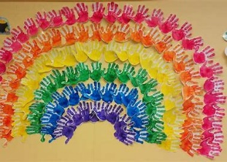
Your task is to create a unique handprint filled with some of your Mathematical knowledge. We can then hopefully collate them all into a Boghall rainbow of our own when we all return to school.

First, you should draw around your hand.
Next, you should colour your hand in with the colour assigned to your class. You might want to do it quite light so that you can see writing you are going to put on top.
Finally, you should attempt the maths challenge assigned to your class.

You might want to do a pretty pattern as you colour. You may want to do the Maths challenge on a different colour of paper then cut and stick it on. Another idea might be to leave white bubbles for you to write your maths challenge in. The creative part is entirely up to you!

We would love for you to share a photo of your Mathematical handprint by the end of January 2021. Keep hold of it somewhere safe if you can so that you can bring it in to school when we are all safely back in the building.
Primary class | Colour | Maths
P1 | Red | Label each finger with the digits 1,2,3,4 and 5.  Can you create your own sum that uses these digits? Write these on the palm of your hand.
P2 | Orange | On each finger, can you write, in 12 hour time, what time you;  - Wake up at  - Start school  - Eat lunch  - Have dinner  - Go to bed
P3 | Yellow | Can you estimate how long each finger is in cm and write this on?
P4 | Your choice of the 6 colours listed. | Can you create a symmetrical pattern across your handprint? (You may want to use a mix of colours.)
P5 | Blue | If your pinky is the ones column, the next finger is the tens column and so on up to ten thousands (if you wish) – can you create your own number? Write each digit on each finger and write the number in words in the palm.
P6 | Purple | Can you create a number pattern? Use each finger to write each part of the pattern. Can you explain your number pattern in the palm?
P7 | Green | Label each finger 1 – 5. Can you create a decimal sum for each finger where the answer is the digit you’ve written?

