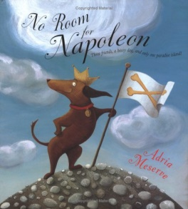
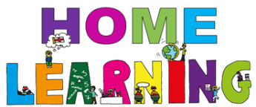

Week Beginning: 1st February 2021

Class: Primary 2 Teachers: Miss Keillor, Miss Cushley, Miss Arkless and Miss Anderson Learning theme: No room for Napoleon.

This week, the learning grid is themed around this week’s Word Boost story, ‘No Room for Napoleon.’
You will be able to head over to Seesaw to listen to Miss Arkless reading the story to you.
If you would like to share a photo or video of how you got on with any of these activities below, there will be a blank activity set up on Seesaw called ‘Learning Grid Activities,’ where you can post what you have been busy doing!
Be a tour guide!  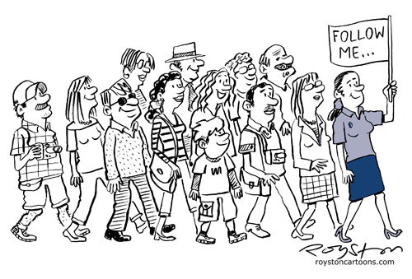  You learned about the word ‘tour.’ A tour guide is someone who takes people on tours and tells them all about the place they are touring.  Could you be a tour guide of your own house? Ask an adult to film you and take your teacher on a guided tour of your house, your favourite room, or your garden! Tell us all about it. | 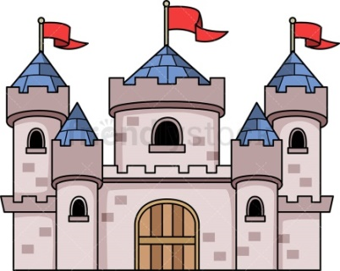  Build your own castle!  In the story, Napoleon is determined to build himself the biggest grandest castle he can manage.  Could you have a go at building an amazing castle for yourself or your favourite soft toy?  What could you use from around your house or garden to help you build it? | Design your own paradise island!  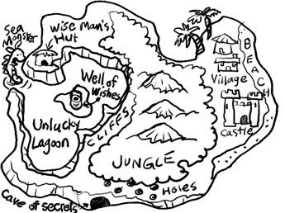  Ask an adult to help you look at different photographs of real ‘Paradise Islands’ online. There are so many beautiful islands all around the world!  Why not have a go at designing your own paradise island? You could use the example above and make it like a map, or you could draw a detailed picture. Use the blank template if that helps. What is on your island? A jungle? A water park? A buried treasure chest? A private waterfall for swimming? A floating trampoline? You can be as creative as you like!
Try some island relaxation.  It’s always important to take some time to relax and switch off.  Click the link below which will take you to a 20 minute ‘Magical Island Meditation.’ This can be for adults too!  Why not try it together?  https://www.youtube.com/watch?v=aNTXpJV8aUg | Make a floating raft!  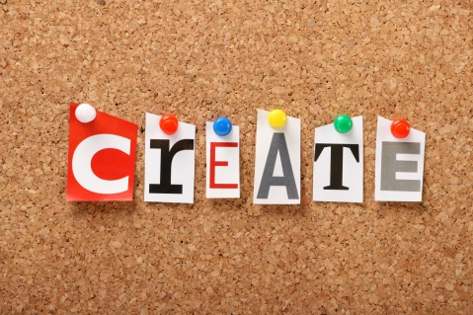  Bunny, Bear and Crab need a raft to sail back to their island. Can you help?  You will need to use materials that float, like straws, corks, lolly sticks, playdough or plastic tubs. Why not test out your raft in a basin of water.  Don’t forget to share a video or photo on Seesaw! | 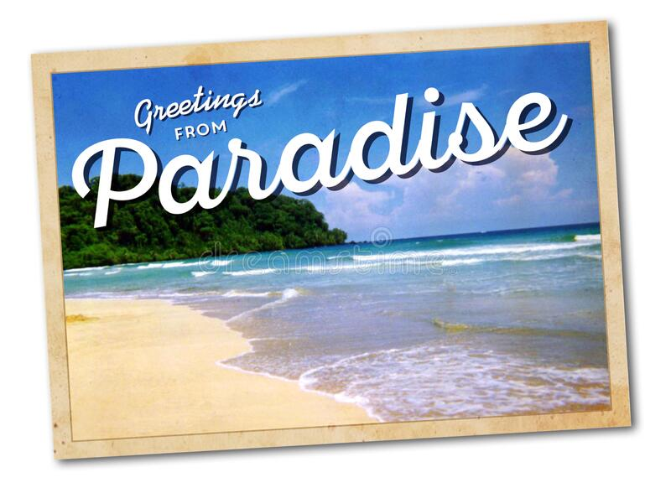  Write a post-card  Imagine you are Napoleon and you are writing a post card home to your family.  Things to include:  What is the weather like on the island?  Have you made any friends? What are their names?  What is your favourite thing about the island?  Use the link provided to get a blank post card template. Remember, a picture of the island goes on one side, and your message on the other.  Don’t forget to share a photo or video of your post card on Seesaw!

