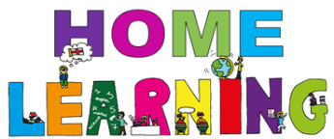

Week Beginning: 25th January 2021
Class: Primary 1 and 2 Teachers: Miss Keillor, Miss Cushley, Miss Arkless and Miss Anderson Learning theme: Scotland

Here are some ideas for you to complete throughout the week at a time that best suits you and your family. There are a range of digital and non-digital activities for you to do – please feel free to adapt these as you wish. We are also encouraging you to use the Seesaw app where your class teacher will be posting literacy and numeracy activities for your child. Seesaw will allow your child to interact and communicate with a class teacher and share all of their amazing work with us. You can upload any learning you have completed from this grid to Seesaw and you should log in to Seesaw to complete the activities we have provided for you each week.If you have any questions this week please just send us an email!
HWB  You have all been working so hard over the last couple of weeks and it is important to make some time for you!  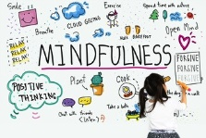  Click on the link to take part in a mindfulness activity with cosmic kids.  https://www.youtube.com/watch?v=QQCnWvwrO8U  OR  Take a moment to the mindfulness colouring pages that we have sent out on our weekly blog post. It is up to you! | Expressive Arts  For this activity you will need lots of colourful pencils or pens and some paper. We have included a highland cow template in our weekly blog post if you would like to print this off! | Robert Burns  It’s almost Robert Burn’s Birthday!  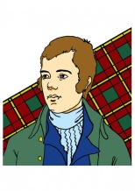  Take a look inside his virtual classroom by clicking on the link below for some fun activities and links!  https://docs.google.com/presentation/d/1sphOOwFIXzvZZk6NoGfzKSZtvIdbebToKb1J62CB61g/mobilepresent?slide=id.p
HWB – Technologies  This week we are setting you a photography challenge, using a camera or any device you have at home.  You will find a grid to take part over on Seesaw. | STEM  Design and build a trap for Nessie!  Today your challenge is to plan and build a trap for Nessie! You can use lots of different materials around your house from milk cartons to lego – it's completely up to you! Remember to send us a photo of your trap and explain how it works!  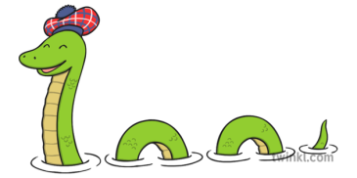 | Music  Can you listen to the song and keep the rhythm using your body as the instruments?  Here is a link to Auld Lang Syne – a famous Scottish song. You could even record yourself and send a video to us on Seesaw!  https://www.youtube.com/watch?v=whvzQw7MVm0  