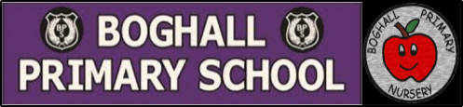
Scotland – First Level Learning Grid
Scottish Poem  Choose one of the poems and work on learning it so you can:  *Recite it from memory  *Recite it using expression  *Include actions in your performance | Scottish Entertainment – Competition  Record yourself performing something with a Scottish theme!  This could be:  *Playing Scottish tune on a musical instrument?  *Singing a Scottish song?  *Scottish dancing? | The Life of Robert Burns  Watch this short animation all about the life of Robert Burns:  https://bit.ly/35pAVXV  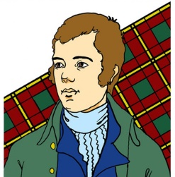  Can you draw a picture of Robert Burns and write a paragraph about him?  Remember to use finger spaces and full stops and capital letters.
Design your own tartan  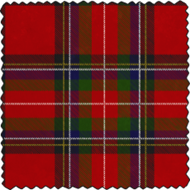  Tartan is a pattern, made by horizontal and vertical coloured lines crossing over each other.  Can you create your own style of tartan?  Create an item using your tartan design – a phone cover, handbag, trainers? | Traditional Scottish Food  With the help of an adult, find out about some traditional Scottish food.  Can you find and follow a recipe?  http://bbc.in/38CJil3  Taste it and send us your review over seesaw!  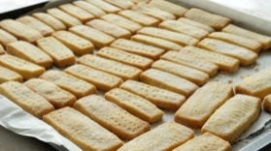  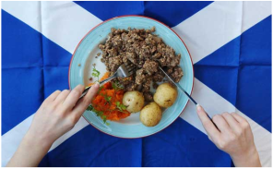 | The Gruffalo in Scots  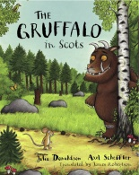  Below is a link to a read aloud of ‘The Gruffalo in Scots.’  Before you watch it, can you guess what these Scottish words might mean?  Dauner Todd Hoolet Een. Clook  Now watch the story and listen out for those words! Were your guesses right?  If you aren’t sure, ask an adult to help you.  https://www.youtube.com/watch?v=Kk9Gq62-de0

