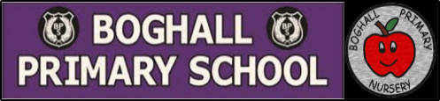
Scotland – Early Level Learning Grid
Scottish Poem  Choose one of the poems and work on learning it so you can:  *Recite it from memory  *Recite it using expression  *Include actions in your performance | Scottish Entertainment – Competition  Record yourself performing something with a Scottish theme!  This could be:  *Playing Scottish tune on a musical instrument?  *Singing a Scottish song?  *Scottish dancing? | The Life of Robert Burns  Watch this short animation all about the life of Robert Burns:  https://bit.ly/35pAVXV  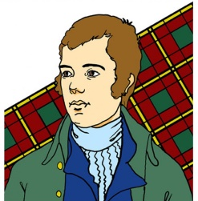  Can you draw a picture of Robert Burns and write a few sentences about him? Remember to use finger spaces and sounding out.
Design your own tartan  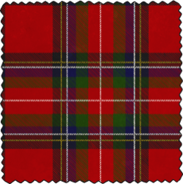  Tartan is a pattern, made by horizontal and vertical coloured lines crossing over each other.  Can you create your own style of tartan?  Use the colouring sheet provided. | Traditional Scottish Food  With the help of an adult, find out about some traditional Scottish food. Can you find and follow a recipe?  http://bbc.in/38CJil3  Taste it and send us your review over seesaw!  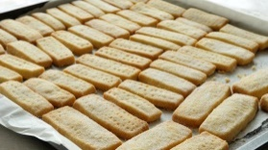  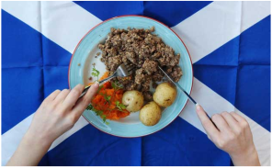 | Scottish Animals  The words below are Scottish names for animals. First, can you guess what animals these are? Second, find out with an adult if you were correct. Finally, can you draw a picture of these animals?  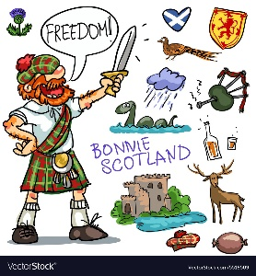  Puddock  Dug  Moose  Mappie  Cuddie

