Week Beginning: 15.6.20
Class: Primary 2 Teachers: Miss Anderson & Miss Arkless
Here are some ideas for you to complete throughout the week at a time that best suits you and your family. There are a range of digital and non-digital activities for you to do – please feel free to adapt these as you wish. Do not feel that you have to complete all of these activities – we recommend that you do at least one from literacy, numeracy and across the curriculum throughout the week. We are also encouraging you to use the Seesaw app to have regular communication with your class teacher and for you to share all of your amazing work! You can upload learning you have completed from this grid or can log on and complete the activities we have provided for you this week.
Literacy | Numeracy and Maths | Across the Curriculum
Reading  Head over to Seesaw to listen to Miss Arkless read a very popular (and disgusting!!) book...  ‘The Dinosaur that pooped a planet!’  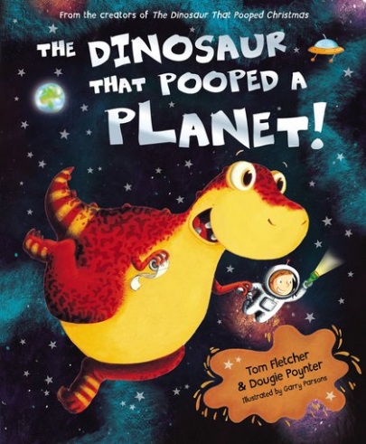  Follow up task:  Once you have listened to the story, we would love you to come up with a new title and front cover for this book series.  So far, there is:  ‘The Dinosaur that pooed a planet’  ‘The Dinosaur that pooped Christmas’  ‘The Dinosaur that pooped the past’  What could be the next book?  Your title must begin with:  ‘The Dinosaur that pooped...’  And your front cover must include a picture that is linked to your title.  You can be as creative as you like!  An A4 piece of paper would probably be best to do this on. | Problem Solving  Here is a problem solving task that encourages you to record your thinking in a systematic way. You could write down all the possible answers, or draw them, or even act them out. You can also click on the link for a tool that will help you. 😊  https://nrich.maths.org/2858  Two children are playing with three balls, one blue, one red and one green.  They toss up the balls, which run down a slope so that they land in a row of three.  In how many different ways could the balls land?  Remember to share your answers on Seesaw! | Primary 2 Reflection  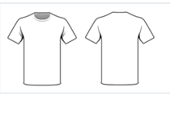  Head on to Seesaw to find the template for this activity.  We would love you to think about all the learning and activities we have been doing this year and reflect on them. There has been so many fun activities and you have all been so engaged in your learning, can you design a t-shirt to reflect on what you have been doing.  There are lots of ides on Seesaw to remind you of some of the things we have been learning about. You can use words or pictures on your t-shirt to make it as colourful and exciting as you can!  We can’t wait to see them!
My Heart Fills with Happiness  It is almost the end of Primary 2 and although this year hasn’t been exactly how we had planned, Miss Anderson and Miss Arkless are thinking about all the times we have had together with you that have filled our hearts with happiness.  We have enjoyed spending time with you, watching you learn and grow and being there for you when you need us.  Listen to this short story call ‘My Heart Fills with Happiness’ and think about what fills your heart with happiness.  https://www.youtube.com/watch?v=UneEukwYbsI  Head over to Seesaw and fill in the heart to show what fills you with happiness! | Sort the Houses  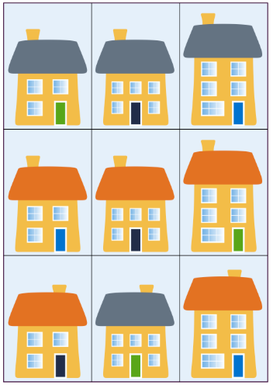  Head over to Seesaw for a different kind of problem solving activity, all about sorting into groups.  Or, you can use the link below instead.  https://nrich.maths.org/5157 | Class Dance Challenge!  We love music and we love to dance! We can’t all be together but now is the time to practice your dance moves and get dancing and we can be together virtually!  We think Dance Monkey has been the song of the year, it’s fun, and definitely catchy!  Have a listen here  https://www.youtube.com/watch?v=bddBfkS0O7k  Can you make a video or you dancing along for around 15 seconds and send it to us on Seesaw – there will be an activity on Seesaw for you to post it to!  We will put it all your videos together and share it on Seesaw next week for you to enjoy and you will be able to see everyone dancing along to the music.  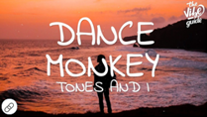
Boggle!  Below is a grid of letters, can you use these letters only to make as many words as you can.  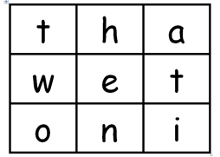  You should aim to try and find 10 words. If you would like to challenge yourself there is at least 20 words that you can make.  Write all your words you make in a list and send them to your teacher on Seesaw.  If you manage this you could make your own game of Boggle.  Ask an adult to draw you a 3x3 grid and pick 9 letters. Make sure you pick 4 vowels  a e i o u  Then choose 5 letters from the following  b c d f g h j k l m n p q r s t v w y | White Rose Maths  Below is link to the ‘White Rose Maths’ website which has a range of home learning games, activities and videos. Take a look and choose something you would like to do. The link is for Year 1 activities, if you find these too easy, take a look at the Year 2 options. 😊  Click on the different weeks for different maths topics – there is so much to choose from!  https://whiterosemaths.com/homelearning/year-1/ | Build a DVD Den  We think that since you have worked so hard over the last 7 weeks, you deserve to kick back, relax and watch your favourite DVD!  But first, you have a challenge.  Can you build a cosy DVD den? This den could be in front of your TV so you can watch your DVD from it, or somewhere else if you can watch your DVD inside it!  Your den must have the following things:  - A roof and/or sides (you could get some chairs and drape a big blanket over them so you can sit underneath!)  - Pillows or cushions and blankets to get comfortable and cosy!  - A ‘Do not disturb’ sign to hang outside your den during the movie.  - An area for your favourite toys and teddies to watch the DVD with you.  - A tub or bowl for movie snacks.  - Any finishing touches you might have around the house – bunting, fairy lights, a lava lamp, a plant, or anything else you would like to decorate with!  Share a photo on Seesaw of you in your den ready to watch the DVD.  Relax and enjoy! 😊

