Week Beginning: 8th June 2020
Class: Primary 3 Teachers: Miss Heenan & Miss Anderson
Here are some ideas for you to complete throughout the week at a time that best suits you and your family. There are a range of digital and non-digital activities for you to do – please feel free to adapt these as you wish. Do not feel that you have to complete all of these activities – we recommend that you do at least one from literacy, numeracy and across the curriculum throughout the week. We are also encouraging you to use the Seesaw app to have regular communication with your class teacher and for you to share all of your amazing work! You can upload learning you have completed from this grid or can log on and complete the activities we have provided for you this week.
Literacy | Numeracy and Maths | Across the Curriculum
Literacy  There’s 2 sides to every story – have you heard that saying before?  This week we would like to to listen to the story – The Tale of Two Beasts  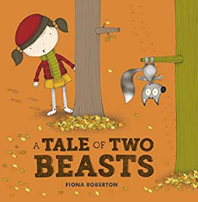  You will find the link to this on Seesaw with instructions on how to complete the activity. This activity will make you think how every story has 2 sides and we all look at things a little bit differently! | Arrays Game  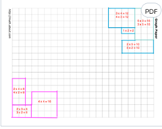  On Seesaw you will find the template for this game and the instructions. Or you can play on some squared paper if you have some.  You will need 2 dice and a sibling/parent/carer to play along with.  Roll your two dice and make an array using the two numbers. For example If you roll a 2 and 5 the array would be  2x5 or 5x2  The aim of the game is to try and take over as much space as possible! | Social Studies/STEM  In order to be responsible citizens, it is important we learn about things happening in the world around us.  Did you know that in the country of Bangladesh, they have huge problems every year with extreme flooding? The terrible flooding means that alot the farmer’s crops are completely ruined. The people of Bangladesh have had to think of creative ways to work around the flooding.  Head over to SeeSaw to learn how and to complete a STEM challenge, building your own floating garden!
Word Boost  This week is a word boost revision week, on Seesaw you will find the revision sheets for some of the books you have been listening to  .  If you would like to challenge yourself, before you start try and write down as many boost words as you can remember for this year! Let your teacher see your list | Multiplication  Can you make it all the way from left to right without getting any answers wrong?  Rub out the honeycomb piece you would like to tackle and voice record yourself working out each of the answers.  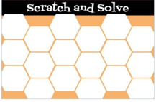 | Art – Draw Our Health Heroes.  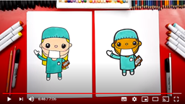  Click the link below to challenge your drawing skills with this great draw along video. If the video is a bit fast for you, you can pause and play as many times as you need to.  Don’t forget to share your drawings with us on Seesaw! We can’t wait to see them 😊  https://www.youtube.com/watch?v=xMXJtiaNTac
Writing  It’s time to do some writing!  Not so long ago we did some recount writing – we wrote about our trip to the cinema to see Angry Birds 2.  You are going to do a piece of recount writing about one of your days this week or from last week with as much detailas you can remember.  Remember the features of a piece of recount writing...  You should write about who, what, where and when. Make sure you include all 4 things.  You should write your recount in order, start with the morning and then finish at night time.  You should include a picture  Try to add in your feelings at the time  Share your writing with your teacher on Seesaw and don’t forget to use capital letters and full stops! | Hit the Button  How well have you practiced your times tables?  Let’s have a ‘Hit the Button’ challenge!!!  Head over to the Top marks website or click the link below to take you straight there..  https://www.topmarks.co.uk/maths-games/hit-the-button  You can choose a specific times table or mix them all up and play with them all.  Always play in the Hit the Answer section!  You will have 1 minute to answer as many questions right as you can.  Practice as much as possible and when you think you have reached your high score take a picture of it and send it to your teacher! | Think Outside the Box  It’s time to get your imagination running wild and your creative juices flowing.  When you go onto Seesaw you will see an activity call ‘Think Outside the Box’ and that’s the idea – the line that is on the page makes you think that the picture will be a butterfly – you have to try and use that line in a picture, it can be anything you like!  Have a look on Twitter if you’re stuck, for some ideas from last week!  