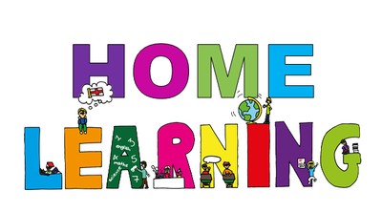
Week Beginning: 8th June 2020
Class: Teachers: Miss Arkless and Miss Anderson
Here are some ideas for you to complete throughout the week at a time that best suits you and your family. There are a range of digital and non-digital activities for you to do – please feel free to adapt these as you wish. Do not feel that you have to complete all of these activities – we recommend that you do at least one from literacy, numeracy and across the curriculum throughout the week. We are also encouraging you to use the Seesaw app to have regular communication with your class teacher and for you to share all of your amazing work! You can upload learning you have completed from this grid or can log on and complete the activities we have provided for you this week.
Literacy | Numeracy and Maths | Across the Curriculum
Make your own alphabet!  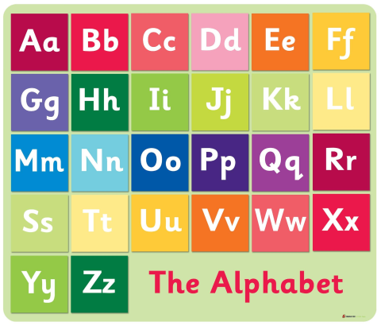  You will need 26 post it notes or pieces of paper. Write each letter of the alphabet on a piece of paper – you could do lower case and upper case like the picture above, or just lower case.  Now lie your alphabet letters out in order, in a big long line on the floor.  Now, your challenge is to hunt around the house or garden and find something that belongs with each sounds of the alphabet. Remember, think about the sounds, not the letter names. As you find your objects, lie them beside your letters on the floor.  Can you find 26 objects?  X and Z might be tricky!  Once you are finished, you might want to take a photo and put a picture of your very own alphabet on your wall!  Don’t forget to share on Seesaw 😊 | Measure  Last week we were learning to estimate and measure the length of things. This week we are going to think about measuring weight.  Weight is often measured in grams or g for short.  Task:  Can you find 10 food packets, or cans, or boxes and look for the weight written on the label?  Like the packet of crisps below.  Write down all the different weights on post it notes. Can you put these in order? What is the heaviest thing you have found? What is the lightest?  If you have digital scales, weigh each object and see if the weight on the scales is the same as the weight written on the packet!  Don’t forget to share your work on Seesaw!  Another weight activity will posted this week on Seesaw. 😊 | Social Studies/STEM  In order to be responsible citizens, it is important we learn about things happening in the world around us.  Did you know that in the country of Bangladesh, they have huge problems every year with extreme flooding? The terrible flooding means that alot the farmer’s crops are completely ruined. The people of Bangladesh have had to think of creative ways to work around the flooding.  Head over to SeeSaw to learn how and to complete a STEM challenge, building your own floating garden!
Reflective Reading  Spot the SIlly Word!  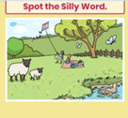  Head on to Seesaw to see this week’s activity. You have a picture and 4 sentences. The only problem is, there is a silly word in each sentence. Follow the instructions to fix the sentences.  Challenge – See if you can send a sentence back to your teacher with a silly word in it and they will try to find your silly word and replace it with a sensible one! | Counting by 5’s  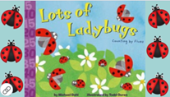  Not long ago we were practicing counting by 5’s, here is a little practice for you.  On Seesaw you will find the link to the story, listen to the story then follow the instructions to complete the activity!  When you finish it – give someone a HIGH 5!!! | Art – Draw Our Health Heroes.  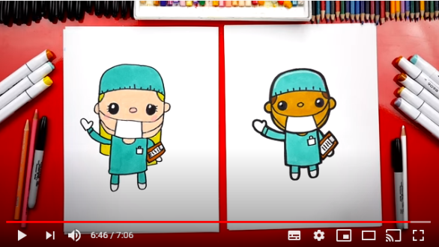  Click the link below to challenge your drawing skills with this great draw along video. If the video is a bit fast for you, you can pause and play as many times as you need to.  Don’t forget to share your drawings with us on Seesaw! We can’t wait to see them 😊  https://www.youtube.com/watch?v=xMXJtiaNTac
Writing  It’s time to do some writing!  Not so long ago we did some recount writing – we wrote about our trip to the cinema to see Angry Birds 2.  You are going to do a piece of recount writing about one of your days this week or from last week with as much as you can remember.  Remember the features of a piece of recount writing...  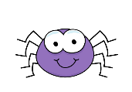  You should write about who, what, where and when. Make sure you include all 4 things.  You should write your recount in order, start with the morning and then finish at night time.  Share your writing with your teacher on Seesaw and don’t forget to use capital letters and full stops! | Taller and Shorter  We usually use the words taller and shorter when we are talking about height or how big or small something is.  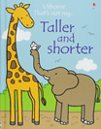  For example – the giraffe is taller than the elephant or the elephant is shorter than the giraffe.  Can you have a look around your house and find some things which are taller or shorter than you.  Make a table of what you find like this one...  Taller Shorter  Door Curtain Couch Little sister | Think Outside the Box  It’s time to get your imagination running wild and your creative juices flowing.  When you go onto Seesaw you will see an activity call ‘Think Outside the Box’ and that’s the idea – the line that is on the page makes you think that the picture will be a butterfly – you have to try and use that line in a picture, it can be anything you like!  Have a look on Twitter if you’re stuck, for some ideas from last week!  