Week Beginning: 25th May 2020
Class: Teachers: Miss Arkless and Miss Anderson
Here are some ideas for you to complete throughout the week at a time that best suits you and your family. There are a range of digital and non-digital activities for you to do – please feel free to adapt these as you wish. Do not feel that you have to complete all of these activities – we recommend that you do at least one from literacy, numeracy and across the curriculum throughout the week. We are also encouraging you to use the Seesaw app to have regular communication with your class teacher and for you to share all of your amazing work! You can upload learning you have completed from this grid or can log on and complete the activities we have provided for you this week.
Literacy | Numeracy and Maths | Across the Curriculum
‘sh’ sound  This week we are working on the ‘sh’ sound.  How many ‘sh’ words can you think of? Can you try writing them?  Remember the ‘sh’ sound might be at the start, in the middle or at the end of the word.  Head onto Seesaw where there is a ‘sh’ wordsearch for you to complete.  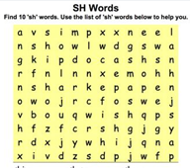  Can you make your own wordsearch using the other ‘sh’ words which you thought of?  There is a video on Seesaw showing you how to do this! | It’s Competition Time  We have a school wide competition taking place on Sumdog,  The competition is live between 9am on Monday morning and 12pm on Thursday afternoon.  Head on to Sumdog and answer as many questions as you can.  There are exciting prizes to be won! | Origami  Origami is the art of paper folding and you can make lots of exciting things!  Head over to this site to have a look at the instructions or head onto Seesaw and watch Miss Anderon’s how to video!  https://www.origami-fun.com/origami-talking-dog.html  You might need an adult to help you, it can be a little tricky!  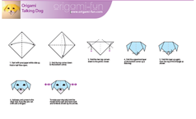  You can have a go at making ny other origami shapes, and don’t forget to share your creations with us.
What The Ladybird Heard by Julia Donaldson,  Watch the film clip of Mrs Thacker reading this very exciting story and then log on to Seesaw for some tasks to do. There are also some links to resources on Seesaw. Share your work on Seesaw or post to twitter @BoghallPsch  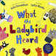 | Measure.  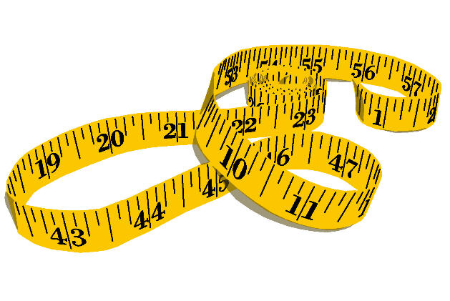  This week we are going to focus on measuring length – that is, how long something is. We are going to look at centimetres (cm) and metres (m).  Task 1:  With an adult, use a ruler or a measuring tape to look at what 1cm looks like.  Can you draw a 1cm line on a piece of paper?  Can you use your finger and thumb to measure out 1cm?  Can you find anything in the house or garden that is the same length as 1cm? A small piece of lego perhaps maybe?  Now practice using a measuring tape to measure things around the house. Remember to put the 0 end of your tape or ruler the start of the object, then read the number on the tape at the end of the object. Do this more than once until you get the hang or reading the measurement accurately.  Task 2:  Head over to Seesaw for Task 2 😊 | Les Couleurs  Can you remember any of the French colours?  Here is a recap -https://www.youtube.com/watch?v=-4kNeFGBAcw  Once you have listened to the song, head over to Seesaw and see if you can colour in the crays with the correct colours.  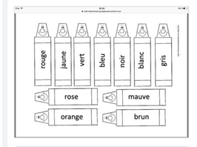  Can you record yourself saying the colours? We would love to hear them.
Writing  Write an Acrostic poem with your name!  Head over to SeeSaw where Miss Arkless will show you how to write an acrostic poem. This is something new that we hadn’t covered in class but it’s very fun!  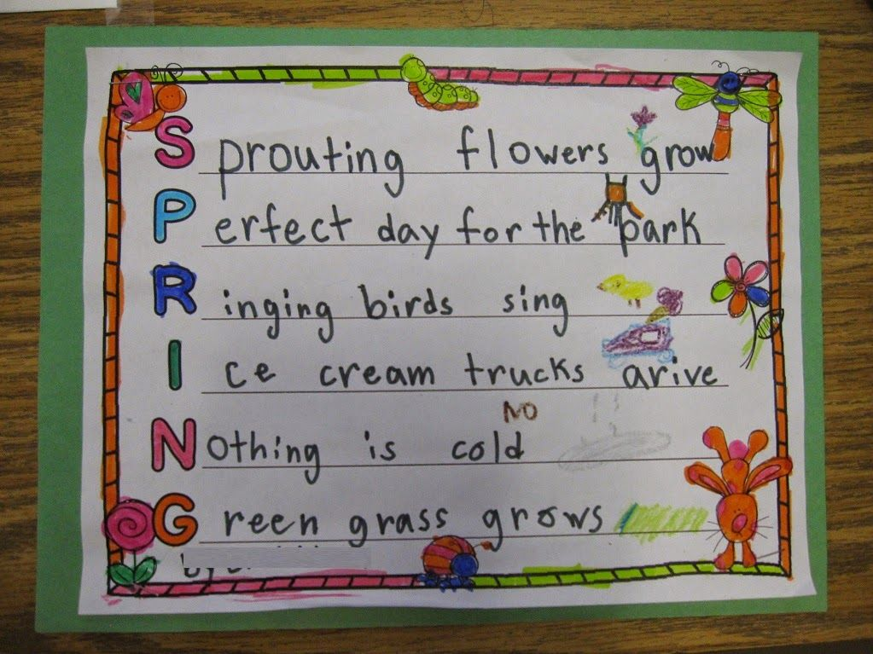  Once you have made one for your own name, you could have a go at writing one with someone else’s name. It can be a lovely idea for sticking on the front of a birthday card or posting to someone to make them smile. 😊 | 2D and 3D shapes.  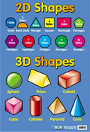  Can you make a 2d picture, you could make anything, you like, it may be a house, a cat, dog, rocket or a boat.  You could make it from paper, leaves, play-doh, paint or anything else you can find around the house.  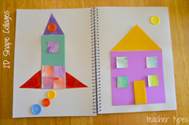  There are 3 main features of 3d shapes which we spoke about in school  Faces – edges - corners  Can you find any 3d shapes around the house (cereal boxes, food packaging, toys etc) and count the number of faces, edges and corners they have? | Great Big Bug Hunt Competition  http://www.schoolscience.co.uk/bughunt  Can you go into the garden or any outside space to see what bugs you can find? Remember to follow social distancing guidelines when you are exploring and then create a personal project about what you find. You could draw it, examine it (carefully), and find out what does it eat, where does it live etc? Maybe you could even write a story or poem about it, design a poster, shoot a video and then email by the12th June to rebecca@ase.org.uk (use mailbigfile free to send large files).

