Week Beginning: 18th May
Class: Teachers: Miss Keillor and Miss Angus
Here are some ideas for you to complete throughout the week at a time that best suits you and your family - please feel free to adapt these as you wish. Do not feel that you must complete all these activities – we recommend that you do at least one from literacy, numeracy and across the curriculum throughout the week!
Literacy | Numeracy and Maths | Across the Curriculum
Phonics  This week in phonics we are working on recognising words with oo and ee!  Log in to SeeSaw to complete the activities provided for you! | This week we are learning to subtract. Log in to SeeSaw to complete the activities provided for you! | Skip to be Fit  We have all had our skipping ropes from school, but let’s have a little challenge.  Miss Anderson has hers too and she is going to join in!  For 2 minutes each day you need to skip. You might want to ask an adult to time you or use a stopwatch on a tablet or device  Take a note of how many skips you do in the 2 minutes on Monday, Tuesday, Wednesday, Thursday and Friday and you can send your results to your teacher on Seesaw  There will be a prize for the most amount of skips in 2 minutes and a prize for the person who has improved the most over the week.  Miss Anderson will post her results on Seesaw 😊
Reading Skills  The tricky words that we are going to focusing on this week are:  from, here, were, with  Can you see how many of each word you can write in 1 minute? Miss Angus can get 24!  Make sure to upload your pictures to SeeSaw!  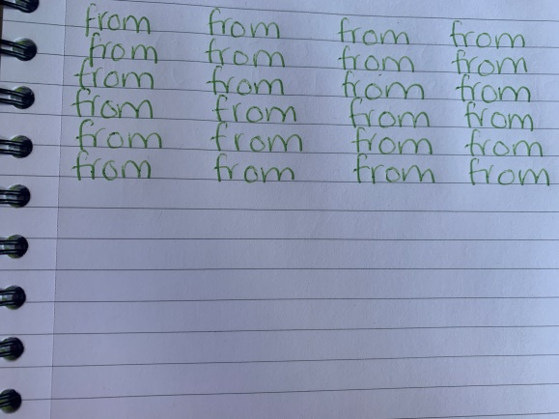 | We are learning and consolidating subtraction Have a go at completing the following sums:  9 - 4 = 10 - 2 =  4 - 2 = 7 - 1 =  6 - 2 = 8 - 3 =  Challenge:  20 - 4 = 13 - 3 =  15 - 8 = 12 - 5 =  18 - 3 = 16 - 7 = | Rainbow Nature Hunt  This week spend some time outside and see if you can complete this rainbow scavenger hunt. Can you find something for every colour of the rainbow?  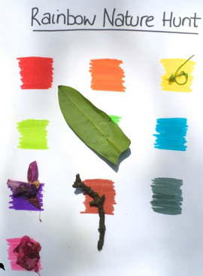
Rhyming!  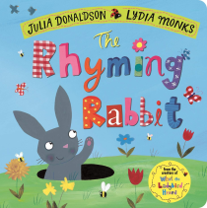  This Tuesday Miss Keillor will be reading a book all about a rhyming rabbit! Can you think of two words that rhyme?  If you need a little reminder take a look at this video to find out more about rhyming words: https://www.bbc.co.uk/bitesize/topics/zkvmjhv/articles/zfypxyc  Can you figure out which words rhyme below?  sat top  mop man  fan cat | Time  This week we are consolidating our learning all about time. Why not check out some of the live lessons on BBC Bitesize on Time by clicking on the link below:  https://www.bbc.co.uk/bitesize/topics/zfp3d6f/resources/1  We have also posted some fun activities on Education City all about time. For you to try!  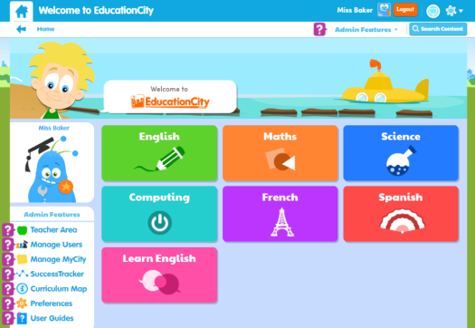 | French  Consolidate your days of the week by listening and singing along to the song;  https://www.youtube.com/watch?v=Lpwf5N0rfVE  Can you write out these days of the week in order and say them aloud? You could draw something that you do on each of these days! Make sure you upload your work to SeeSaw! 😊  Lundi Mardi Mecredi Jeudi  Vendredi Samedi Dimanche

