Week Beginning: 18th May
Class: Teachers: Miss Anderson & Miss Arkless
Here are some ideas for you to complete throughout the week at a time that best suits you and your family. There are a range of digital and non-digital activities for you to do – please feel free to adapt these as you wish. Do not feel that you have to complete all of these activities – we recommend that you do at least one from literacy, numeracy and across the curriculum throughout the week. We are also encouraging you to use the Seesaw app to have regular communication with your class teacher and for you to share all of your amazing work! You can upload learning you have completed from this grid or can log on and complete the activities we have provided for you this week.
Literacy | Numeracy and Maths | Across the Curriculum
Tricky word Practice  - Pick the tricky words you are practicing and make them on a paper chain, each link of the chain has a letter and you need to connect them to make your word.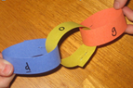  - Ask an adult to write your tricky words on a piece of white paper with a white crayon. Using watery paint or a felt tip, colour over each box to reveal the word inside! Read the word out loud.  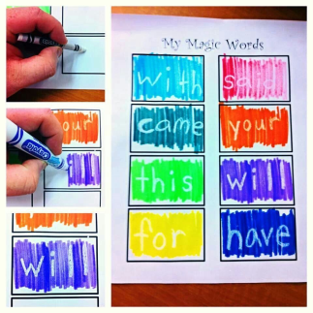  - Make your own fishing rod by tying string or an old shoe-lace to a pencil. Attach a magnet to the bottom of the string. Write out your tricky words on separate pieces of paper and put a paper-clip on each one. Now go fishing! Whichever word you catch, you have to read it and write it in a silly sentence.  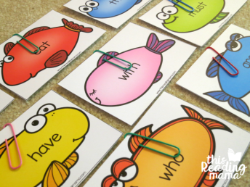  - Write out your tricky words on pieces of card, twice. Use these cards to play pairs or tricky word snap!  - Write out your tricky words on pieces of card then ask an adult to hide them around the house for you. Now go looking! Every time you find a word you have to read it and write it correctly to get a point (which could be a penny or a small sweetie!) 😊 | More and Less  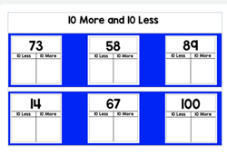  On Seesaw you will see the activity where you need to find ten more and ten less than the numbers.  If you find this tricky, ask an adult to help you make a 10x10 grid and fill in all the numbers from 1 – 100.  Challenge – Can you find 5 more and 5 less than these numbers. Can you pick another 6 numbers, they could be as big or small as you like and try to find 10 more and ten less and then 5 more and 5 less. | Draw with Mrs Martin-Law  Head over to Seesaw where Mrs Martin-Law has done a video showing you all the steps to draw a sunflower, She has even added some symmetry in there for you!  Have a go at drawing your own – you could pause the video as you are drawing to help you.
Reflective Reading – Picture it  Go to SeeSaw where you will find a new Reflective Reading activity.  Can you use your Picture It skills to draw a picture of the castle using all the description there is about it?  Extra challenge  Why not write your own description of a castle?  Send it back to us (Miss Arkless or Miss Anderson) and we will have a go at using your description to draw it and send it back to you! 😊 | Dot to Dot  Can you create a dot to dot for someone at home to complete.  Think about what you would like the picture to be, give it an outline and put dots around the outline. Use the numbers 1-10, 1-20, 1-30 or go even higher if you would like to challenge yourself.  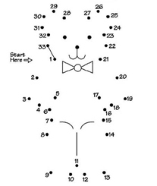  Just for fun – we have added a few dot to dots on Seesaw for you to have a go at if you would like! | French  This week we are doing a recap on:  the days of the week – Les jours de la semaine  Can you remember them?  Lundi, Mardi, Mercredi, Jeudi, Vendredi, Samedi, Dimanche  Here is a little song reminder  https://www.youtube.com/watch?v=Lpwf5N0rfVE  On Seesaw there is an activity to complete all about the French days of the week, putting them in order and matching them with the English days of the week,  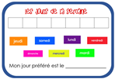
Talking  We always love hearing about your favourite toy or item, so now you can do this from home.  Head over to Seesaw for all the instructions and to upload your video.  Choose something which is special to you, it might be a toy, a picture of someone or even a pet – tell us what it is, does it have a name, why you like it and why it is special to you!  We can’t wait to watch them! | Clap Counting  Play on your own or with as many people in your house as you like,  Choose a number, the easier ones to start with are 2, 5 or 10.  Take turns to count up in ones, then when you reach the number you have to clap instead of saying the number.  Example – 1, clap, 3, clap, 5, clap, 7, clap  1, 2, 3, 4, clap, 6, 7, 8, 9, clap, 11, 12...  When you feel confident with these numbers you could challenge yourself to clap every 3rd, 4th, 6th, 7th, 8th or 9th number! | Skip to be Fit  We have all had our skipping ropes from school, but let’s have a little challenge.  Miss Anderson has hers too and she is going to join in!  For 2 minutes each day you need to skip. You might want to ask an adult to time you or use a stopwatch on a tablet or device  Take a note of how many skips you do in the 2 minutes on Monday, Tuesday, Wednesday, Thursday and Friday and you can send your results to your teacher on Seesaw  There will be a prize for the most amount of skips in 2 minutes and a prize for the person who has improved the most over the week.  Miss Anderson will post her results on Seesaw 😊  