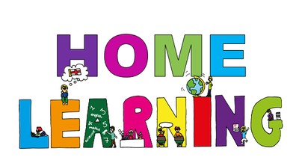
Week Beginning: 11th May 2020
Class: Teachers: Miss Arkless & Miss Anderson
Here are some ideas for you to complete throughout the week at a time that best suits you and your family. There are a range of digital and non-digital activities for you to do – please feel free to adapt these as you wish. Do not feel that you have to complete all of these activities – we recommend that you do at least one from literacy, numeracy and across the curriculum throughout the week. We are also encouraging you to use the Seesaw app to have regular communication with your class teacher and for you to share all of your amazing work! You can upload learning you have completed from this grid or can log on and complete the activities we have provided for you this week.
Literacy | Numeracy and Maths | Across the Curriculum
Rhyming  Head over to SeeSaw for a fun ‘rhyming emojis’ activity.  Or, if you’d rather do something on paper, have a go at creating your own rhyming words flowers!  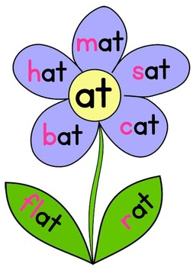  - Draw a blank flower outline.  - Choose one of the end sounds below to write in the centre of the flower.  - Fill the petals and leaves with words that rhyme.  - Share a photo on Seesaw! 😊  an en in un et it ut ot eg ig og ug ab am im om um ip op up  **Adults**: Rhyming can be tricky! In order to help your child find the rhyming words themselves, you can suggest a sound for them to put at the beginning. For example, say ‘What about p? What would p a t make?’ Then encourage them to blend p a t together themselves until they hear ‘pat.’ | Know your numbers!  Head over to SeeSaw to complete the missing numbers in the number grid.  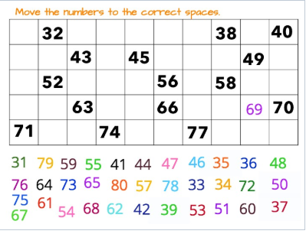  Extra challenge:  Once you have completed the task, ask an adult to use the magic pen to colour over 3 numbers. Can you work out which numbers they have hidden from you?  OR  Make your own 100 square! Ask an adult to make a 10 x 10 squared grid for you and you fill it in from 1 –100. | Nature rainbow hunt 🌈  Time to get out the house and explore all the beautiful colours that nature produces this time of year.  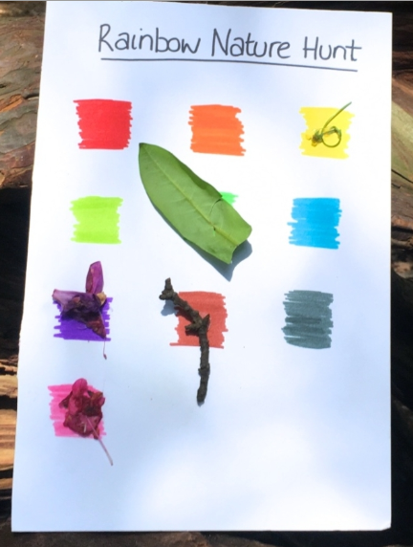  Choose 12 different coloured pens, pencils or crayons. Draw 12 boxes on a piece of paper (or even better, card). Set off on your nature walk. Take a glue stick with you, but if you don’t have one just take a bag to collect your bits of nature and you can cellotape them on once you’re back home.  Look closely at the plants and trees around you, when you spot something that matches one of your favourite colours, take a small bit and place it on top of that colour. Remember, try not to pull of anything that is still growing. 😊
Word Boost Wednesday  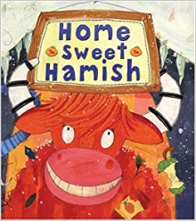  Tune in to SeeSaw for Word Boost Wednesday!  This week’s boost words are:  crush clumsy chaos relax plenty  --------------------------------------  Once you have read the story and completed the word boost activities, look out for another activity on SeeSaw which involves making a character mind-map for Hamish!  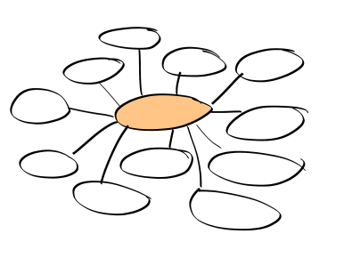 | Super Symmetry  In class we learned about symmetry. This is when you can split something in half, or down the middle and it is exactly the same on both sides.  Head over to SeeSaw to complete your own symmetrical image using the drawing tools.  OR  If you fancy doing something outdoors, why not have a go at making your own symmetrical stick insect?  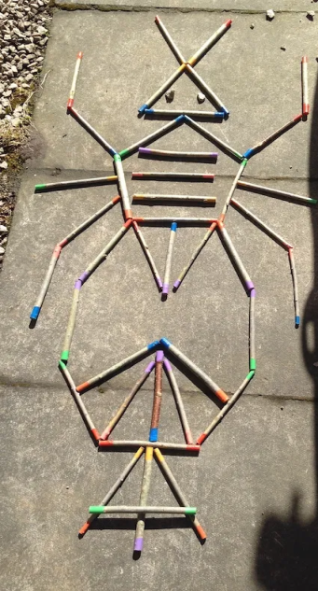  - Find something long and thin to be your ‘middle’ - this could be a long stick, a sweeping brush or even a piece of tape stuck to the ground  - Using pens or pencils or cutlery, begin to build up your body. Remember whatever you put on one side of the middle line, you must put on the other.  - Once you are happy with your body, use buttons, pebbles or grass to add eyes and feet. etc to your insect.  - Take a photo and share with us on Seesaw! | French  Can you remember number 1-20 in French?  Here is a video to help remind you  https://www.youtube.com/watch?v=UsEz58BblMY  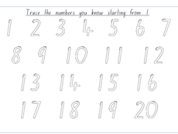  Go to Seesaw and see if you can trace the numbers and record yourself saying them.  What age are you?  Quel age as tu?  Can you draw a picture to represent your age and send it to us on Seesaw – you could try to reply with...  J’ai …... ans  Pop your age in using the french numbers!
Write a Letter  It’s very difficult not being able to see our family and friends just now.  Can you choose one person who you really miss and write them a letter.  You could tell them how you are feeling, some of the activities you have been doing at home, what you really hope for when you are able to see them again.  If your letter is for somebody who lives close could you maybe post it through their door on your daily walk?  Or if your letter is for a friend in school, send your letter on Seesaw and we could share it with them. | Shopping Time!  Can you play shops at home.  You could use some of your toys or teddies, or even some things around the house, as long as an adult agrees 😊  Give them a value and stick a note on with how much they cost. Remember to use the £ or p sign,  *Parents – feel free to stick with values for the items which are the same as coins ie. 1p, 2p, 5p, 10p 20p etc  You could make your own coins and try to pay for some of your items using the right amount. | SHANARRI  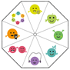  Think about all the work we have been doing in school with Safe Sophie, Healthy Helen, Active Annie, Nurtured Nelly, Achieving Archie, Responsible Rosie, Respected Robbie and Rita and Included Iggy!  How are you safe, healthy, active etc. at home?  Just discuss with an adult or share thoughts in any way you would like. poster? Video?

