Week Beginning: 27th April
Class: Primary 1 Teachers: Miss Keillor and Miss Angus
Here are some ideas for you to complete throughout the week at a time that best suits you and your family. There are a range of digital and non-digital activities for you to do – please feel free to adapt these as you wish. Do not feel that you must complete all these activities – we recommend that you do at least one from literacy, numeracy and across the curriculum throughout the week. We are also encouraging you to use seesaw to have regular communication with your class teacher and for you to share all your amazing work! You can upload learning you have completed from this grid or can log on and complete the activities we have provided for you this week.
Literacy | Numeracy and Maths | Across the Curriculum
Phonics  This week we are learning about the sound r. Can you think of something that begins with the sound r? Draw a picture.  Can you use your sounding out strategies to read these words:  rat ran cat sip pin man cap  You can also tune in to SeeSaw to complete the activity or upload photos of your work! 😊 | This week we are learning about doubles. Log in to SeeSaw to complete the activities provided for you! | French  Have a go at writing all the numbers to 10! Can you say and write them in French?  un deux trois quatre cinq  six sept huit neuf dix  Can you make your own song with these numbers to 10 in French?
Reflective Reading  Read some stories with an adult this week. Which one was your favourite story?  Can you draw a new front cover for your story? | Coin Rubbing  Using some coins, put them under a blank bit of paper or under a page in your jotter. With a pencil, lightly colour over them until the coin appears on the paper! Can you label each of the coins? For example, 1p, 2p, 50p, £1 etc.  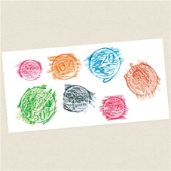 | Sunflower Challenge!  Watch the video created by Mrs Thacker on the Boghall PS Blog or on SeeSaw and complete the activities! We have loved seeing all of your sunflowers so far!  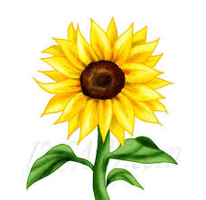
Writing  Have a look at the sunflower challenge video created by Mrs Thacker either on Boghall PS blog or on SeeSaw! This week, Miss Keillor and Miss Angus would like you to have a go at writing instructions on the life cycle of a plant. Log on to SeeSaw to use the template attached or complete the instructions in your jotters! Make sure to upload your finished work on to SeeSaw! 😊  First...  Next...  Then...  Last...  Remember:  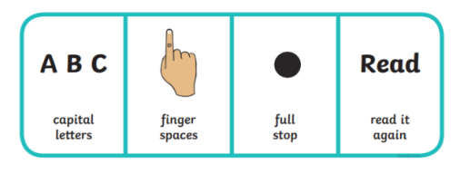 | Butterfly Doubles!  Fill in the other half of the butterfly to make doubles! E.g, if there are 2 dots on one side, draw 2 dots on the other side and count how many dots you have in total! You can then have a go at making your own butterflies!  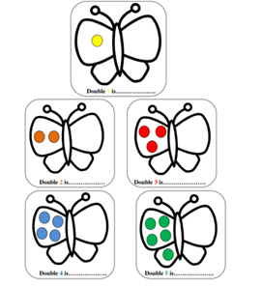 | Draw someone in your life as a Superhero! Design a costume for them and create a great superhero name! What would their superpower be?

