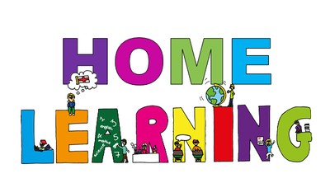
Week Beginning: 27th April 2020
Class: P2 Teachers: Miss Arkless & Miss Anderson
Here are some ideas for you to complete throughout the week at a time that best suits you and your family. There are a range of digital and non-digital activities for you to do – please feel free to adapt these as you wish. Do not feel that you have to complete all of these activities – we recommend that you do at least one from literacy, numeracy and across the curriculum throughout the week. We are also encouraging you to use the Seesaw app to have regular communication with your class teacher and for you to share all of your amazing work! You can upload learning you have completed from this grid or can log on and complete the activities we have provided for you this week.
Literacy | Numeracy and Maths | Across the Curriculum
Phonics  We are going to practice revising some sounds we have already learned.  Choose one (or more!) of the sounds below.  ai oi igh  Have a go at blending these sounds together to build as many words you can think of. Use the sounds below as your start and end sounds.  b c d f g h j k l m n p q r s t v w y z  For example: f + igh + t = fight  Or, challenge yourself to use more than one start sound.  E.g. br + ai + k = braik  *Adults* – if your child does something like this:  l + ai + t = lait  This is OK! We know this isn’t the correct spelling of late, but they are still using the sound they know in the right way. | Tally Marks  In class, we learned about tally marks. Can you make a tally chart (like the one below) for how many doors, windows and radiators you have in your house?  Remember, after four tally marks the fifth one should be a cross. 😊  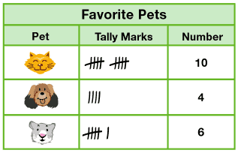  Challenge: For some extra tally practice, ask an adult to shout out a number and you make it with tally marks as fast as you can! | Art & Design  Kitchen roll magic art!  Watch your pictures come to life with this magic trick! All you need is kitchen roll, felt tip pens (sharpies if possible!) and a bowl of water!  Have fun!  Video link below:  https://www.youtube.com/watch?v=KX19xFfaRo8  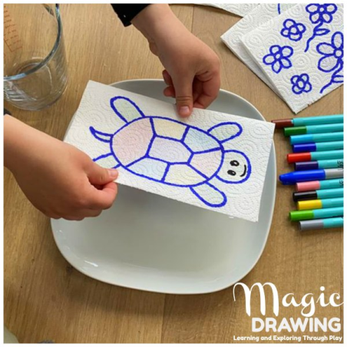
Reading / Spelling  Log on to SeeSaw and you will find a task.  1. Tap to listen to the story.  2. Tap to start your activity.  3. Read the question and take a moment to think about your response.  4. Tap to share your response.  5. Tap to submit your work. | Time  We were learning to tell the time in class. Can you make a time diary of your day?  Use a clock or a watch to help you write down what time you:  - Get up  - Have breakfast  - Have lunch  - Have dinner  - Go to bed.  Stick to times like ‘o’clock’ and ‘half past’ or if you fancy a challenge, use ‘quarter past’ and ‘quarter to’.  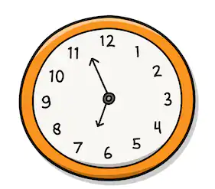 | Logo Time!  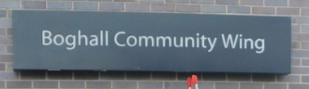  Can you help the Boghall Community Wing by designing a logo for the following youth clubs and our young volunteers?  Primary 1 – Primary 3  Primary 4 – Primary 7  Primary 7 – Secondary 4  Your logo must have all the following colours in it:  Red Purple Dark Green Maroon Teal  Send your finished artwork on an A4 piece of paper and the winning logo will be added to the artwork gallery within the Drop-In Centre.  A prize might also be up for grabs!
Writing  Can you write a set of instructions showing and telling ‘How to Draw a Robot’  Don’t forget to include what you will need, try to write your instructions in order and use the words ‘First, Then and Finally'  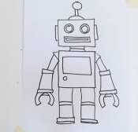  Challenge: Have a go at reading your instructions to someone else and see if they can follow them. | Addition  We would like you to practice some addition. We will post a ‘mild, spicy, hot’ task on Seesaw. Complete the level you feel most confident with.  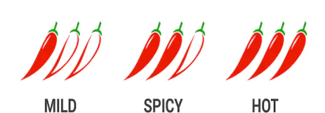  Complete the questions using whichever strategy you prefer.  You can use counters to work it out or you can try and work it out in your head!  Feel free to use the microphone icon to record a voice clip explaining to us how you worked out your answers. We would love to hear! | Seesaw  This week we would like you to try and become familiar with using SeeSaw.  Make sure you download the app and complete the check-in activity posted by Miss Anderson and Miss Arkless!

