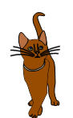
Change the boring verbs (in red) and ordinary
adjectives (in blue)
Underline your WOW verbs and adjectives.

- Paul was sad when the football burst.

- Bill felt mad with his little sister.

- Ann went into the big, dark cave.

- She has a nice face and nice hair.

- We saw the old bus go up the big hill.

- The thief took a new watch, and then ran away.

- She saw a scared kitten holding on to the branch and went to rescue it.

- When the vampire got up from the coffin, Jim was scared. He got a stake and tried to hit him.

