SCHOOL LOGO.wmfBlackburn Primary School

Riddochhill Road

Blackburn

West Lothian

EH47 7HB

Telephone: 01506 653481

Email: [wlblackburn-ps@westlothian.org.uk](mailto:wlblackburn-ps@westlothian.org.uk)

Website: blackburnprimary.westlothian.org.uk/

Principal Teacher: Alison McCarney Head Teacher: Janet Clarkson

**Tuesday 21st June 2022**

**Head Teacher Comment**

****We are now in our final days of session 2021/2022 and although not as challenging as the last two sessions we have continued to work under Covid 19 restrictions. I am looking forward to our school community having the opportunities that we used to enjoy and hope that the restrictions will relax further and allow our parents to be more engaged and involved in the school in session 2022/2023. Despite the challenges and interruptions to learning we have managed to pull through and have had many positive learning experiences this session. We truly enjoyed having our P1/2 parents and P 6/7 parents in recently to see our Enterprise project and find out more on how we learn through play based pedagogy in the early years. It was also lovely to see such a great turn out at our sports day and we hope to continue with more events like these in the future.

I would like to take this opportunity to thank all the teaching and support staff for their hard work and commitment to the life and work of the school as without which the school would be unable to support our pupils in the positive way that they do.

**Say hello wave goodbye**

This session we have had a number of staff who have gone on maternity leave; Mrs Bryce was the first and I am delighted to say that Mrs Bryce has a lovey baby girl called Lorena who was born at the start of the year. Miss Meikle was second and she and her family also have a lovely baby girl called Olivia and last but not least was Miss Miller who too had a lovely baby girl in May and her daughter is called Aria. We have had the opportunity to meet with Lorena and Olivia however we have still to meet up with wee baby Aria. I am sure like me you will wish them all a happy time with their new additions to their families and a happy maternity leave.

We are saying goodbye to Miss Kelsie Rodger who has been working in our ASD resource this session. Miss Rodger is taking up a position at University in September to do primary teacher training and her contribution to the school has been fully appreciated by staff, the senior leadership team and families. I wish Miss Rodger every success in her future career and know that the experience she has gained working in the ASD resource will equip her fully when undertaking teaching practice and meeting the needs of all learners. We are delighted to be welcoming new teachers, Miss Denholme and Miss Hood to the Blackburn Primary School team and I am sure they will be made very welcome.

We are also saying good bye for a temporary period of time to Mrs Topping who was successful in interview for a Principal Teacher position at St Mary’s Primary Polbeth to do a maternity cover until Easter 2023. Mrs Topping has a wealth of experience especially supporting pupils for targeted interventions in literacy and numeracy and we are delighted for Mrs Topping in securing a leadership role and wish her every success in her new role.

We are also saying goodbye to our Primary 7 pupils. They have been a superb group of individuals who have contributed fully to the life of the school and have fully developed into confident and responsible individuals. I wish them every success in the future and I am sure if they continue to thrive in the same way as they have done at Blackburn Primary School they will go far!

**Blackburn Primary Nursery**

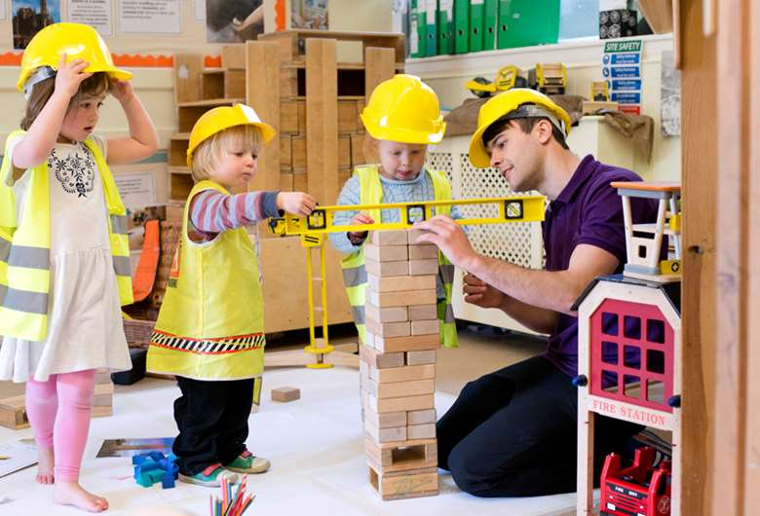You may have been keeping a watchful eye on the building development of our new nursery at Blackburn Primary School. We are all really excited about getting a custom built nursery and are looking forward to the completion. As yet there is still a considerable amount of work and inspection checks that need to be completed before the nursery can officially open and we will further update you on this in the future.

Next session we are making changes to the classes and staffing structure and I am delighted to inform you that we have been allocated an additional main stream class which will allow us to have some single stream classes. Please see below the table highlighting the class teacher and classroom your child will be in session 2021/2022.

|  |  |  |
| --- | --- | --- |
| Class | Class room | Teaching staff |
| A2 | 2 | Miss McLuckie |
| A1 | 3 | Mrs Brodzka |
| P1 | 4 | Miss Carroll |
| P2/3 | 6 | Miss Wallace |
| P4/5 | 8 | Mrs Dunlop |
| P6 | 5 | Miss Denholme and Mrs Lund |
| P7 | 7 | Mr Riding |
| Non-Contact cover |  | Miss Hood |
| Support for Learning |  | Mrs Beestone and Mrs Lund |

**School Uniform**

This session there has been a relaxation of wearing school uniform due to the Covid Pandemic and increased opportunities for outdoor learning. For the start of next session please ensure your child is wearing their polo shirt and sweatshirt to school and black or grey trousers/joggers/leggings/skirt.

I would like to thank you for all the support that you have given me and the staff at Blackburn Primary School throughout the session. I would especially like to thank Mrs McCarney for supporting our families and school community this session and everything that she does to support the effective running of the school. I know we still have a way to go with the Covid 19 restrictions and I wish you all a pleasant summer and I look forward to seeing you in August. I hope the sun shines brightly on you all and you manage to get some time to relax and enjoy the summer months with your family and friends.

Miss Clarkson

Head Teacher

