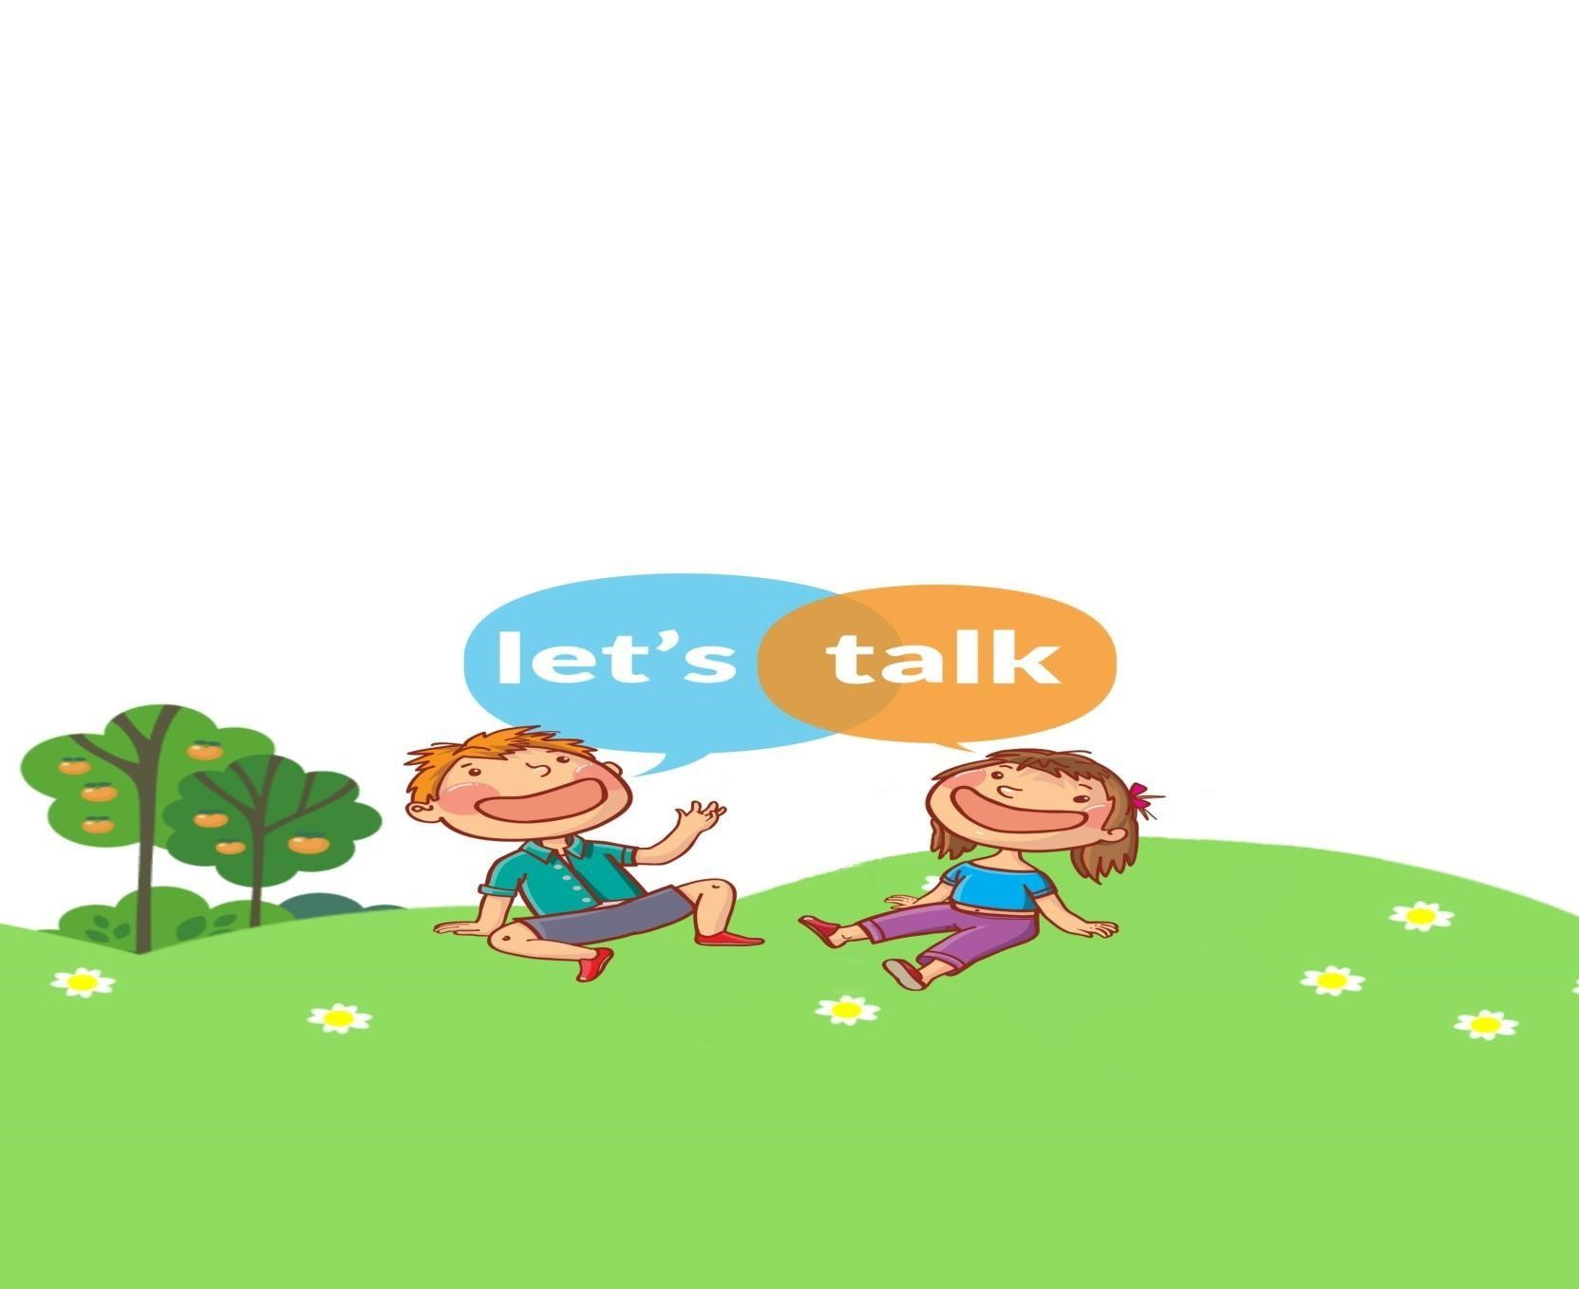
Call us to chat to a Speech and Language Therapist about your concerns and get some practical advice on how you can support your child’s ability to understand and use spoken language!
Do you have concerns and would you like advice on how to support your child’s talking and understanding at home?
Is your child at primary school?

LET’ S TALK

Speech and Language Therapy

Advice Phone Line

1st Wednesday of every month
12pm – 2pm

07866 219 181
www.lets-talk.scot.nhs.uk

