Price List / Order Form  Child’s Name: Class:  P1/2: Personalised Christmas Baubles - £2.00  Quantity Total Cost  A1: Mini Wooden House Scene - £3.50  Quantity Total Cost  A1: Personally designed light bottle - £3.00  Quantity Total Cost  P3/4: Festive Playdough Jars - £1.50 each  Rudolph the Reindeer or Ho Ho Santa!  Quantity Total Cost  P5/6: Rudolph hanging tree decoration - £2.00  Quantity Total Cost  P6/7: Natural Christmas Wreaths - £3.00  Quantity Total Cost  A2: Pompom wreaths - £2.00  Quantity Total Cost  Personalised Christmas Eve Plates £2.50  Quantity Total Cost  Raffle Tickets: £1.00 per strip  Child or Adult  Quantity Total Cost | 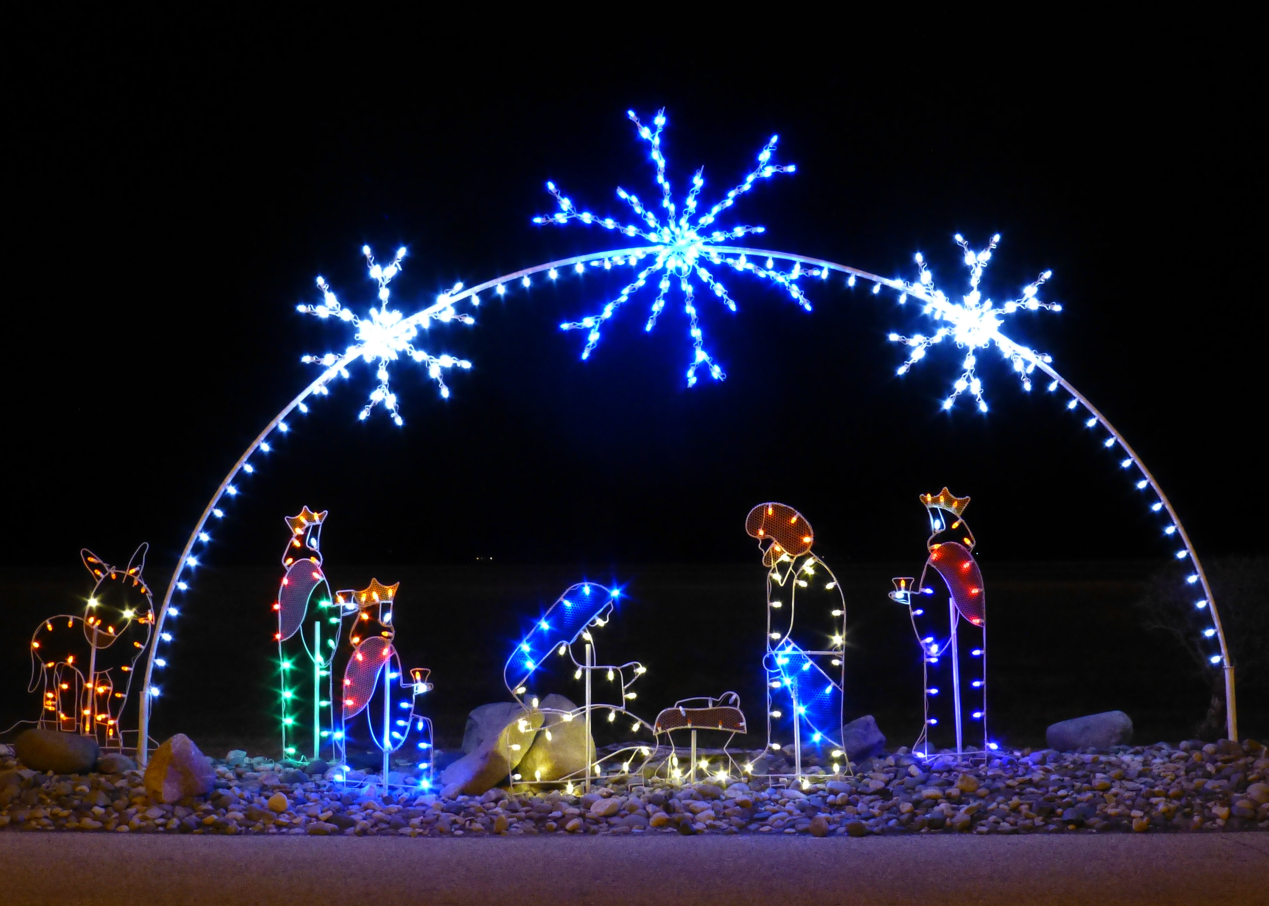  Best wishes to all our school family  Thank you  We know Christmas is not going to be the same again this year, but we want to thank you for your ongoing support and commitment to helping us give your children the very best experiences they deserve. | Blackburn Primary’s  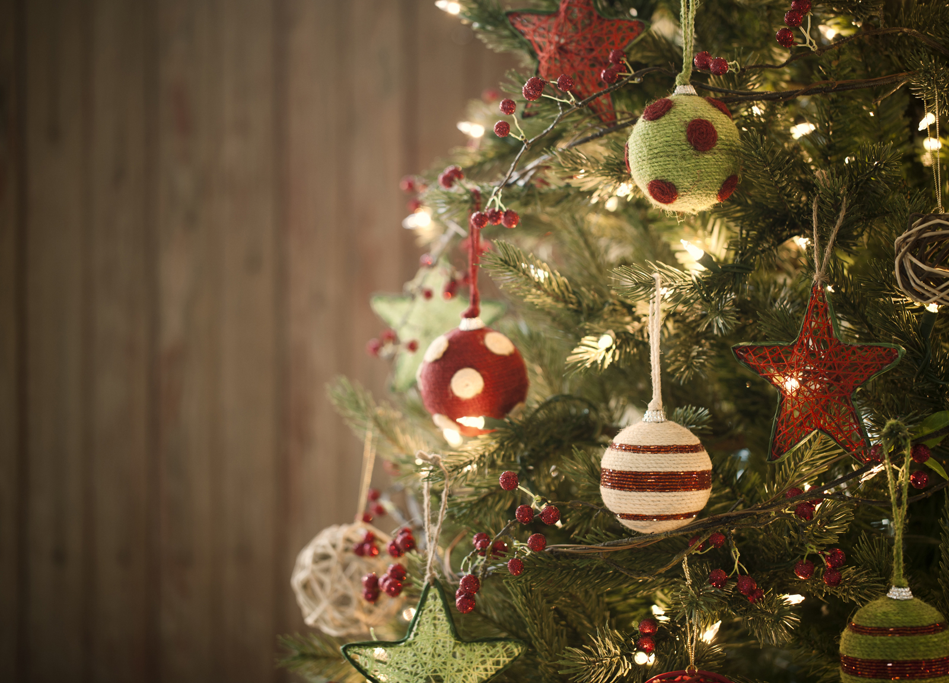
Please PRINT personalised messages in the box below: | - Wishing you a very special Christmas from all the staff @ Blackburn Primary School | - Virtual 2021  - Christmas Craft
Handmade Christmas craft  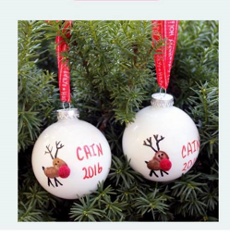  P1/2 - £2.00 each  P1/2 will decorate your Personalised Christmas bauble with glitter inside (to look like snow), a Christmas picture, your name and the year.  If the order is for a child in P1/2 they will decorate their own bauble.  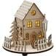  A1 - £3.50 each  Brighten up your festive decorations with a Mini Wooden House. Place it in your window or on your table and make your guests feel welcome.  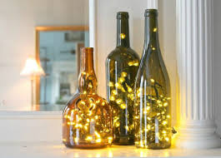  A1 - £3.00 each  Brighten up your Christmas table with a personally designed light bottle. You choose the design and A1 will make it especially for you. | Handmade Christmas craft  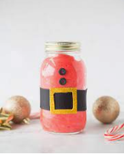  P3/4 - £1.50 each  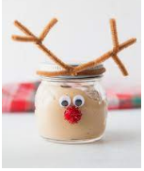  The children in P3/4 have been busy helping Santa’s elves to create some lovely, festive playdough jars to get us in the mood for the festive season. Our playdough not only looks but smells like Christmas in a jar so what are you waiting for? We have limited availability so get your orders in early to avoid disappointment!!  Disclaimer – the products you buy may not look exactly like the ones shown but we will do our best. Ho Ho Ho!!!  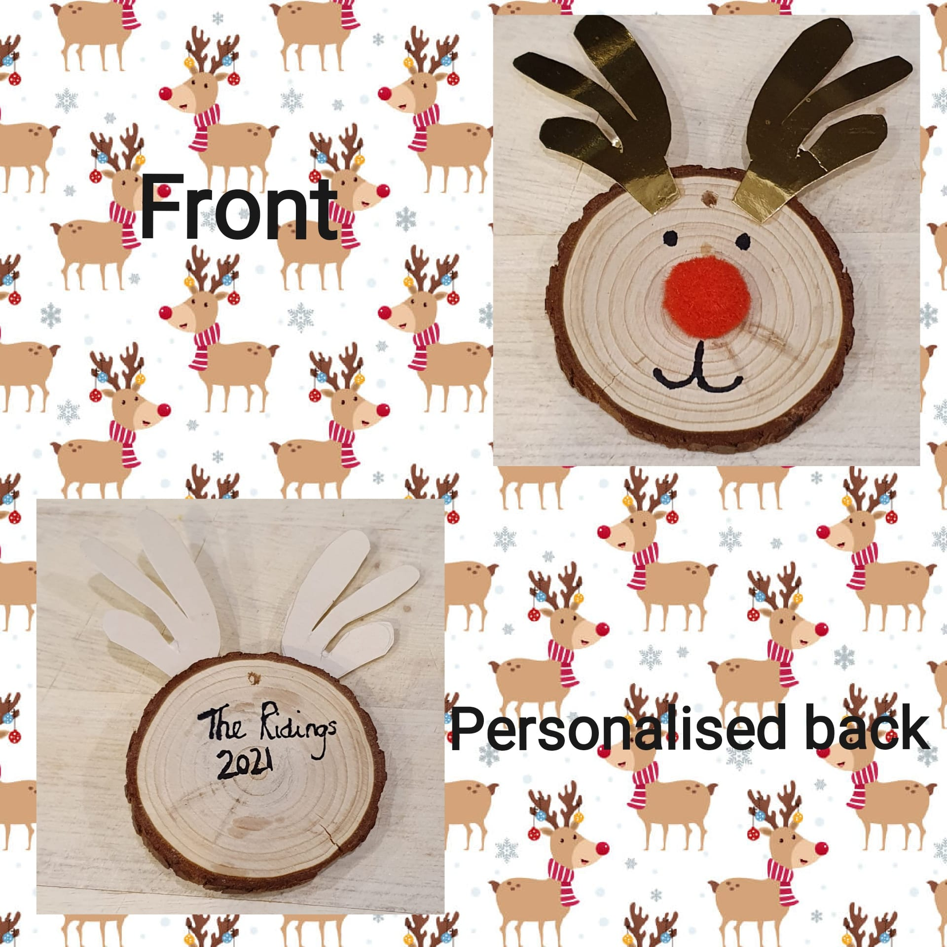  P5/6 - £2.00 each  You know Dasher and Dancer and Prancer and Vixen, Comet and  Cupid and Donner and Blitzen… But do you recall the most famous reindeer of all?  Well now you can own your very own Rudolph hanging tree decoration. Personalised on the back with a surname and date of your choice. | Handmade Christmas craft  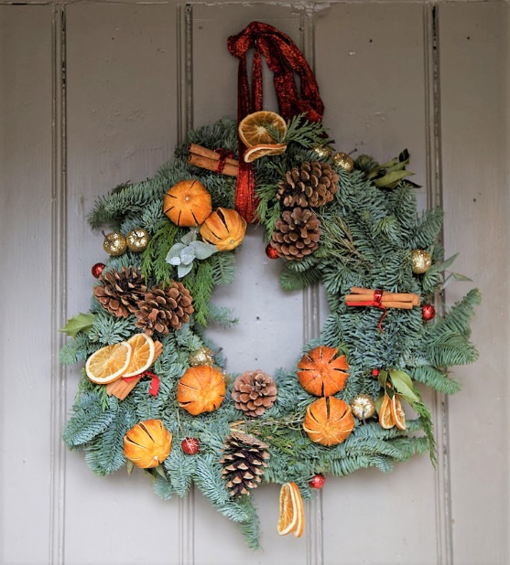  P6/7 - £3.00 each  We are trying to do our bit to help combat climate change! For this reason, we are going foraging and creating our very own beautiful Christmas wreaths. Do you love that fresh, outdoor scent? Do you want to be surrounded by Christmas joy? Then our Christmas wreaths are for you! They are created using florist wire and tape alongside a variety of luscious greenery, freshly picked from Blackburn’s local green spaces! We value creativity in Blackburn, therefore, your Christmas wreath and it’s additions (orange slices, berries, cinnamon etc.) will depend on the artisan creating the piece! A truly unique piece of craftsmanship!  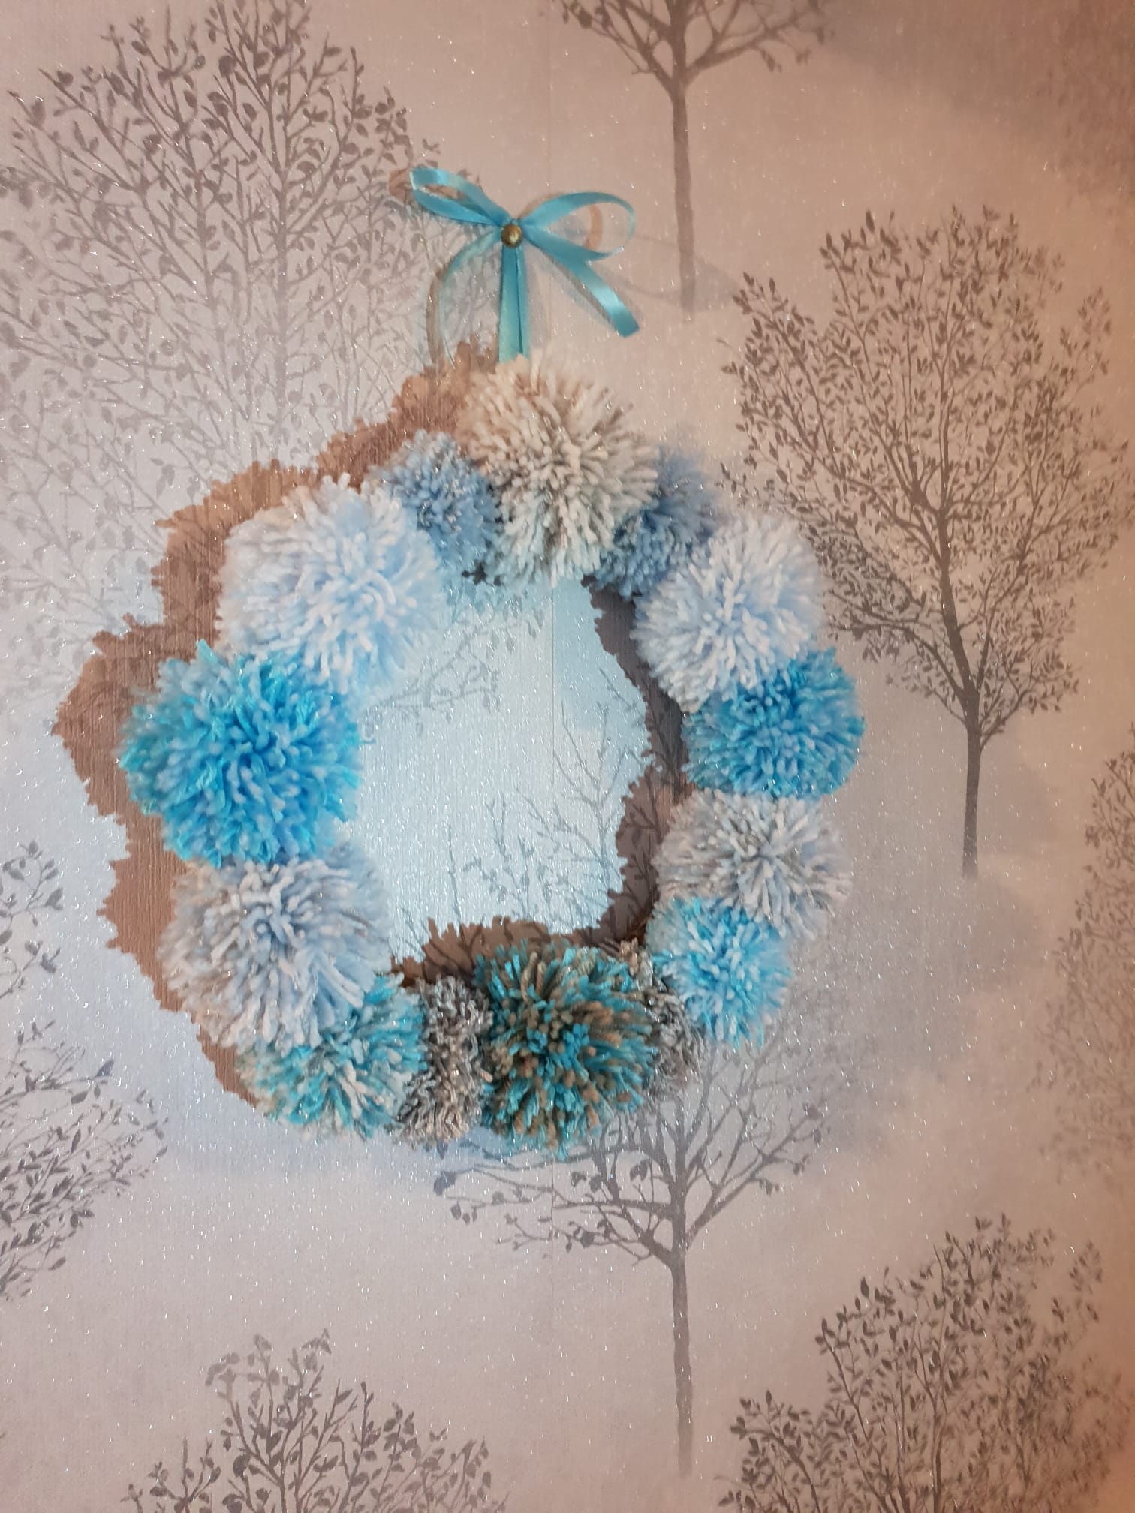  A2 - £2.00 each  Beautiful pompom wreaths handcrafted by A2 for your homes this Christmas. Created in a range of colours to brighten up any home no matter the colour scheme. They are also light and easy to hang!

