SCHOOL LOGO.wmfSCHOOL LOGO.wmf**Blackburn Primary School**

**Hopefield Nursery Class**

**Newsletter**

**December 2021**

**Head Teacher’s Comments**

We are reaching the end of 2021 and although we have continued to have many challenges this year with the ongoing presence of Covid 19 we have managed to keep on going! The children have been remarkably resilient, have enjoyed being in school and have been very receptive to learning. Due to the Coronavirus Pandemic we continue to have restrictions and are therefore unable to undertake the usual Christmas activities that we have enjoyed in previous years. Parents and carers will not be allowed in school to attend a school fair and or a nativity and we cannot congregate in large groups outdoors. However we are a very creative team and are constantly thinking of ways to make our learning meaningful and fun that will involve our parents and partners as much as possible. This year we will be doing a virtual school fair and Christmas around the World Sway Presentation (which will be posted on the Blog), we will be engaging all our children in challenge based activities throughout December and we will have individual class parties. We are also hoping that we will be able to get a virtual message from a very special person for some of our early year’s pupils.

**Christmas Craft and Raffle**

Still wondering what to get that special person in your life for Christmas then your Christmas shopping worries are over! The school have been busy making and creating Christmas craft that they can sell to raise money for our school fund. The children have had many super ideas on what to make that will be an excellent present for Christmas or to use as a Christmas decoration. All classes have made Christmas craft items and we have put them together in a Blackburn Primary Christmas Brochure. Please take time to browse through our Christmas craft brochure and place any orders with the correct money and return to the class teacher and your gifts will be with you before the end of term. Also if you want to buy any raffle tickets then please order with the correct money and your raffle tickets will be given to you within the same day. As expected we have many wonderful prizes from the raffle ranging from hampers to getting your car valeted. We also plan to have a children’s raffle. The cost of a strip will be £1.00.

**2022 Primary 1 Enrolment**

If your child will be 5 years old on or before 28th February 2023, you are invited to enrol your child at Blackburn Primary School. Enrolment forms are no longer distributed from Pupil Placement to pupils at Blackburn Primary School and you need to apply online at [pupilplacement@westlothian.gov.uk](mailto:pupilplacement@westlothian.gov.uk) However if you are not able to access the internet please contact the school office on 01506 653481 and we will be delighted to help you with your application.

**Motivating Monday**

We have been running Motivating Monday for several years now where the children bring a healthy snack such as fruit, dried fruit or a cereal bar on a Monday. We have noticed recently that many of the children are bringing in bars of chocolate, sweets and crisps to eat at snack time particularly on a Monday. Please note that if our child/children bring an unhealthy snack to school on a Monday they will be requested to put their snack away until lunch time.

**School Uniform**

Although there has been a relaxation of the wearing of school uniform because there have been more opportunities to learn outdoors we have noticed that very few children are wearing their school sweatshirt. Whilst it is important to be dressed for the outdoors we would appreciate that the children wear their school sweatshirt and polo shirt as part of their clothing for learning outdoors.

**Staff changes**

At the end of the term we will be saying goodbye to Mrs Bryce as she will be starting her maternity leave. Mrs Bryce is expecting her third baby which is due on the 1st of January and we are all looking forward to welcoming wee baby girl Bryce to the world. We will also be saying good bye to Mrs Hamilton who is taking up a new position in the New Year. I would like to thank Mrs Hamilton for the work that she has done throughout the years at Blackburn Primary and wish her every success in the future. We will be welcoming new teaching and support staff in the New Year and look forward to having Mrs Brodzka full time in A1 in the New Year.

**Christmas Cards**

Due to current measures being taken in school to minimise items going between home to school and other homes, we would request that children do not exchange cards with other pupils. Pupils may wish to bring in one card for their class that the teacher will display in the classroom.

2021 has continued to be a challenging year for us all and Mrs McCarney and I would like to thank the staff of the school for their continued support and for making sure that the needs of the children are at the heart of everything they do. All staff have worked tirelessly to make sure that our children are receiving the best possible education in a safe and secure environment. With all the restrictions that have been placed upon us it has not been an easy job however the staff have rallied to the challenge and have done an amazing job. I know that this Christmas will continue to have its restrictions however I hope that staff, families, pupils and partners will have a peaceful time at Christmas and all best wishes for Christmas and the New Year.

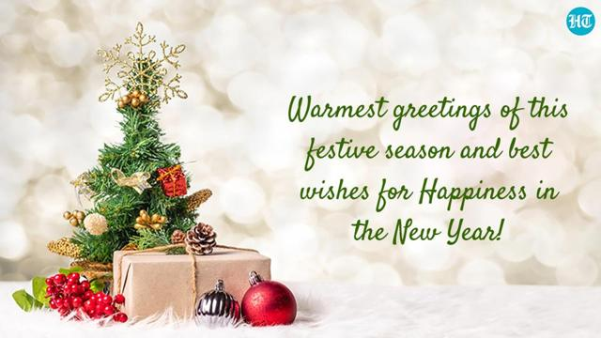

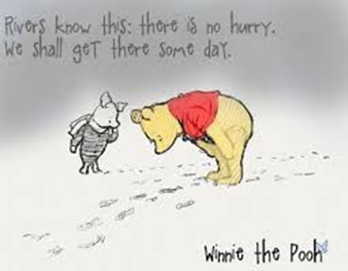

**Term Dates Blackburn Primary School Session 2021/2022**

Monday the 6h of December Leg it to Lapland Christmas challenge starts for the wee

Thursday the 9th of December Christmas School Lunch: Children to donate £1 and wear Christmas jumper/tee- shirt/bobbly hat for Save the Children

Friday the 10th of December Last day to order from the School Christmas Craft Brochure

Week beginning the 13th of December Christmas Buddy treasure hunt

Friday the 17th of December Last day to buy raffle tickets

Monday the 20th of December Virtual Christmas raffle

Monday the 20th of December Christmas movie

Monday the 20th of December A1 and A2 Christmas parties: pm

Tuesday the 21st of December P1/2 and P 3/4 Christmas parties pm. A special visitor has been invited and we are hopeful that he will be able to attend our party virtually here is hoping our internet connection is good enough to reach the North Pole!

Wednesday the 22nd of December Primary 5/6 and 6/7 Christmas Parties

Wednesday the 22nd of December Pupils from school break up for Christmas holiday

Wednesday the 5th of January In-service day for teaching staff

Thursday the 6h of January School pupils resume

