SCHOOL LOGO.wmfSCHOOL LOGO.wmf**Blackburn Primary School**

**Hopefield Nursery Class**

**Newsletter**

**March 2021**

**Head Teacher’s Comments**

We have had many challenges to face this year and having to undertake remote learning for the majority of our pupils from January 2021 onwards was a huge disappointment. We have truly missed having all the children in school and although many of our families have managed this in different ways the children have been remarkably resilient and many have engaged well with the tasks that have been set by their class teacher whilst learning at home. I would like thank all of our parents and carers for their remarkable resilience too as juggling learning at home and doing their own jobs at the same time is not an easy task! The school staff know how tiring it can be after a week in school so managing almost a full term is a true achievement. It was a pleasure welcoming our pupils back to school and it is a joy having our school community back in its entirety. It is lovely hearing the classes and corridors filled with laughter and lots of children’s voices playing in the playground.

**National Galleries Project**

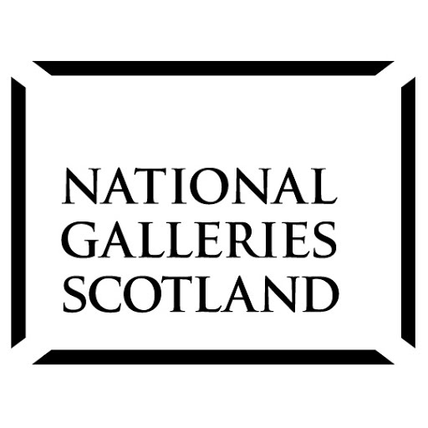This term our pupils have been engaged in a creativity project that has worked in partnership with artist from the Scottish National Galleries and an organisation that the school has worked with over a number of years to develop pupil voice and creativity called Hidden Giants. The project has involved the key question of ‘What is essential?’ and the children have been exploring this question in many creative ways. The culmination of this project will look at the role of artists in society and explore the question of what or who are essential whilst living in times of uncertainty especially during the Covid 19 pandemic. We are also delighted to have Professor Do Coyle from Edinburgh University doing research on redesigning our curriculum through this project which has involved discussions and interviews with pupils and staff. Hidden Giants and the artists have been blown away and impressed by the responses of the pupils and the dedication of the class teachers to undertake the art project and we will be looking forward to seeing the final research report and will keep up all updated.

**Parent Consultation**

We will be having our Parent Consultation on Wednesday the 31st of March from 3.30 pm to 8.00 pm. We will be using a new system for our consultations called ‘Parents Booking System’ where you will be able to book your own appointment time. The appointments will be a video meeting and will last no longer than ten minutes. I appreciate that due to the Covid 19 Pandemic and the majority of children doing remote learning from January to March the reporting of children’s progress will include updating work and progress that the children have made in school prior to Christmas, their engagement with on line learning and how the children have settled back in their respective classes. More information regarding how to book an appointment will follow.

**Covid 19 Update**

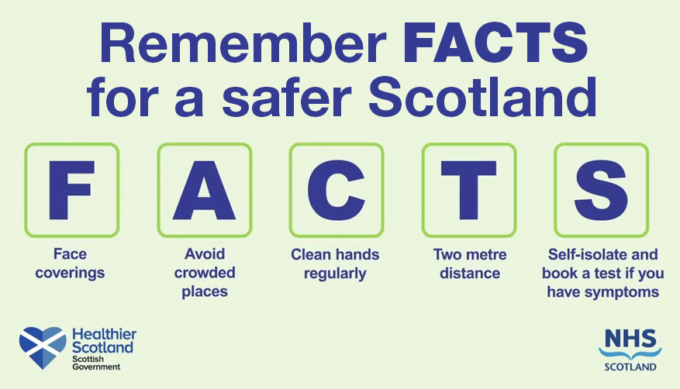

It is important that the school community does their best to stop the spread of the coronavirus by following the Scottish Government’s guidelines. The staff in the school and nursery are following robust risk assessments which is updated regularly and we ask that you help us too in preventing the spread of the virus.

Please help us by doing the following:

* Do not send your child to school or nursery if they are symptomatic. If in doubt please always err on the side of caution to avoid multiple staff and pupils having to self-isolate as this puts additional pressures on our staffing when working at a reduced capacity
* If you or your child are symptomatic please self-isolate, book a test and inform the school of the results as soon as possible
* Do not send your child to school if anyone in their household are symptomatic as they are considered a close contact.
* Avoid congregating together at the school gates and reduce the number of parents/carers dropping off and picking up their children
* Always wear a face covering when picking up and dropping of your child
* Keep two metres apart and follow social distancing guidelines

Hopefield Nursery News

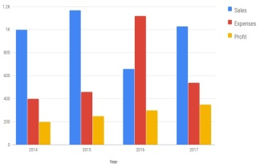Children have settled back into the nursery routines well this session. Thank you to all those who returned our survey. We are still waiting on few to come back. The response so far has been positive. We continue to deliver a variety of different experiences indoors and outdoors and would like to remind to dress their child accordingly for the weather. We are playing outside for most of the day.

We intend to start outdoor education soon. We would appreciate if you could discuss road safety with your child. We will be continuing our Junior Road Safety program.

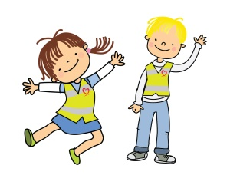

We hope that the information we are sharing over Twitter, school blog, learning journals, telephone calls and group calls are reaching everyone but we would like to remind you that if you would like to discuss any requirements in confidentiality please call the nursery. We post surveys, pictures and any important information you need to know on our school blog and twitter account. We will continue to post our interactive Thinglinks for you to enjoy on a weekly basics.

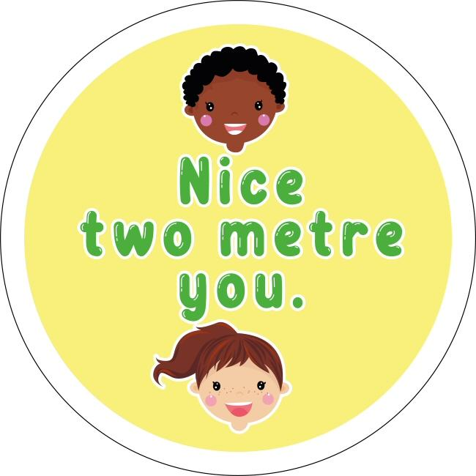

With the difficulties we have had to face this year, children and parents/ carers have been amazingly helpful and understanding and we would like to thank you for your continued commitment and support.

Primary 1/2 News

We are delighted to have our P1/2 pupils back in school and it is great to see the children excited to be back and are ready to learn. We have been focusing on our health and wellbeing to support the children in their return to school. We have discussed self-belief and the importance of having hope. Next we will be looking at gratitude and connectedness. We have been using the Place2Be website which has great links to children’s mental health.

In literacy we will be revisiting sounds we learned during home learning, using our Colourful Consonants and Vowel House approach. We will be focusing on non-fiction writing and will be beginning with a procedure (writing instructions).

In numeracy we will be working on addition and subtraction whilst reinforcing the fantastic learning that took place at home.

We have been watching the Storybots and took an interest in the space episode. We decided we wanted to learn more about space and have lots of big questions such as ‘What is it like to be an astronaut?’ and ‘How are stars and planets made?’ We have created a space station in the classroom with astronaut costumes and equipment such as telescopes, we have built a rocket and have carried out lots of exciting science experiments. We are very engaged with our learning.

We are looking forward to carrying out the rest of this session together, having fun and achieving!

**Primary 2/3/4 News**

The children in P2/3/4 have worked unbelievably hard since the return to school after the Christmas holidays and we are very proud of them. They worked well on Seesaw and we will continue to use this platform for homework.

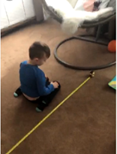

The children have been very resilient and they adapted to the change to remote learning well. They took it in their stride and the work they produced was fantastic. During the lockdown, we began by revising parts of our learning from just before the end of term on things such as our sounds and place value. The children have also participated in lots of interesting challenges, some of which were based on the live lessons provided by Adam from the Five Sisters Zoo which proved very popular with many children. Some children wanted to find out if they could jump as far as a snow leopard and came up with lots of different ways to measure and record the distance.

Here is Marcel measuring his own jump:

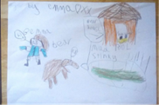  
Adam’s final lessons were linked to 'Developing the Young Workforce' and he invited pupils to create a visual of “A Day in the Life of a Zookeeper” using a medium of their choice.   
The children continued to develop their writing skills and produced some super pieces of writing on a variety of themes including their Winter Break, Snowmen, Nessie and Scots Alliterations. They were also supported in the telling of their own stories by a book character called “Ralph”.

We have moved on to new topics and concepts recently, such as rounding and estimation, the Vikings and 'making connections' with texts that we are reading which some of the class are now working on in the classroom. We are also enjoying STEAM challenges around a Winter and ice theme, following our mini Winter topic during lockdown. They are thoroughly enjoying these challenges and they have led to interesting conversations and investigations on things such as climate change.

This is Emma's fantastic work.

**Primary 4 to P 7**

Our P4-7 children have been up levelling their digital competency this week by using an online 'book creator' app.  Our pupils have taken the lead with this term's newsletter.  Find out more about what they have been up to by visiting this link

|  |  |
| --- | --- |
| [https://assets.api.bookcreator.com/Ehy0cytZbhV4kMr5RYwZWNWlhoo1/books/kF0OT3zIRemceLORRYihbw/cover/share](https://read.bookcreator.com/Ehy0cytZbhV4kMr5RYwZWNWlhoo1/kF0OT3zIRemceLORRYihbw) | [P4-7 Newsletter Entries](https://read.bookcreator.com/Ehy0cytZbhV4kMr5RYwZWNWlhoo1/kF0OT3zIRemceLORRYihbw)  Click to read this book, made with Book Creator  read.bookcreator.com |

<https://read.bookcreator.com/Ehy0cytZbhV4kMr5RYwZWNWlhoo1/kF0OT3zIRemceLORRYihbw>

This is the first time we have collaborated in this way and we hope to develop our own online library very soon!

A1 News

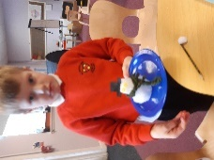The epic snow we have had, instigated many questions and predictions for investigation … particularly, ‘if we build a snowman will it melt?’ Therefore, the boys decided to make mini snowmen and place them in different places for example outside, in the dark, on the window and on the radiator. Can you guess what we found out? Our STEM/STEAM work was evident, not only in science but through Art, as we gathered information about an artist called Wassily Kandinski and designed our own pictures of ‘Concentric Circles. Did you know he had ‘Synesthesia’? He could see colours in music.

We have been busy using Cuisenaire Rods to help us count.

We are continuing to count forwards and backwards, looking for missing numbers and recognising numbers from 0-10/20, 2D and 3D shapes, positional language and programming robot Beebots to move forwards, backwards, to the right and to the left. We created symmetrical butterflies and patterns, and can share and group objects in different ways: colour, shape, size etc.

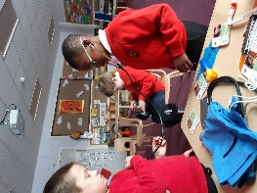As the NHS staff are our superheroes during this epidemic, we have been role playing doctors and nurses and been learning about the equipment they use, how to book an appointment for the doctor, how they care for us, and the number we call in an emergency. We have found out how our heart and lungs work and why we need to be healthy in our mind and body.

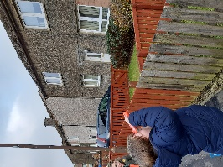

During the Big Bird Watch, we made binoculars and explored the nearby woods looking for birds. ‘I see a batman bird!’ announced Jack as he pointed to the roof of a nearby house.

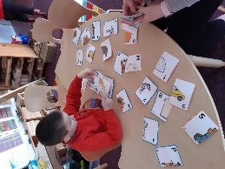Finally, for now, literacy is important as we are learning our letter sounds, listening to stories such as ‘The Owl Babies’ and retelling them in our own words, taking turns and giving and writing instructions; first, second, third … and as Spring approaches look out for all the wonderful bulbs and vegetables we have been planting.

A2 News

**Art Project**

We have really enjoyed working with Heather, our artist partnered the National Art Galleries of Scotland. Heather has been asking us lots of interesting questions like ‘What is essential to us?’ So we started by going on a walk to find out what different businesses were open or closed due to Covid-19 restrictions. We found out that food shops and takeaways were open as they are essential because we all need to eat food. We discovered that The Post Office and Pharmacy are essential to. Some shops and businesses were closed because they are not essential. Some of us thought that parks are not essential and wondered why they are still open but some of us argued that all children need to exercise and play so agree that parks are essential and should be open.

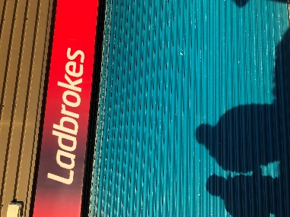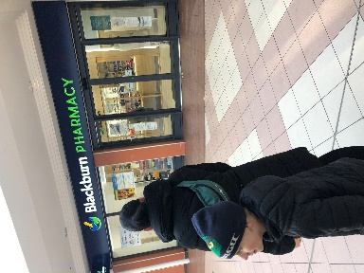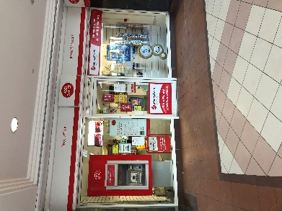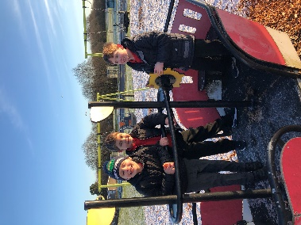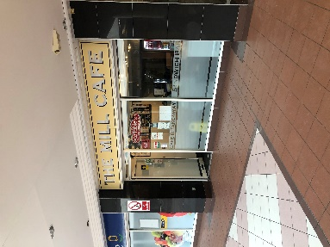

Heather then set us a challenge of showing a collection of things that are essential to us. It was very interesting to see what different collections we made. All of the children chose photography to showcase their collections.

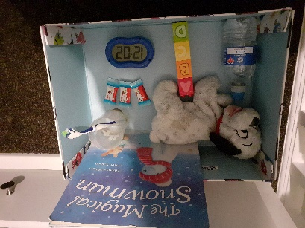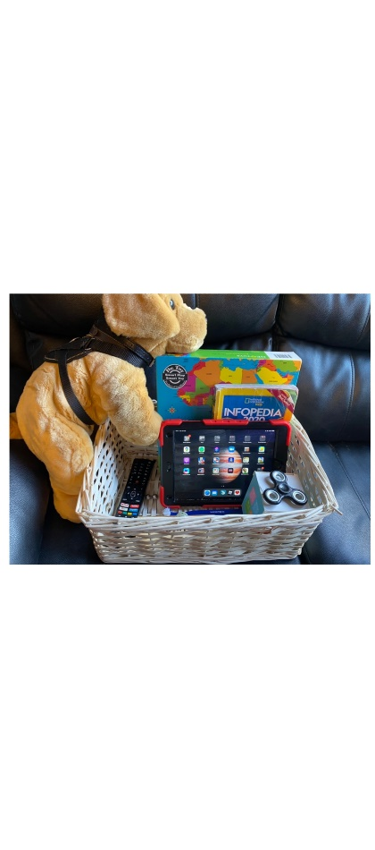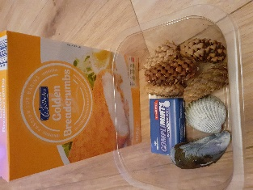

We have been thinking about all the different things that are essential to us and we have discovered that different people need different things. We read a story called ‘The Wonder’ by Fay Hanson. The story is about a boy who needs to use his imagination to help him with his art lesson. We have been thinking about whether our imagination is essential…

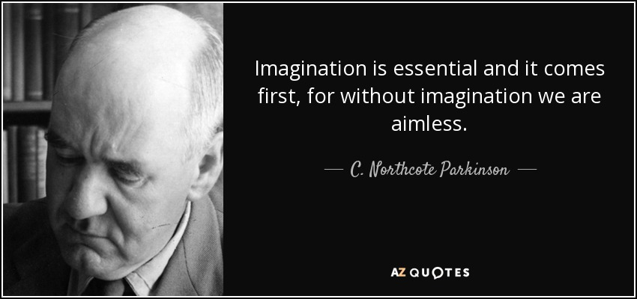

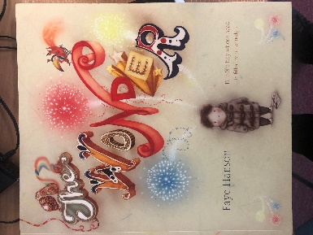

Heather sends us lots of interesting things to help us use our imagination to create different kinds of art. In one of our boxes she sent lots of twigs, string and circles that she had made out of willow. Mrs Bryce set us a challenge to create something out of sticks and string. We all made different things…

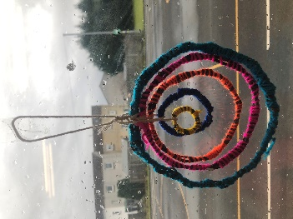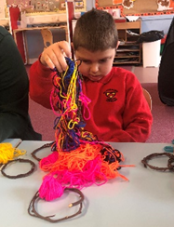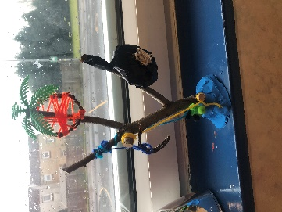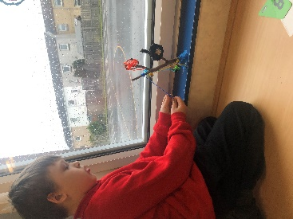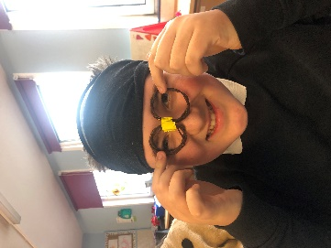

We wonder what our imaginations will have us creating next…

**Science**

Over the last few weeks we have been learning lots of different skills in our science sessions. When the snow came, we learned about how snow crystals were made and about the different types of snow crystals there are. We went out to observe the snow that was falling and looked very closely at the snowflakes to see what kinds of snow crystals were falling. We used the snow crystal chart to compare and discovered the snow crystals we could see were dendrites. We have had lots of fun carrying out different science experiments from making fake snow to making a snowstorm in a jar and learning how we can record our findings by writing science reports. In our most recent science experiment we were learning how to make a hypothesis about what would happen when we mixed an acid and an alkaline together. Our hypotheses included “it will bubble”, “it will go bigger”, “when I pour one cup into the other cup it will go very high” and “it will be like a volcano”. Our hypotheses were all very accurate. We called this experiment Volcano in a Cup. We cannot wait for our next experiment!

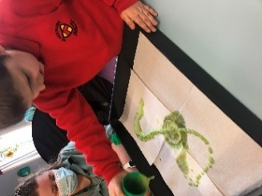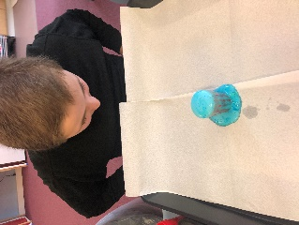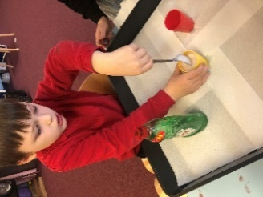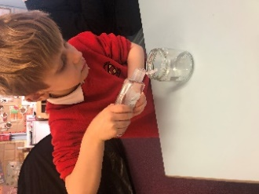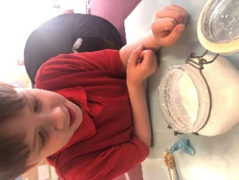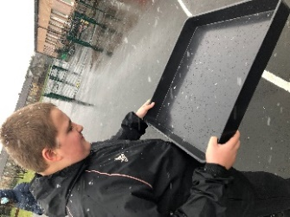

**Term dates and times**

**Session 2020/2021**

Thursday the 1st of April Break up for the Easter holidays

Friday the 2nd of April Hopefield Nursery closed

Monday the 5th of April Hopefield Nursery closed

Tuesday the 6th of April Hopefield pupils to resume

Monday the 19th of April School pupils to resume

Monday the 3rd of May May holiday for school and nursery

Thursday the 6th of May School In-service day school closed for pupils

Monday the 24th of May Spring day holiday School closed

Friday the 25th of June End of school term