

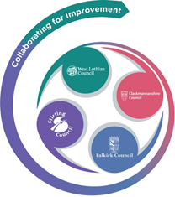

FVWL RIC Numeracy Academy – Home Learning Support

**Number Talks – SECOND Level - Thursday**

**Remember** – Number Talks are all about how you solve a task, mentally.

For this activity, don’t use anything to help you, just use your brain!

**Once you have an answer, draw and/or write down the way you worked it out, take a picture and send it back so that we can see how you solved it.**

Look at the multiplication sentences. What mental strategy did you use to work out the answer?

Did you use the same strategy? Was it an efficient strategy?

**15 x 8**

**12 x 13**

**14 x 25**

Remember to share with someone at home. Did they work it out the same way or a different way? Which way was the most efficient?

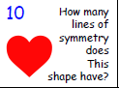 **Watch this clip to help you** [**https://www.bbc.co.uk/bitesize/topics/zrhp34j/articles/z8t72p3**](https://www.bbc.co.uk/bitesize/topics/zrhp34j/articles/z8t72p3)

