Powers of persuasion!
On Monday Paul wrote to us to ask some questions about our festival plans. The Head Teachers in Australia were considering copying our idea but had a few concerns (there is another copy of Paul’s letter on the last page).

Yesterday we explored the features of a persuasive text.
Now we need to reply to Paul and reassure him and the Head Teachers about our festival plans!
Why should our festival go ahead? What skills will be using? What are the benefits?
Use the word mat and you can use one of the letter frames to help you structure your letter.
***Remember to download this file before editing!!
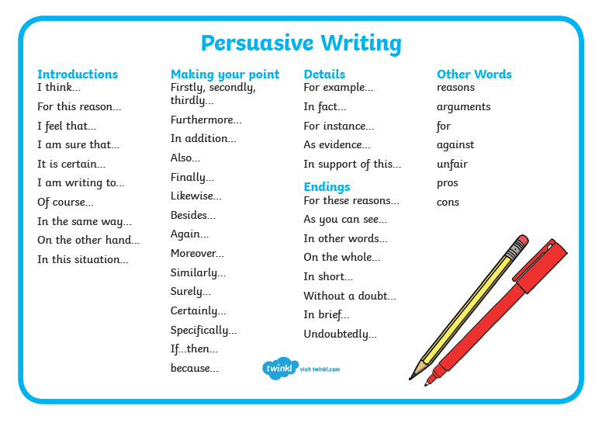

Dear

From,
Conclusion:
Argument 3:
Argument 2:
Argument 1:
Opening Statement:
Dear
Address

From,
In conclusion, I think that
Firstly, I think you should know that

To support this
Thank you for your letter, I understand you feel concerned. I am writing to tell you that
Finally,
Secondly,
Dear
Address

Dear Better Together Team, (BTT)

Hope you are all well.

I have been hearing and seeing a bit about the project you are working on. I'm really intrigued and wondered if you could help me out.

I have been telling the schools we work with in Australia about your project but I didn't have all the information they were looking for. I would be very interested to hear a bit more about what you intend to do, how you are going to achieve it - and most importantly why?

A few of the Head Teachers were a bit unclear and sceptical about what you are actually learning by doing this? They were freaking out as they said that it doesn't sound like traditional school work. They are thinking about asking their classes and teachers to copy you but got a bit concerned that by spending your time working on the project there might be things that you should be learning that you won't. What would you say to reassure them?

I look forward to hearing from you all!

Paul

P.S. I have a bit of experience planning online festivals if you have any questions.
P.P.S. One of the schools who are interested in your project is on Christmas Island - look it up. Pretty cool.

