SCHOOL LOGO.wmfSCHOOL LOGO.wmf**Blackburn Primary School**

**Hopefield Nursery Class**

**Newsletter**

**December 2020**

**Head Teacher’s Comments**

We are almost reaching the end of 2020 and what an incredible year this has been for us all. Although we have had many challenges to face this year and have managed this in different ways the children have been remarkably resilient, have enjoyed being in school and have been very receptive to learning. Due to the coronavirus pandemic and the most recent restrictions we are unable to undertake the usual Christmas activities that we have enjoyed in previous years as parents/carers will not be allowed in school and we cannot congregate in large groups indoors. However the Blackburn and Hopefield staff are a very creative team and are constantly thinking of ways to make our learning meaningful and fun that will involve our parents and partners as much as possible. This year we will be doing a virtual school fair and nativity (which will be posted on the Blog), we will be engaging all our children in challenge based activities throughout December, we will have individual class parties and of course we are in the process of organising the very important business of inviting Santa to a virtual meeting with our P 1/2, A 1 and Nursery pupils.

**Christmas Craft and Raffle**

**Not done any Christmas shopping yet due to essential shops only being open in West Lothian? Then your Christmas shopping worries are over! The school and the Nursery pupils have been busy making and creating Christmas craft that they can sell to raise money for our school fund. The children have had many super ideas on what to make that will be an excellent present for Christmas or to use as a Christmas decoration. All classes have made Christmas craft items and we have put them together in a Blackburn and Hopefield Christmas Brochure. Please take time to browse through our Christmas craft brochure and place any orders with the correct money and return to the class teacher and your gifts will be with you before the end of term. That is a guarantee! Also if you want to buy any raffle tickets then please order with the correct money and your raffle tickets will be given to you within the same day. As expected we have many wonderful prizes from the raffle ranging from hampers to getting your car valeted. We also plan to have a children’s raffle and the cost of a strip will be £1.00.**

**2021 Primary 1 Enrolment**

If your child will be 5 years old on or before 28th February 2022, you are invited to enrol your child at Blackburn Primary School. Enrolment forms are **no longer** distributed from Pupil Placement to pupils at Hopefield Nursery Class or at Blackburn Primary School and you need to apply online at [pupilplacement@westlothian.gov.uk](mailto:pupilplacement@westlothian.gov.uk) However if you are not able to access the internet please contact nursery staff on 01506 630944 or the school office on 01506 653481 and we will be delighted to help you with your application.

**School Improvement Planning and Pupil Equity Funding Planning (PEF) Session 2020/2021**

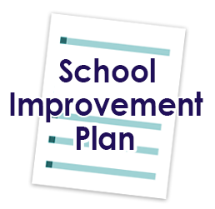Our School Improvement Planning this session has had a strong focus on supporting the Health and Wellbeing of our children and families post lockdown. We are developing a One Trusted Adult (OTA) approach across the school and are beginning to engage in OTA conversations with the pupils to support their mental, social and physical health. We are also focusing on developing pupil voice and developing learner’s agency (learners leading the learning) where the children have a say in what they want to learn and how. I am sure that you will agree that our sharing the learning experiences posted on our Blog and or Twitter is a brilliant example of learner’s agency. We will continue to have a focus on raising attainment in literacy and numeracy to close the poverty attainment gap between our most and least disadvantaged children in line with West Lothian’s priorities and to continue to develop the young workforce. Other priorities include the following:

* Development of a whole School Nurture approach
* Continued development of a reading and writing culture
* To provide targeted interventions for identified pupils
* To work in collaboration with the organisation Hidden Giants and the Scottish National Galleries to improve creativity in classroom practice and provide more opportunities for pupils to lead the learning in these uncertain times
* To fully implement the Scottish Government 1+2 Modern Languages Policy by August 2021
* To ensure outdoor learning is an integral part of daily practice

Motivating Monday

We have been running Motivating Monday for several years now where the children bring a healthy snack such as fruit, dried fruit or a cereal bar on a Monday. We have noticed recently that many of the children are bringing in bars of chocolate, sweets and crisps to eat at snack time particularly on a Monday. Please note that if our child/children bring an unhealthy snack to school on a Monday they will be requested to put their snack away until lunch time.

School Uniform

Although there has been a relaxation of the wearing of school uniform because there have been more opportunities to learn outdoors we have noticed that very few children are wearing their school sweatshirt. Whilst it is important to be dressed for the outdoors we would appreciate that the children wear their school sweatshirt and polo shirt as part of their clothing for learning outdoors.

Wellbeing Packs

Mrs McCarney, Community Action Blackburn (CAB) and Blackburn Family Centre have created a Wellbeing pack for people in the community who may need a little ‘pick me up’ in these troubled times. The pack consists of a reflection journal, a scented candle, seeds for new life, a pack of pencils with mindfulness colouring sheets, a leaflet containing helpful tips on maintaining wellbeing and most importantly a bar of chocolate! Many of these packs have already been distributed in the community and we hope to deliver more by the end of term. If you receive a pack we hope you enjoy using the pack to support your wellbeing.

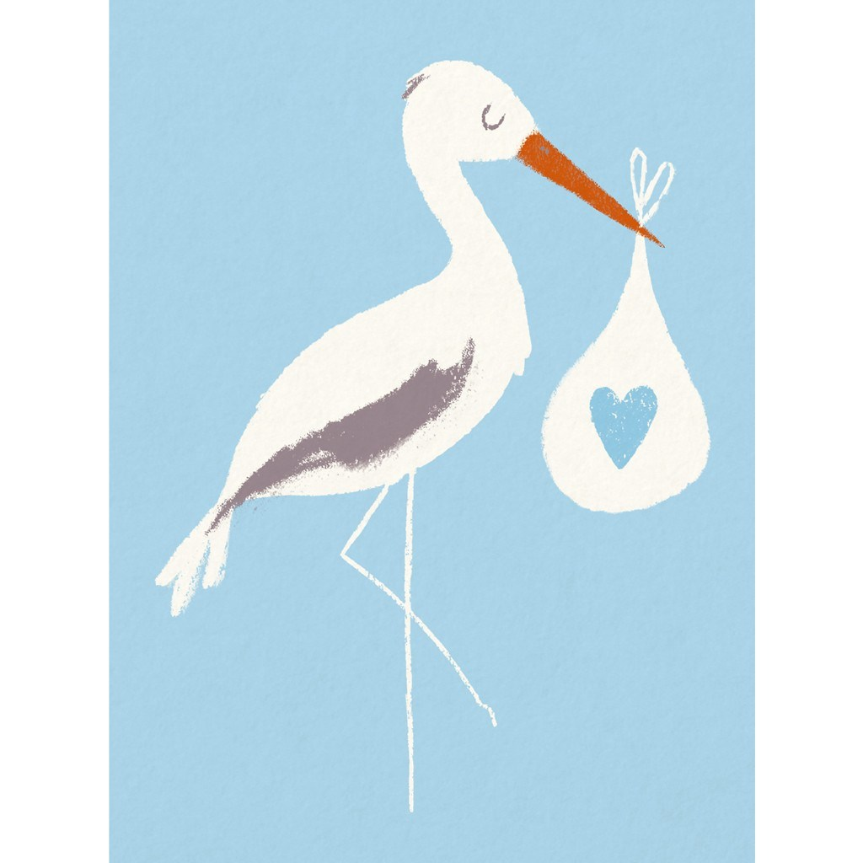

New Arrivals!

We have some lovely news to share. We are delighted to inform you that our Blackburn family is growing as Mrs Smith has had a baby girl called Rayne and Mrs McMillan is expecting her baby in a few weeks’ time. We wish Mrs Smith and Mrs McMillan well and hope that they enjoy their first Christmas with their new born baby.

Due to current measures being taken in school to minimise items going between home to school and other homes, we would request that children do not exchange cards with other pupils. Pupils may wish to bring in one card for their class that the teacher will display in the classroom.

**2020 has been a very challenging year for us all and Mrs McCarney and I would like to thank the staff of the school and the nursery for their continued support and for making sure that the needs of the children are at the heart of everything they do. All staff have worked tirelessly to make sure that our children are receiving the best possible education in a safe and secure environment and have worked hard to ensure that our children are ready to learn after being away from school and nursery for many months. With all the restrictions that have been placed upon us it has not been an easy job however the staff have rallied to the challenge and have done an amazing job. I know that this Christmas will be like no other however I hope that staff, families, pupils and partners will have a peaceful time at Christmas and all best wishes for Christmas and the New Year.**

**Term Dates Blackburn Primary School & Hopefield Nursery Class - Session 2020/2021**

Week beginning the 30th of November Leg it to Lapland Christmas challenge

Monday the 7th of December Nursery Christmas scavenger hunt

Thursday the 10th of December Christmas School Lunch: Children to donate £1 and wear Christmas jumper/tee- shirt/bobbly hat for Save the Children. This will be followed by a live author virtual meet by Paul Walsh who has written Fash, Chaps and Banz. There will also be an opportunity to purchase his book

Thursday the 10th of December Nursery children to donate a £1 and wear Christmas jumper/tee- shirt/bobbly hat for Save the Children

Monday the 14th of December Nursery parties A special visitor has been invited and we are hopeful that he will be able to attend our party virtually. Here’s hoping our internet connection is good enough to reach the North Pole! All day Monday children will attend the morning party and children who are not in on a Monday can attend the 1.15 pm to 3.15 pm session

Tuesday the 15th of December Last day to order from the School Christmas brochure and raffle

Wednesday the 16th of December Virtual Christmas raffle

Thursday the 17th of December Primary 1 to 7 Christmas parties: pm. A special visitor has been invited and we are hopeful that he will be able to attend our party virtually here is hoping our internet connection is good enough to reach the North Pole!

Thursday the 17th of December Hopefield Nursery pupils break up for the Christmas holiday

Friday the 18th of December Christmas movie

Friday the 18th of December 12.30 pm Pupils from school break up for Christmas holiday

Tuesday the 5th of January In-service day for teaching staff

Tuesday the 5th of January Nursery pupils resume

Wednesday the 6h of January School pupils resume

