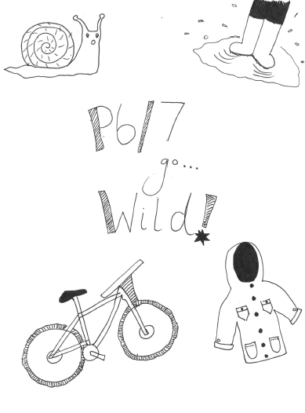

**Home Learning**

**Pupils should bring an ‘alternative paintbrush’ into school on Wednesday to use. This could be something as simple as a sponge, cotton bud or piece of lego! Think wild!**

**Lunches**

**Where possible packed lunches will be eaten outside. We will have outdoor shelters available for this ☺**

**Dr Bike!**

**Pupils should bring their bikes to school on Thursday 20th August as they will be taking part in a ‘Dr Bike’ session with Rowanne from IBike! If your child has problems with their bike e.g. a rusty chain, flat tyres etc. then this will be a perfect opportunity to learn how to fix those issues!**

**If your child does not own a bike then they can still take part in the session and will use one of the school’s bikes ☺**

**P.E**

**To minimise risk and to maximise learning experiences we will be spending a lot of time outdoors this session – come rain or shine! This can be tricky to prepare for in Scotland! We will be exploring the best ways to do this throughout the session in our class and alongside our parents as the seasons change!**

**Due to restrictions and safety measures we are limiting children changing clothes in school. All pupils in P6/7 should come to school every day dressed in outdoor P.E kit e.g. leggings, joggy bottoms etc. a polo shirt and their school jumper. Coming dressed like this every day will allow for flexibility.**

**After a number of soggy feet recently (including Miss Anderson’s!) I would recommend bringing a spare pair of socks! We would also be able to store wellies in our cloakroom if pupils wish to have a pair of wellies and a pair of trainers to change into for outdoor P.E.**