Date: Monday 25th May 2020 | 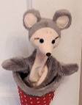  Theme this week: Using our imaginations - snakes  On the way home by Jill Murphy https://www.youtube.com/watch?v=x1Rr55dwLEw
Curriculum Area | Science | Numeracy | Literacy  Word Boost book for this week is:  On my way home – Author: Jill Murphy
LIT 0-07a / LIT 0-16a /  ENG 0-17a  I am learning to understand stories and other texts by asking questions and linking together what what I already know or find out.  MTH 0-17a  In movement, games, and using technology I can use simple directions and describe positions.  SCN 0-01a  I have observed living things in the environment over time and am becoming aware of how they depend on each other. | In the Story this week there is a ‘big fat snake that squeezed and squashed,’ Claire, what kind of snake do you think it was?  Can you find out about snakes how they move, what they eat and where they live?  https://www.youtube.com/watch?v=BOHFt15eVD4  Then have a look at how other animals move and see if you can use your body to move like a snake and other creature.  https://www.youtube.com/watch?v=CT86Dl442j  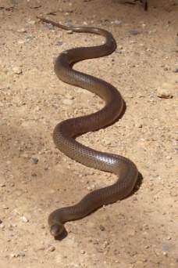  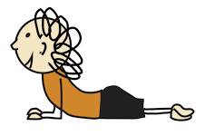 | 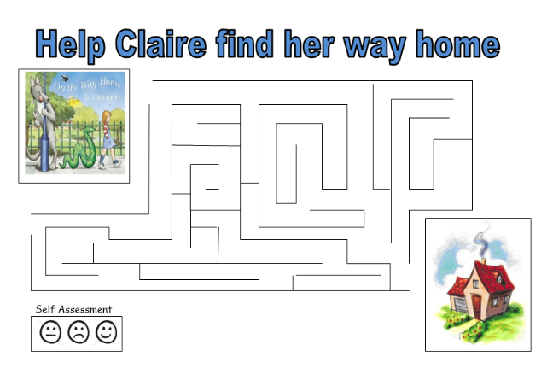  Can you help Clair find her way home? Who was the 1st creature she met and which was the last? Can you draw them on the maze?  Try this counting game and help George -  https://pbskids.org/curiousgeorge/busyday/hideseek/ | 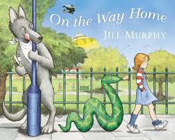  Read the story or watch the video.  The word for today is: Gigantic and it means really, really big and enormous.  Clap out Gi –gan- tic. How many claps were there?  Do you know any other creatures that are gigantic, perhaps bigger or taller than you?  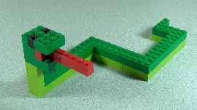  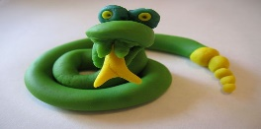  If you have some lego, play dough or anything else, could you try to make a Gigantic snake?

