Date: W/C 5th May 2020 | 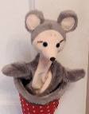  Theme today: The Sea  https://www.youtube.com/watch?v=XqZsoesa55w&vl=en  Can you dance to Baby Shark?
Curriculum Area | Science | Numeracy | Literacy
LIT 0-01b / LIT 0-11b I love to explore and choose stories and to listen and watch them.  MNU 0-10a  I am beginning to be aware of how routines and events in my world link with times.  SCN 0-20a  I can talk about science stories to develop my understanding of science and the world around me. | https://www.youtube.com/watch?v=gAjzH0vWSIA&feature=youtu.be  Flying fish  Tiddler sees some flying fish on his adventures. Watch this video to find out some more about them.  Do you think that they can really fly?  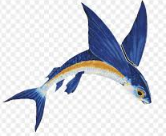  Which other creatures live in the sea? | https://www.mykidstime.com/things-to-do/easy-and-fun-clock-activities-for-kids/  Tiddler is always late and should be at school for 9 o’clock. One day he is very late and does not come at 10 o’clock, 11 o’clock or 12 o’clock … where can he be?  Are you able to follow the video and make your own clock.  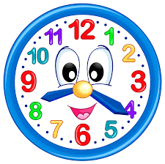 | Word Boost – Tiddler – The Story Telling Fish  https://www.youtube.com/watch?v=qcTQADUywZY  Listen to the story  The word today is imagination, which means that you think about new and exciting ideas. Remember to tap, clap or stamp out the word. Remember who the author is, the illustrator and what does the blurb tell us?  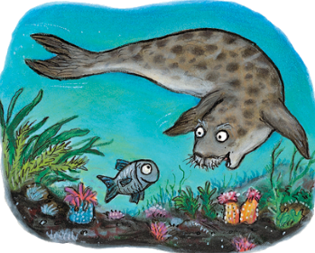  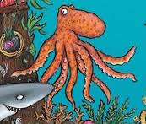  Can you draw a picture of one of Tiddler’s friends and use your imagination to tell a story about them. I wonder where they are and what they are doing?

