Date: W/C 28th April 2020 | 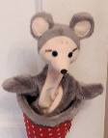  Theme today: Dinosaurs  Try out this dinosaur dance and use simple, repeated movements https://www.youtube.com/watch?v=XqE-tkd6DOI
Curriculum Area | Science | Numeracy | Literacy
LIT 0-01a / LIT 0-11a /  LIT 0-20a  Can you hear the patterns in the new word  Listen out for the rhyming words  MTH 0-16a  Are you able to recognise, describe and sort common 2D e.g., round, flat and curved.  SCN 0-20a  Can you talk about science stories to develop your understanding of science and the world around you. | 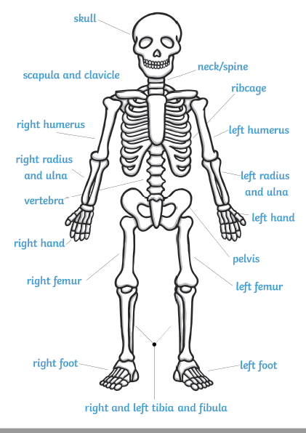  Here is a human skeleton, do you think it is different from the dinosaur skeleton from yesterday? Can you draw yourself and all your bones? | Use the different shapes to create your own dinosaur. Which shapes can you see, can you make a different dinosaur today?  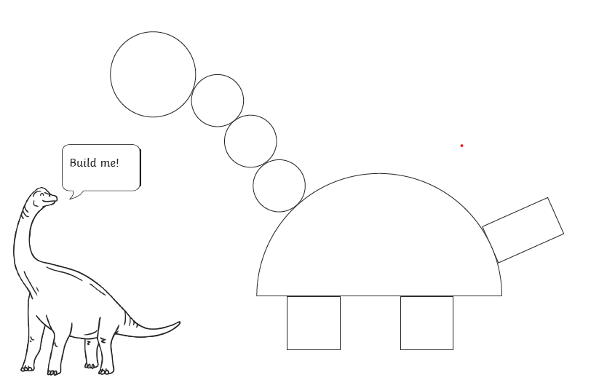  Semi-circle  Rectangle  Square  Circle | Word Boost for this week:  ‘The Dance of the Dinosaurs. Part 2 – listen on TWITTER to the second part of the story and tell your family what you think happens next. Can you hear words that sound the same?  Part 3 tomorrow!  Day 2 The word for today is flash.  A flash is a quick bit of light you see and  then it goes away again. (a flash of lightening). Clap, Tap your head or shoulders, stamp with your feet or jump the syllable sound for – flash  - Look out for lights that flash, for example traffic lights, car lights, bike lights etc.  - if you have a torch you could switch it on and off to make it flash  - build a den and use a torch to make flashing shadows

