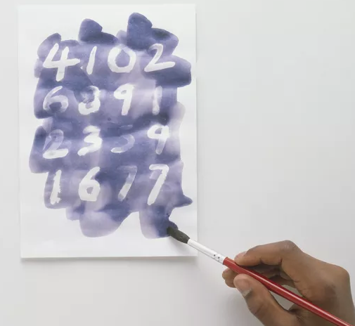
Making invisible ink to write and reveal secret messages is a great science project to try, even if you think you don't have the right chemicals. Why? Because just about any chemical can be used as invisible ink if you know how to use it.
What you'll need:
- Half a lemon
- Water
- Spoon
- Bowl
- Cotton bud
- White paper
- Lamp or other light bulb
Instructions:
- Squeeze some lemon juice into the bowl and add a few drops of water.
- Mix the water and lemon juice with the spoon.
- Dip the cotton bud into the mixture and write a message onto the white paper.
- Wait for the juice to dry so it becomes completely invisible.
- When you are ready to read your secret message or show it to someone else, heat the paper by holding it close to a light bulb
What's happening?
Lemon juice is an organic substance that oxidizes and turns brown when heated. Diluting the lemon juice in water makes it very hard to notice when you apply it the paper, no one will be aware of its presence until it is heated and the secret message is revealed. Other substances which work in the same way include orange juice, honey, milk, onion juice, vinegar and wine. Invisible ink can also be made using chemical reactions or by viewing certain liquids under ultraviolet (UV) light.

