Monday 20th April 2020
- I enjoy exploring and playing with the patterns and sounds of language, and can use what I learn. I am participating actively in songs, rhymes and stories.
LIT 0-01a / LIT 0-11a / LIT 0-20a.
- I am developing a sense of size and amount by observing, exploring, using and communicating with others about things in the world around me. MNU 0-01a
- I have helped to grow plants and can name their basic parts. I can talk about how they grow and what I need to do to look after them.
SCN 0-03a
- Learn the song, ‘Dingle Dangle scarecrow’
- Make a Scarecrow
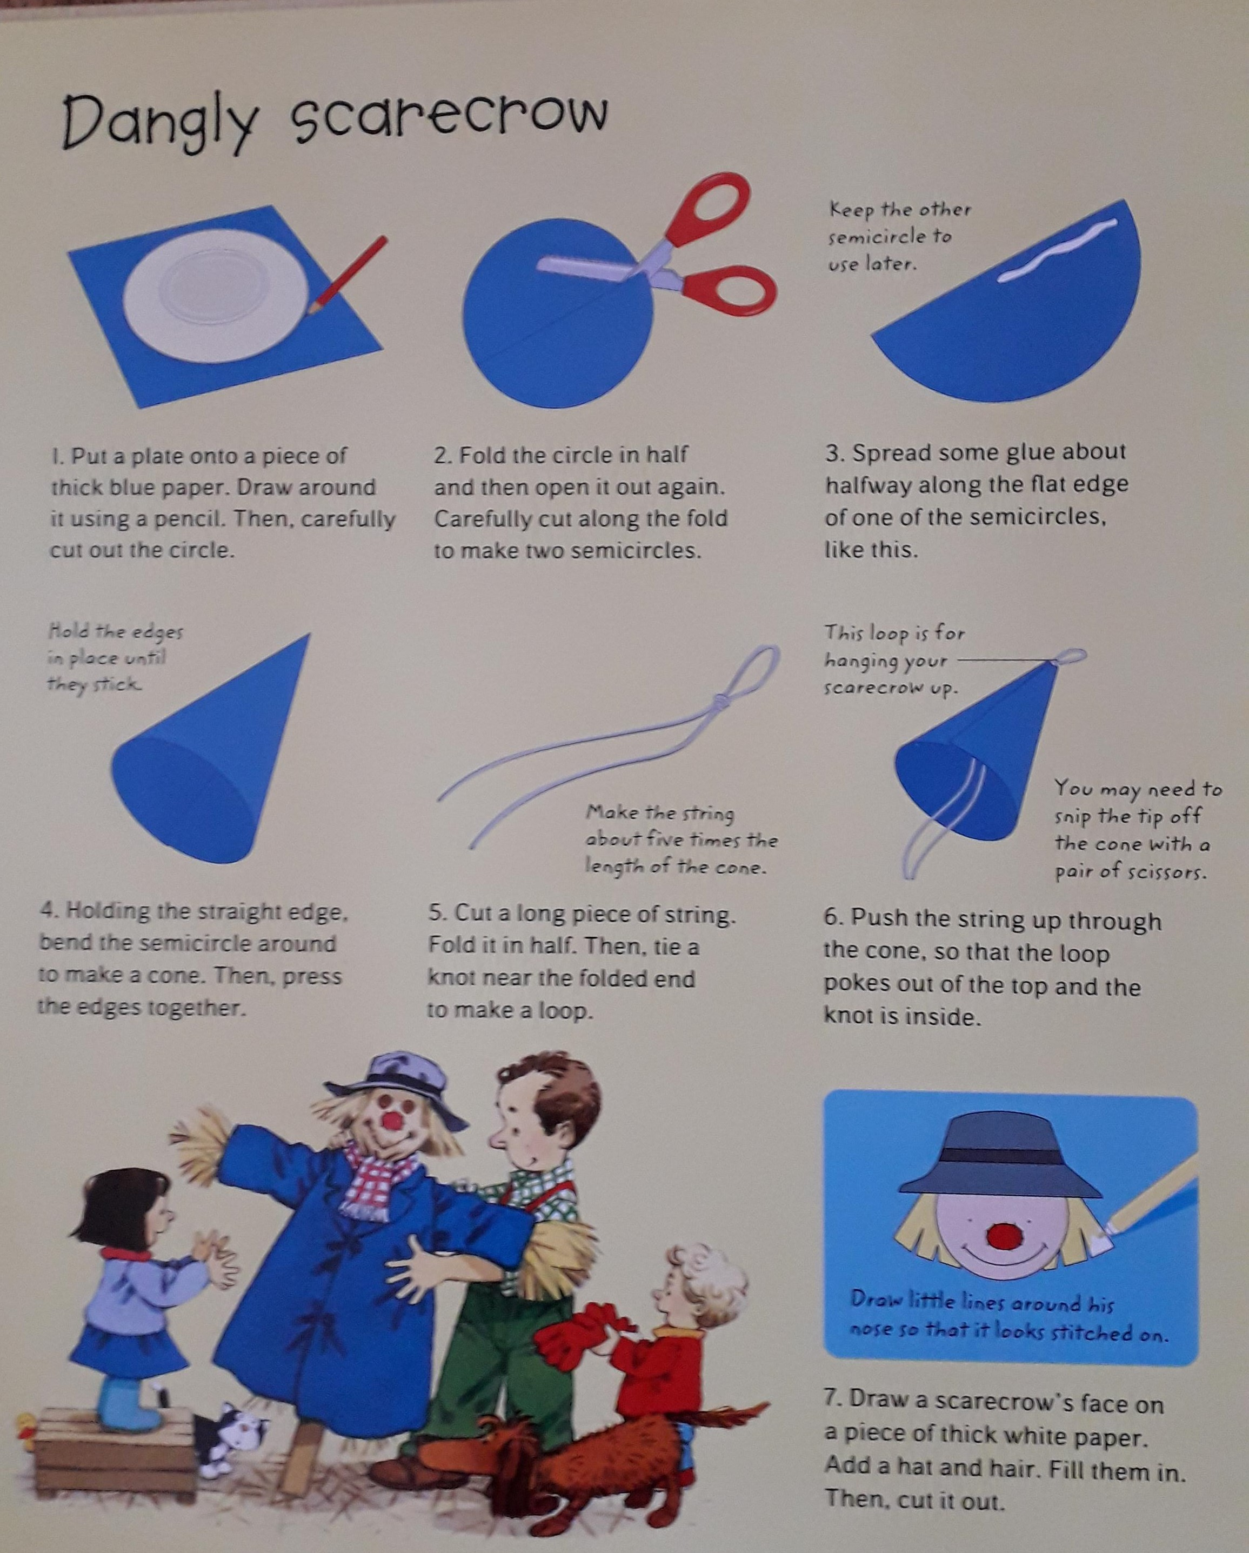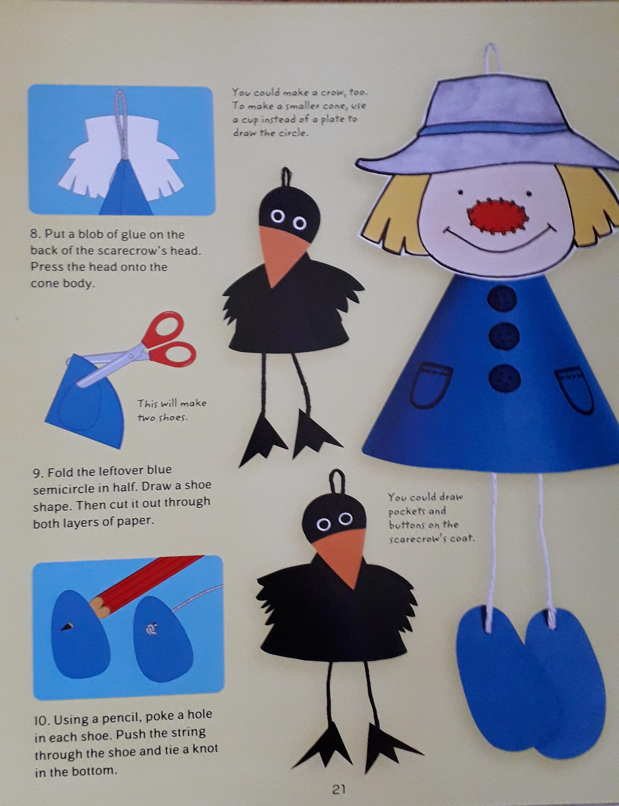

- If you have done some planting are you able to measure your plant, in the garden, in the woods, in the park when you are out for your walk, take a picture and put on Twitter.
- Think about what makes them grow and how tall do you think they will grow. Can you make your own ruler and mark it 1-10.
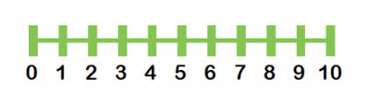

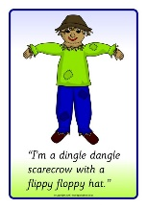
Dingle Dangle Scarecrow
When all the cows were sleeping
And the sun had gone to bed
Up jumped the scarecrow
And this is what he said
Chorus:
I'm a dingle, dangle scarecrow
With a great big floppy hat
I can shake my hands like this
And I can shake my feet like that
When all the hens were roosting
And the moon behind a cloud
Up jumped the scarecrow
And shouted very loud
When dogs were in the kennels
And doves were in the loft
Up jumped the scarecrow
And whispered very soft

