- 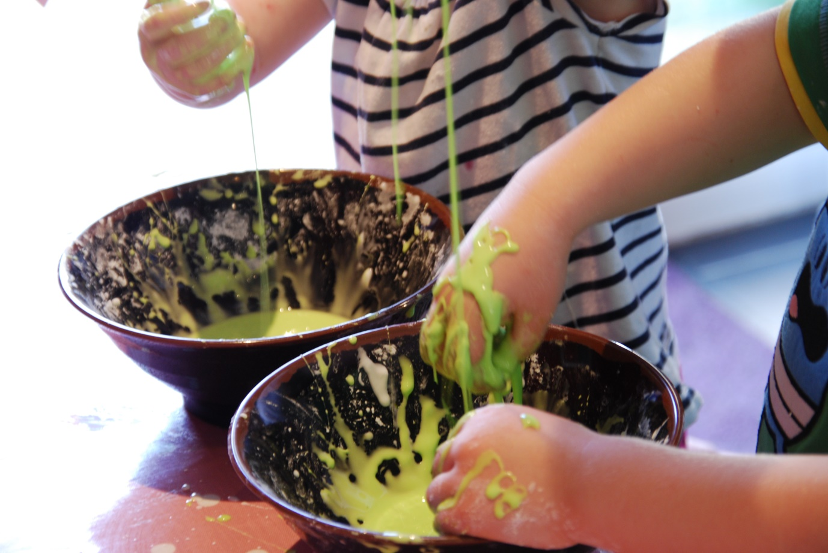Cornflour
- Water
- Food colouring – optional
- Ice cube trays – optional
- Mixing bowl
- Colander, funnel and beakers – optional, but great for messy fun!

INSTRUCTIONS FOR MAKING CORNFLOUR GLOOP
- Fill a cup with cornflour and add to the bowl
- Add water very slowly mixing with your hands, until you get a sticky, slimy gloop.
- If you want to make it coloured add some food colouring. ( be careful this can stain skin and clothes)
- Play with the slime and see how it behaves. Can you make it into a ball? and what happens if you throw it onto the floor?

THE SCIENCE OF OOBLECK
Did you notice that if you make a ball with oobleck or gloop it feels solid, but if you drop the oobleck on the floor it turns liquid again? The slime is a non – Newtonian fluid as it doesn’t flow like liquids normally do.

