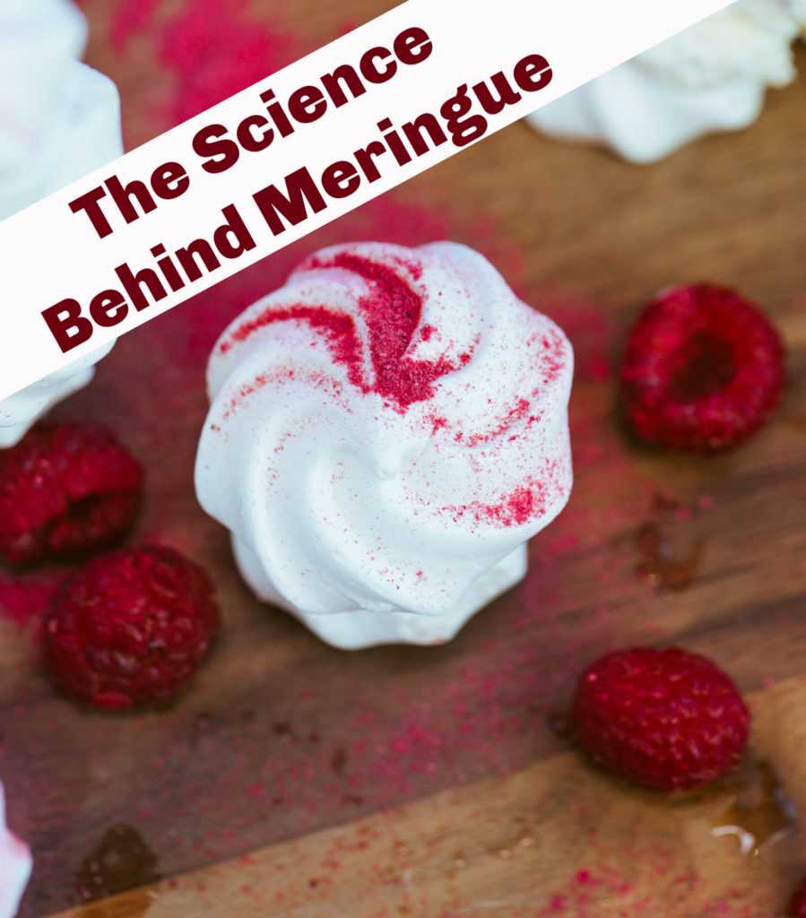

This experiment looks at how egg white ( albumen ) is transformed as it is whisked. Egg white is about 2/3 of the total weight of an egg, and is 10% protein, the rest being mostly water. To demonstrate the change in the egg white we are going to discover how to make meringue!

MERINGUE RECIPE
What you need:
- A bowl
- A whisk
- Baking sheet
- 4 egg whites
- 225g caster sugar
You can use less eggs as long as you use about 55g of caster sugar per egg white.

INSTRUCTIONS FOR MAKING MERINGUE
- Pre-heat the oven to 140 degrees, gas mark 1.
- Line 2 baking sheets with parchment
- Put the egg whites in a bowl and whisk slowly at first then faster as they expand. Once you get stiff peaks the egg whites are ready.
- Add the sugar slowly a few tablespoons at a time and whisk after each sugar addition.
- Place 2 heaped tablespoons of mixture onto the baking parchment, leave a gap and then repeat until all your mixture is used up.
- Place in the oven on a low shelf for about 45 minutes. Then turn the oven off, but leave the meringues inside for a further 15 minutes.
- Serve with whipped cream and fruit.
For more fun try making meringue towers, how high can you build them before they topple?

THE SCIENCE BEHIND MERINGUE
When we whisk egg white, two things happen:
- The whisk creates a force through the egg white which unfolds the protein molecules.
- The whisking also causes air bubbles to be trapped in the unfolded proteins which makes a foam.
- When baked the foam hardens into meringue! How cool is that?

